Concussion networks

# Method

## Statistical analysis

All analyses were conducted using R (R Core Team, 2024), version 4.4.1. The network models were estimated with the Bayesian Gaussian Graphical Models (BGGM) package. The scores were standardized and analyzed as continuous. To handle missing data, multilevel multiple

imputation was conducted with the mice package (van Buuren and Groothuis-Oudshoorn, 2011)

### Between-person networks

We estimated the Gaussian graphical model with all the symptoms averaged across all time points, controlling for the effect of sex and including the whole sample. The results include the posterior mean and 95% credible interval for the edge weight estimates. Graphically, these relations are shown as a network plot. Additionally, we also compute the bridge strength of each symptom. It represents the absolute edge weights for each node, such that the value is a composite of all associations (positive or negative) a node has with other nodes.

### Within-person networks

In the within-person network model, we investigate the associations between the symptoms at each measurement occasion after subtracting the person average from each measurement. First, we scaled the symptoms across all the individuals and measurement occasions. We then calculated the mean person score in standardized units. We finally subtracted each standardized score from their own average to obtain a person-centered score. That way, we can observe whether fluctuations around each participant’s mean in one symptom are associated with fluctuations in this same participant’s mean in another symptom. For example, we can examine if someone experiencing more than average vomiting on one measurement occasion would also experience more than average nausea on the same measurement occasion.

### Individual longitudinal networks

Our third analysis consisted of estimating a graphical vector auto-regression (GVAR) for each subject and computing edge weights and bridge strength for each individual contemporaneous network. These networks encode relationships between variables within the same measurement occasion and after controlling for temporal effects. We computed the frequencies for which each node was selected as the most central (higher bridge strength) and the average edge weight from these results. The individual’s partial correlation matrices were transformed into z-scores and then averaged across all participants. The average z-scores were then transformed back into partial correlation coefficients and used to estimate the networks. Due to convergence issues, 113 participants were dropped from these analyses. The final sample consisted of 240 subjects, of which 58 were participants with concussion history, and 91 were controls.

# Results

## Between-person networks

### Total sample

### Edge weight

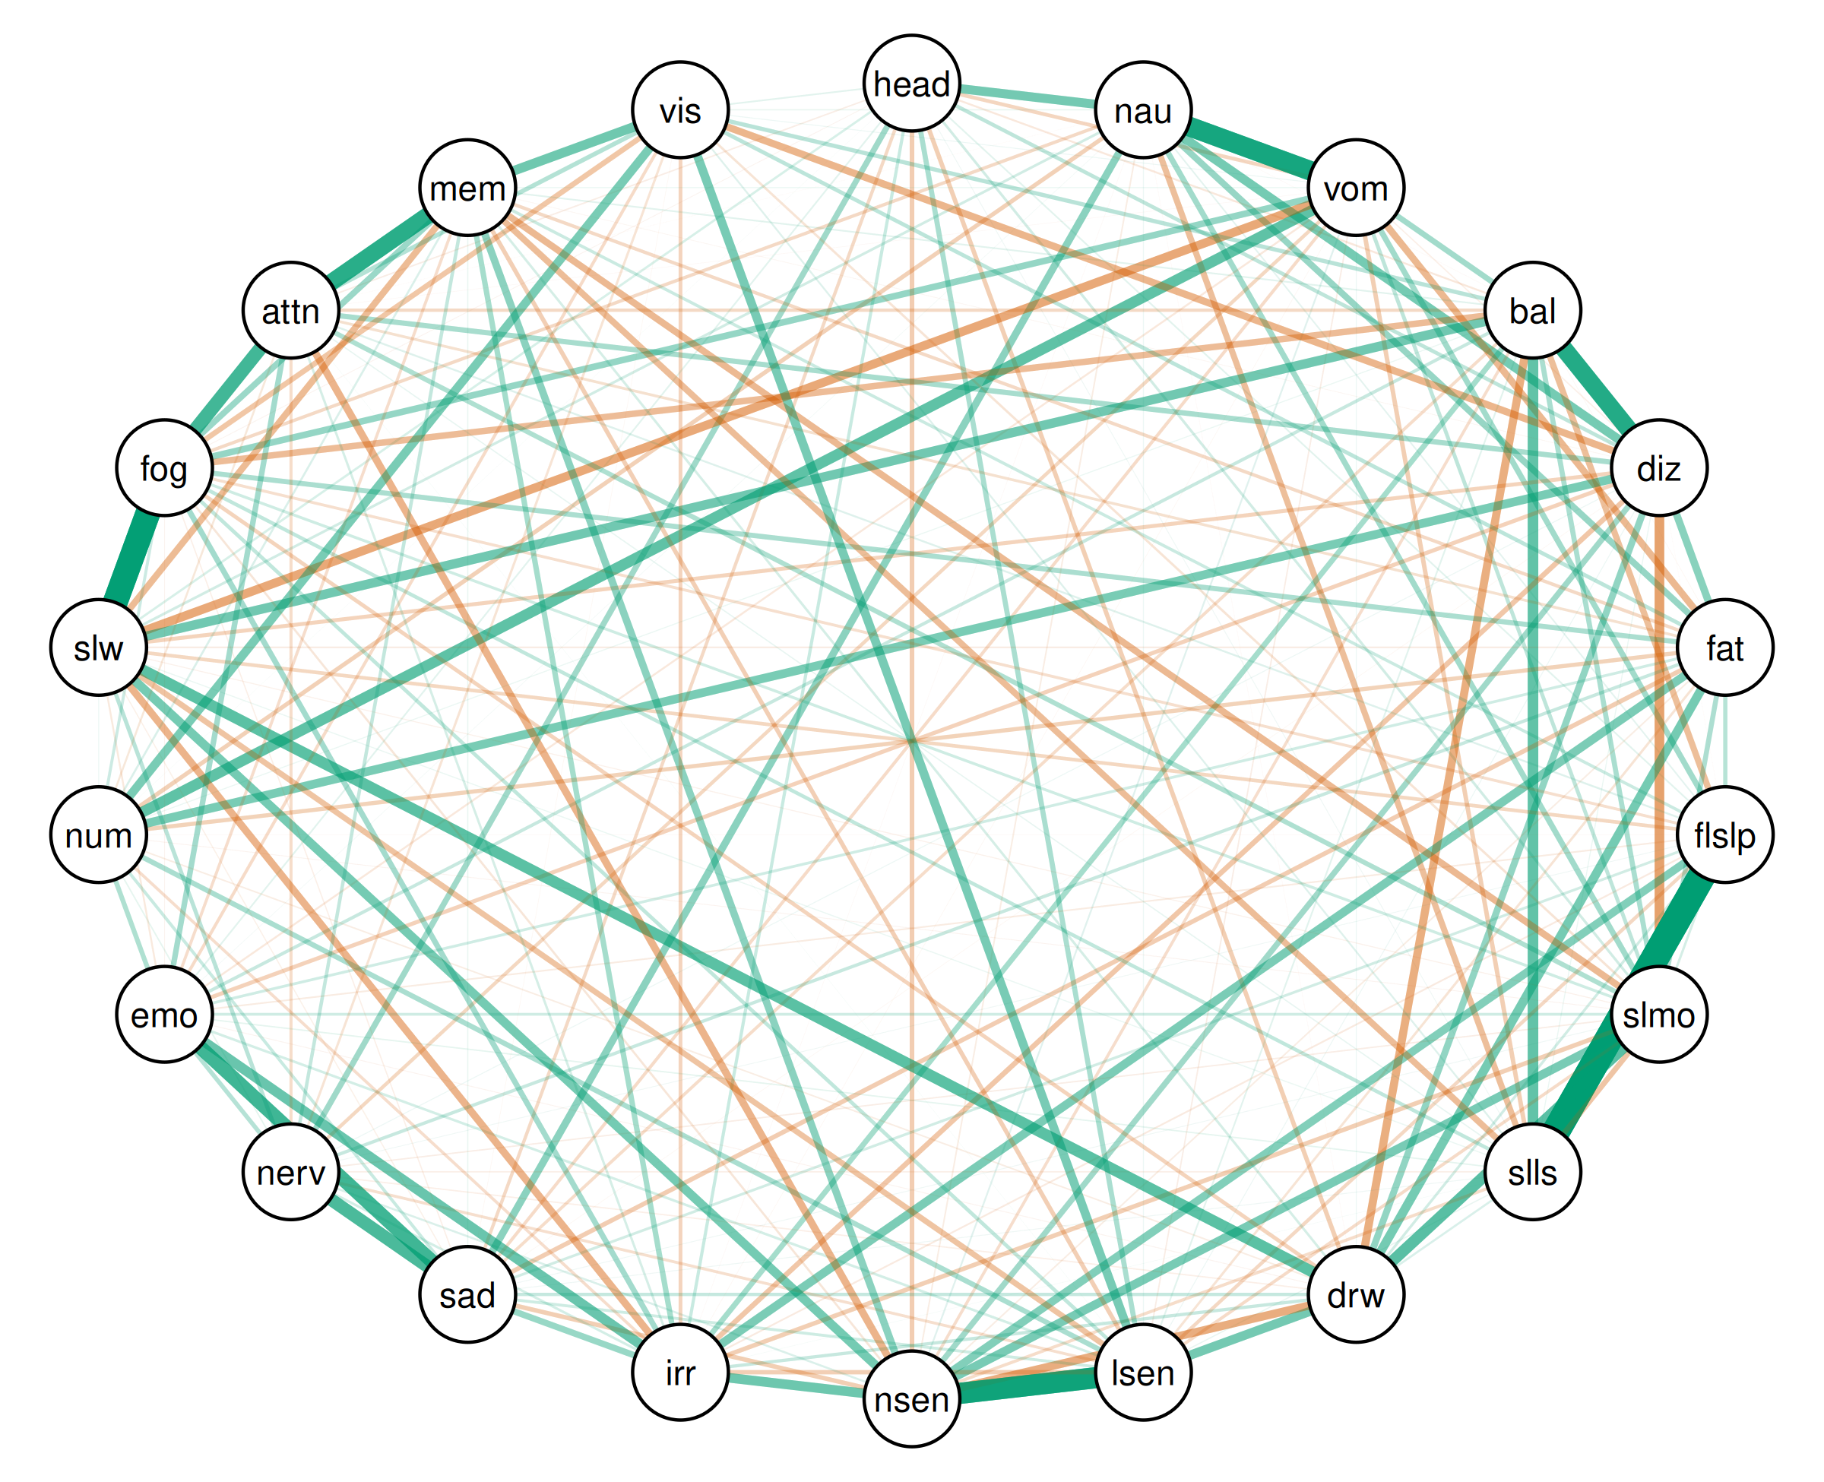

| Relation | Post.mean | Post.sd | Cred.lb | Cred.ub |
| --- | --- | --- | --- | --- |
| Trouble Falling Asleep--Sleeping Less Than Usual | 0.82 | 0.00 | 0.82 | 0.83 |
| Feeling Slowed Down--Feeling Mentally “Foggy” | 0.73 | 0.00 | 0.73 | 0.74 |
| Sensitivity to Light--Sensitivity to Noise | 0.63 | 0.00 | 0.62 | 0.63 |
| Nausea--Vomiting | 0.58 | 0.00 | 0.57 | 0.59 |
| Balance Problems--Dizziness | 0.52 | 0.00 | 0.51 | 0.53 |
| Difficulty Concentrating--Difficulty Remembering | 0.49 | 0.00 | 0.48 | 0.50 |
| Sadness--Feeling More Emotional | 0.41 | 0.01 | 0.40 | 0.42 |
| Feeling Mentally “Foggy”--Difficulty Concentrating | 0.40 | 0.01 | 0.39 | 0.41 |
| Sadness--Nervousness | 0.38 | 0.01 | 0.37 | 0.39 |
| Sleeping More Than Usual--Drowsiness | 0.34 | 0.01 | 0.33 | 0.34 |
| Drowsiness--Feeling Slowed Down | 0.33 | 0.01 | 0.32 | 0.34 |
| Vomiting--Numbness or Tingling | 0.32 | 0.01 | 0.31 | 0.33 |
| Balance Problems--Sleeping Less Than Usual | 0.31 | 0.01 | 0.30 | 0.32 |
| Irritability--Feeling More Emotional | 0.29 | 0.01 | 0.28 | 0.30 |
| Dizziness--Sleeping More Than Usual | -0.28 | 0.01 | -0.29 | -0.28 |
| Sensitivity to Noise--Irritability | 0.28 | 0.01 | 0.27 | 0.29 |
| Difficulty Remembering--Visual Problems | 0.28 | 0.01 | 0.27 | 0.29 |
| Balance Problems--Feeling Slowed Down | 0.28 | 0.01 | 0.27 | 0.29 |
| Drowsiness--Sensitivity to Light | 0.27 | 0.01 | 0.26 | 0.28 |
| Headache--Nausea | 0.27 | 0.01 | 0.26 | 0.28 |
| Fatigue--Drowsiness | 0.27 | 0.01 | 0.26 | 0.28 |
| Sensitivity to Noise--Feeling Slowed Down | 0.27 | 0.01 | 0.25 | 0.28 |
| Nausea--Dizziness | 0.26 | 0.01 | 0.25 | 0.27 |
| Vomiting--Feeling Slowed Down | -0.26 | 0.01 | -0.27 | -0.25 |
| Sensitivity to Light--Visual Problems | 0.26 | 0.01 | 0.25 | 0.27 |
| Sleeping More Than Usual--Sensitivity to Noise | 0.26 | 0.01 | 0.25 | 0.27 |
| Dizziness--Numbness or Tingling | 0.26 | 0.01 | 0.24 | 0.27 |
| Numbness or Tingling--Visual Problems | 0.25 | 0.01 | 0.24 | 0.27 |
| Fatigue--Irritability | 0.25 | 0.01 | 0.24 | 0.26 |
| Drowsiness--Sensitivity to Noise | -0.24 | 0.01 | -0.25 | -0.23 |
| Balance Problems--Drowsiness | -0.24 | 0.01 | -0.25 | -0.23 |
| Trouble Falling Asleep--Sensitivity to Noise | 0.24 | 0.01 | 0.23 | 0.25 |
| Dizziness--Fatigue | 0.22 | 0.01 | 0.21 | 0.23 |
| Sensitivity to Noise--Difficulty Concentrating | -0.22 | 0.01 | -0.23 | -0.21 |
| Sensitivity to Noise--Difficulty Remembering | 0.22 | 0.01 | 0.21 | 0.23 |
| Irritability--Feeling Slowed Down | -0.22 | 0.01 | -0.23 | -0.20 |
| Nausea--Sadness | 0.21 | 0.01 | 0.20 | 0.23 |
| Dizziness--Visual Problems | -0.21 | 0.01 | -0.22 | -0.20 |
| Vomiting--Fatigue | -0.20 | 0.01 | -0.21 | -0.19 |
| Dizziness--Drowsiness | 0.20 | 0.01 | 0.19 | 0.21 |
| Sleeping More Than Usual--Difficulty Remembering | -0.20 | 0.01 | -0.21 | -0.19 |
| Feeling Slowed Down--Difficulty Remembering | -0.20 | 0.01 | -0.20 | -0.18 |
| Vomiting--Feeling Mentally “Foggy” | 0.19 | 0.01 | 0.18 | 0.20 |
| Balance Problems--Feeling Mentally “Foggy” | -0.19 | 0.01 | -0.20 | -0.18 |
| Nausea--Fatigue | 0.19 | 0.01 | 0.18 | 0.20 |
| Sleeping Less Than Usual--Difficulty Remembering | -0.19 | 0.01 | -0.20 | -0.18 |
| Irritability--Sadness | 0.19 | 0.01 | 0.18 | 0.20 |
| Balance Problems--Trouble Falling Asleep | -0.18 | 0.01 | -0.20 | -0.17 |
| Feeling Mentally “Foggy”--Difficulty Remembering | 0.18 | 0.01 | 0.17 | 0.19 |
| Nausea--Sleeping Less Than Usual | -0.18 | 0.01 | -0.19 | -0.17 |
| Dizziness--Sensitivity to Noise | 0.17 | 0.01 | 0.16 | 0.18 |
| Headache--Nervousness | 0.17 | 0.01 | 0.16 | 0.18 |
| Sensitivity to Light--Feeling Slowed Down | -0.17 | 0.01 | -0.18 | -0.16 |
| Vomiting--Balance Problems | 0.17 | 0.01 | 0.16 | 0.18 |
| Nausea--Sleeping More Than Usual | 0.17 | 0.01 | 0.16 | 0.18 |
| Vomiting--Trouble Falling Asleep | 0.17 | 0.01 | 0.16 | 0.18 |
| Irritability--Feeling Mentally “Foggy” | 0.16 | 0.01 | 0.15 | 0.17 |
| Feeling More Emotional--Difficulty Concentrating | 0.16 | 0.01 | 0.15 | 0.17 |
| Sleeping More Than Usual--Sleeping Less Than Usual | -0.16 | 0.01 | -0.17 | -0.15 |
| Balance Problems--Irritability | 0.16 | 0.01 | 0.15 | 0.17 |
| Irritability--Difficulty Remembering | 0.16 | 0.01 | 0.15 | 0.17 |
| Feeling Mentally “Foggy”--Visual Problems | -0.16 | 0.01 | -0.17 | -0.15 |
| Dizziness--Difficulty Concentrating | 0.15 | 0.01 | 0.14 | 0.17 |
| Dizziness--Irritability | -0.15 | 0.01 | -0.16 | -0.14 |
| Sensitivity to Light--Numbness or Tingling | 0.15 | 0.01 | 0.14 | 0.16 |
| Headache--Sensitivity to Light | 0.15 | 0.01 | 0.14 | 0.16 |
| Balance Problems--Sleeping More Than Usual | 0.15 | 0.01 | 0.14 | 0.16 |
| Fatigue--Feeling Mentally “Foggy” | 0.15 | 0.01 | 0.14 | 0.16 |
| Fatigue--Sleeping More Than Usual | 0.15 | 0.01 | 0.14 | 0.16 |
| Sleeping More Than Usual--Difficulty Concentrating | 0.14 | 0.01 | 0.13 | 0.15 |
| Feeling More Emotional--Numbness or Tingling | 0.14 | 0.01 | 0.13 | 0.15 |
| Headache--Sensitivity to Noise | -0.14 | 0.01 | -0.15 | -0.12 |
| Fatigue--Sadness | -0.14 | 0.01 | -0.15 | -0.12 |
| Sleeping More Than Usual--Irritability | -0.13 | 0.01 | -0.14 | -0.12 |
| Vomiting--Sleeping Less Than Usual | -0.13 | 0.01 | -0.14 | -0.12 |
| Headache--Drowsiness | -0.13 | 0.01 | -0.14 | -0.12 |
| Sensitivity to Noise--Sadness | -0.13 | 0.01 | -0.14 | -0.12 |
| Difficulty Concentrating--Visual Problems | 0.13 | 0.01 | 0.12 | 0.14 |
| Sensitivity to Light--Irritability | -0.13 | 0.01 | -0.14 | -0.12 |
| Nervousness--Feeling More Emotional | 0.13 | 0.01 | 0.12 | 0.14 |
| Sensitivity to Light--Difficulty Remembering | -0.13 | 0.01 | -0.14 | -0.12 |
| Nausea--Numbness or Tingling | -0.13 | 0.01 | -0.14 | -0.12 |
| Fatigue--Trouble Falling Asleep | 0.12 | 0.01 | 0.11 | 0.14 |
| Balance Problems--Visual Problems | 0.12 | 0.01 | 0.11 | 0.13 |
| Fatigue--Numbness or Tingling | -0.12 | 0.01 | -0.13 | -0.11 |
| Nervousness--Feeling Slowed Down | 0.12 | 0.01 | 0.11 | 0.13 |
| Dizziness--Feeling More Emotional | -0.12 | 0.01 | -0.13 | -0.11 |
| Dizziness--Feeling Slowed Down | -0.12 | 0.01 | -0.13 | -0.10 |
| Drowsiness--Feeling Mentally “Foggy” | -0.12 | 0.01 | -0.13 | -0.10 |
| Fatigue--Visual Problems | 0.12 | 0.01 | 0.10 | 0.13 |
| Vomiting--Sleeping More Than Usual | 0.11 | 0.01 | 0.10 | 0.12 |
| Headache--Dizziness | 0.11 | 0.01 | 0.10 | 0.12 |
| Irritability--Visual Problems | -0.11 | 0.01 | -0.12 | -0.10 |
| Headache--Vomiting | -0.11 | 0.01 | -0.12 | -0.10 |
| Sensitivity to Light--Feeling Mentally “Foggy” | 0.11 | 0.01 | 0.10 | 0.12 |
| Sleeping Less Than Usual--Feeling Mentally “Foggy” | 0.11 | 0.01 | 0.10 | 0.12 |
| Trouble Falling Asleep--Feeling Slowed Down | -0.11 | 0.01 | -0.12 | -0.10 |
| Trouble Falling Asleep--Sensitivity to Light | -0.10 | 0.01 | -0.12 | -0.09 |
| Vomiting--Nervousness | -0.10 | 0.01 | -0.12 | -0.09 |
| Nervousness--Difficulty Remembering | 0.10 | 0.01 | 0.09 | 0.11 |
| Fatigue--Difficulty Remembering | -0.10 | 0.01 | -0.11 | -0.09 |
| Balance Problems--Difficulty Concentrating | -0.10 | 0.01 | -0.11 | -0.09 |
| Headache--Sadness | -0.10 | 0.01 | -0.11 | -0.09 |
| Drowsiness--Sadness | 0.10 | 0.01 | 0.09 | 0.11 |
| Nausea--Feeling Mentally “Foggy” | -0.10 | 0.01 | -0.11 | -0.09 |
| Fatigue--Nervousness | 0.10 | 0.01 | 0.09 | 0.11 |
| Balance Problems--Feeling More Emotional | 0.10 | 0.01 | 0.09 | 0.11 |
| Drowsiness--Irritability | 0.10 | 0.01 | 0.09 | 0.11 |
| Headache--Irritability | 0.10 | 0.01 | 0.08 | 0.11 |
| Vomiting--Sadness | -0.10 | 0.01 | -0.11 | -0.08 |
| Sleeping More Than Usual--Sensitivity to Light | -0.09 | 0.01 | -0.10 | -0.08 |
| Feeling More Emotional--Visual Problems | -0.09 | 0.01 | -0.10 | -0.08 |
| Sleeping Less Than Usual--Sensitivity to Noise | -0.09 | 0.01 | -0.10 | -0.08 |
| Balance Problems--Sadness | -0.09 | 0.01 | -0.10 | -0.08 |
| Sadness--Numbness or Tingling | 0.09 | 0.01 | 0.08 | 0.10 |
| Nervousness--Difficulty Concentrating | -0.09 | 0.01 | -0.10 | -0.08 |
| Trouble Falling Asleep--Difficulty Remembering | 0.09 | 0.01 | 0.08 | 0.10 |
| Balance Problems--Sensitivity to Noise | -0.09 | 0.01 | -0.10 | -0.08 |
| Irritability--Numbness or Tingling | -0.09 | 0.01 | -0.10 | -0.08 |
| Numbness or Tingling--Feeling Mentally “Foggy” | 0.09 | 0.01 | 0.08 | 0.10 |
| Feeling More Emotional--Difficulty Remembering | -0.09 | 0.01 | -0.10 | -0.08 |
| Sensitivity to Light--Sadness | 0.09 | 0.01 | 0.07 | 0.10 |
| Trouble Falling Asleep--Feeling Mentally “Foggy” | -0.09 | 0.01 | -0.10 | -0.07 |
| Sensitivity to Light--Nervousness | -0.08 | 0.01 | -0.10 | -0.07 |
| Sleeping More Than Usual--Feeling Mentally “Foggy” | 0.08 | 0.01 | 0.07 | 0.10 |
| Fatigue--Feeling More Emotional | 0.08 | 0.01 | 0.07 | 0.09 |
| Sleeping More Than Usual--Feeling More Emotional | 0.08 | 0.01 | 0.07 | 0.09 |
| Fatigue--Difficulty Concentrating | -0.08 | 0.01 | -0.09 | -0.07 |
| Trouble Falling Asleep--Drowsiness | 0.08 | 0.01 | 0.07 | 0.09 |
| Trouble Falling Asleep--Sadness | 0.08 | 0.01 | 0.07 | 0.09 |
| Headache--Sleeping More Than Usual | 0.08 | 0.01 | 0.07 | 0.09 |
| Nausea--Feeling Slowed Down | 0.08 | 0.01 | 0.07 | 0.09 |
| Sensitivity to Light--Feeling More Emotional | 0.07 | 0.01 | 0.06 | 0.09 |
| Irritability--Nervousness | 0.07 | 0.01 | 0.06 | 0.08 |
| Fatigue--Sensitivity to Light | -0.07 | 0.01 | -0.08 | -0.06 |
| Drowsiness--Difficulty Remembering | 0.07 | 0.01 | 0.06 | 0.08 |
| Trouble Falling Asleep--Sleeping More Than Usual | 0.07 | 0.01 | 0.06 | 0.08 |
| Nervousness--Visual Problems | -0.07 | 0.01 | -0.08 | -0.06 |
| Irritability--Difficulty Concentrating | 0.07 | 0.01 | 0.06 | 0.08 |
| Sleeping More Than Usual--Visual Problems | -0.07 | 0.01 | -0.08 | -0.06 |
| Headache--Feeling Slowed Down | 0.07 | 0.01 | 0.06 | 0.08 |
| Sensitivity to Noise--Feeling Mentally “Foggy” | -0.06 | 0.01 | -0.08 | -0.05 |
| Sleeping Less Than Usual--Drowsiness | 0.06 | 0.01 | 0.05 | 0.07 |
| Numbness or Tingling--Difficulty Remembering | 0.06 | 0.01 | 0.05 | 0.07 |
| Sensitivity to Noise--Nervousness | 0.06 | 0.01 | 0.05 | 0.07 |
| Numbness or Tingling--Difficulty Concentrating | -0.06 | 0.01 | -0.07 | -0.05 |
| Headache--Balance Problems | -0.06 | 0.01 | -0.07 | -0.05 |
| Vomiting--Feeling More Emotional | -0.06 | 0.01 | -0.07 | -0.05 |
| Trouble Falling Asleep--Difficulty Concentrating | 0.06 | 0.01 | 0.04 | 0.07 |
| Feeling More Emotional--Feeling Slowed Down | -0.06 | 0.01 | -0.07 | -0.04 |
| Sleeping Less Than Usual--Visual Problems | 0.05 | 0.01 | 0.04 | 0.07 |
| Vomiting--Sensitivity to Noise | 0.05 | 0.01 | 0.04 | 0.06 |
| Trouble Falling Asleep--Irritability | -0.05 | 0.01 | -0.06 | -0.04 |
| Headache--Trouble Falling Asleep | 0.05 | 0.01 | 0.04 | 0.06 |
| Balance Problems--Sensitivity to Light | 0.05 | 0.01 | 0.04 | 0.06 |
| Headache--Feeling More Emotional | 0.05 | 0.01 | 0.04 | 0.06 |
| Fatigue--Feeling Slowed Down | -0.05 | 0.01 | -0.06 | -0.04 |
| Headache--Visual Problems | 0.05 | 0.01 | 0.04 | 0.06 |
| Trouble Falling Asleep--Feeling More Emotional | -0.05 | 0.01 | -0.06 | -0.04 |
| Balance Problems--Difficulty Remembering | 0.05 | 0.01 | 0.04 | 0.06 |
| Nausea--Sensitivity to Noise | -0.05 | 0.01 | -0.06 | -0.03 |
| Fatigue--Sensitivity to Noise | -0.05 | 0.01 | -0.06 | -0.04 |
| Nausea--Trouble Falling Asleep | 0.04 | 0.01 | 0.03 | 0.06 |
| Drowsiness--Numbness or Tingling | -0.04 | 0.01 | -0.06 | -0.03 |
| Nervousness--Numbness or Tingling | 0.04 | 0.01 | 0.03 | 0.06 |
| Headache--Difficulty Concentrating | -0.04 | 0.01 | -0.06 | -0.03 |
| Vomiting--Sensitivity to Light | -0.04 | 0.01 | -0.05 | -0.03 |
| Sleeping More Than Usual--Nervousness | -0.04 | 0.01 | -0.05 | -0.03 |
| Sleeping Less Than Usual--Feeling More Emotional | 0.04 | 0.01 | 0.03 | 0.05 |
| Sleeping Less Than Usual--Nervousness | -0.04 | 0.01 | -0.05 | -0.03 |
| Drowsiness--Nervousness | -0.04 | 0.01 | -0.05 | -0.03 |
| Vomiting--Dizziness | -0.04 | 0.01 | -0.05 | -0.03 |
| Sadness--Feeling Mentally “Foggy” | -0.04 | 0.01 | -0.05 | -0.03 |
| Sleeping Less Than Usual--Difficulty Concentrating | 0.04 | 0.01 | 0.03 | 0.05 |
| Sleeping Less Than Usual--Sensitivity to Light | 0.04 | 0.01 | 0.03 | 0.05 |
| Sadness--Feeling Slowed Down | -0.04 | 0.01 | -0.05 | -0.02 |
| Nausea--Visual Problems | 0.04 | 0.01 | 0.03 | 0.05 |
| Sadness--Difficulty Remembering | 0.04 | 0.01 | 0.02 | 0.05 |
| Sleeping Less Than Usual--Feeling Slowed Down | 0.03 | 0.01 | 0.02 | 0.04 |
| Vomiting--Difficulty Remembering | 0.03 | 0.01 | 0.02 | 0.04 |
| Balance Problems--Numbness or Tingling | 0.03 | 0.01 | 0.02 | 0.04 |
| Dizziness--Sleeping Less Than Usual | 0.03 | 0.01 | 0.02 | 0.04 |
| Sleeping More Than Usual--Feeling Slowed Down | -0.03 | 0.01 | -0.04 | -0.02 |
| Nausea--Sensitivity to Light | 0.03 | 0.01 | 0.02 | 0.04 |
| Dizziness--Nervousness | 0.03 | 0.01 | 0.02 | 0.04 |
| Numbness or Tingling--Feeling Slowed Down | 0.03 | 0.01 | 0.02 | 0.04 |
| Vomiting--Drowsiness | 0.03 | 0.01 | 0.02 | 0.04 |
| Vomiting--Visual Problems | 0.03 | 0.01 | 0.02 | 0.04 |
| Dizziness--Sensitivity to Light | 0.03 | 0.01 | 0.02 | 0.04 |
| Sleeping Less Than Usual--Sadness | 0.03 | 0.01 | 0.02 | 0.04 |
| Headache--Sleeping Less Than Usual | 0.03 | 0.01 | 0.01 | 0.04 |
| Drowsiness--Feeling More Emotional | -0.03 | 0.01 | -0.04 | -0.01 |
| Sleeping More Than Usual--Sadness | 0.03 | 0.01 | 0.01 | 0.04 |
| Sleeping More Than Usual--Numbness or Tingling | -0.03 | 0.01 | -0.04 | -0.01 |
| Headache--Feeling Mentally “Foggy” | -0.03 | 0.01 | -0.04 | -0.01 |
| Feeling More Emotional--Feeling Mentally “Foggy” | -0.03 | 0.01 | -0.04 | -0.01 |
| Trouble Falling Asleep--Nervousness | 0.02 | 0.01 | 0.01 | 0.04 |
| Dizziness--Difficulty Remembering | -0.02 | 0.01 | -0.03 | -0.01 |
| Dizziness--Sadness | -0.02 | 0.01 | -0.03 | -0.01 |
| Nausea--Feeling More Emotional | 0.02 | 0.01 | 0.01 | 0.03 |
| Balance Problems--Fatigue | -0.02 | 0.01 | -0.03 | -0.01 |
| Sadness--Visual Problems | -0.02 | 0.01 | -0.03 | -0.01 |
| Vomiting--Irritability | -0.02 | 0.01 | -0.03 | -0.01 |
| Sleeping Less Than Usual--Irritability | 0.02 | 0.01 | 0.01 | 0.03 |
| Vomiting--Difficulty Concentrating | -0.02 | 0.01 | -0.03 | -0.01 |
| Nausea--Irritability | -0.02 | 0.01 | -0.03 | -0.01 |
| Trouble Falling Asleep--Numbness or Tingling | -0.02 | 0.01 | -0.03 | -0.01 |
| Nausea--Balance Problems | -0.01 | 0.01 | -0.03 | -0.00 |
| Nausea--Drowsiness | -0.01 | 0.01 | -0.03 | -0.00 |
| Sensitivity to Light--Difficulty Concentrating | 0.01 | 0.01 | 0.00 | 0.03 |
| Dizziness--Trouble Falling Asleep | -0.01 | 0.01 | -0.02 | -0.00 |
| Headache--Numbness or Tingling | 0.01 | 0.01 | 0.00 | 0.02 |
| Nausea--Difficulty Concentrating | -0.01 | 0.01 | -0.02 | -0.00 |
| Nervousness--Feeling Mentally “Foggy” | -0.01 | 0.01 | -0.02 | 0.00 |
| Drowsiness--Visual Problems | 0.01 | 0.01 | -0.00 | 0.02 |
| Sadness--Difficulty Concentrating | -0.01 | 0.01 | -0.02 | 0.00 |
| Balance Problems--Nervousness | -0.01 | 0.01 | -0.02 | 0.00 |
| Sleeping Less Than Usual--Numbness or Tingling | 0.01 | 0.01 | -0.00 | 0.02 |
| Sensitivity to Noise--Numbness or Tingling | 0.01 | 0.01 | -0.00 | 0.02 |
| Sensitivity to Noise--Visual Problems | 0.01 | 0.01 | -0.00 | 0.02 |
| Dizziness--Feeling Mentally “Foggy” | 0.01 | 0.01 | -0.00 | 0.02 |
| Drowsiness--Difficulty Concentrating | 0.01 | 0.01 | -0.00 | 0.02 |
| Sensitivity to Noise--Feeling More Emotional | 0.01 | 0.01 | -0.01 | 0.02 |
| Headache--Fatigue | -0.01 | 0.01 | -0.02 | 0.01 |
| Nausea--Nervousness | 0.01 | 0.01 | -0.01 | 0.02 |
| Feeling Slowed Down--Visual Problems | 0.01 | 0.01 | -0.01 | 0.02 |
| Nausea--Difficulty Remembering | 0.00 | 0.01 | -0.01 | 0.01 |
| Fatigue--Sleeping Less Than Usual | 0.00 | 0.01 | -0.01 | 0.01 |
| Feeling Slowed Down--Difficulty Concentrating | 0.00 | 0.01 | -0.01 | 0.01 |
| Trouble Falling Asleep--Visual Problems | -0.00 | 0.01 | -0.01 | 0.01 |
| Headache--Difficulty Remembering | 0.00 | 0.01 | -0.01 | 0.01 |

### Bridge strength

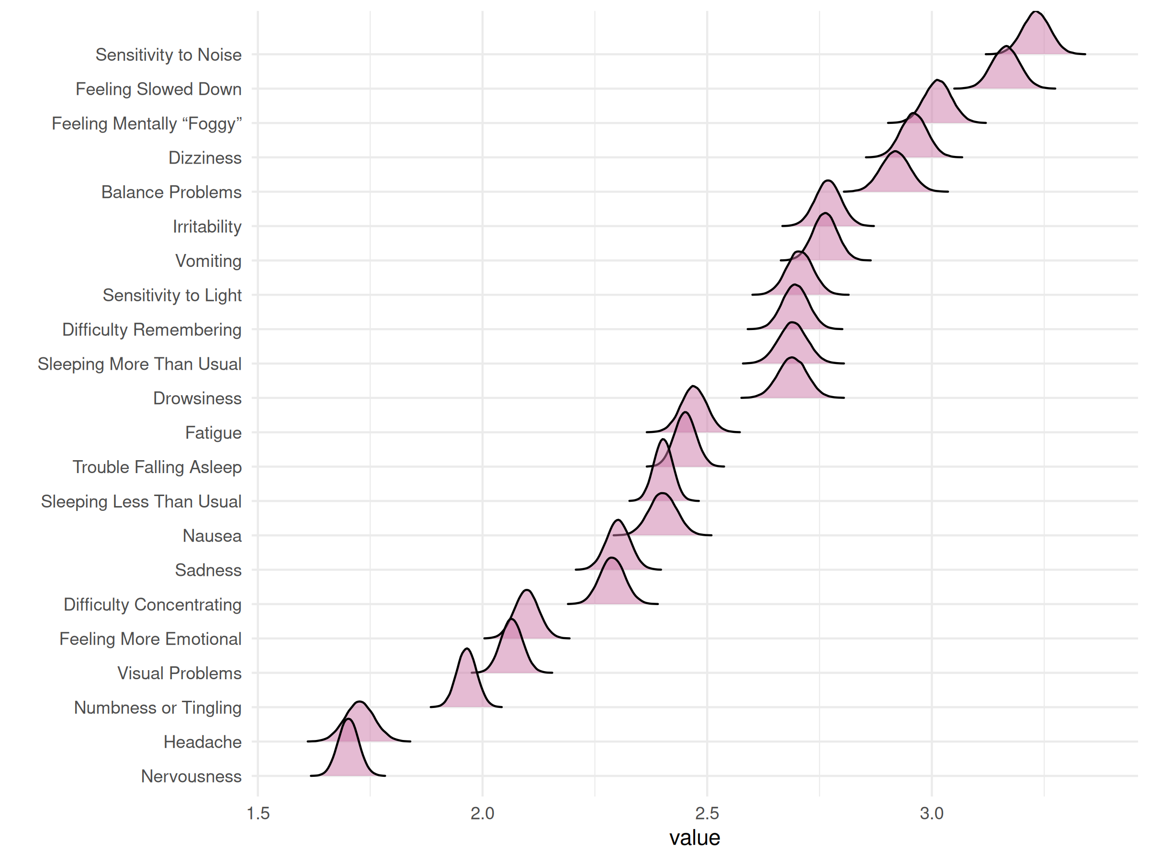

| Node | Post.mean | Post.sd | Cred.lb | Cred.ub |
| --- | --- | --- | --- | --- |
| Headache | 1.73 | 0.03 | 1.66 | 1.79 |
| Nausea | 2.40 | 0.03 | 2.34 | 2.46 |
| Vomiting | 2.76 | 0.03 | 2.71 | 2.82 |
| Balance Problems | 2.92 | 0.03 | 2.86 | 2.98 |
| Dizziness | 2.96 | 0.03 | 2.90 | 3.02 |
| Fatigue | 2.47 | 0.03 | 2.41 | 2.53 |
| Trouble Falling Asleep | 2.45 | 0.02 | 2.40 | 2.50 |
| Sleeping More Than Usual | 2.69 | 0.03 | 2.63 | 2.75 |
| Sleeping Less Than Usual | 2.40 | 0.02 | 2.36 | 2.44 |
| Drowsiness | 2.69 | 0.03 | 2.63 | 2.75 |
| Sensitivity to Light | 2.71 | 0.03 | 2.65 | 2.76 |
| Sensitivity to Noise | 3.23 | 0.03 | 3.17 | 3.29 |
| Irritability | 2.77 | 0.03 | 2.71 | 2.83 |
| Sadness | 2.30 | 0.03 | 2.25 | 2.35 |
| Nervousness | 1.70 | 0.02 | 1.66 | 1.75 |
| Feeling More Emotional | 2.10 | 0.03 | 2.05 | 2.15 |
| Numbness or Tingling | 1.97 | 0.02 | 1.92 | 2.01 |
| Feeling Slowed Down | 3.17 | 0.03 | 3.10 | 3.23 |
| Feeling Mentally “Foggy” | 3.01 | 0.03 | 2.95 | 3.07 |
| Difficulty Concentrating | 2.29 | 0.03 | 2.23 | 2.34 |
| Difficulty Remembering | 2.70 | 0.03 | 2.64 | 2.75 |
| Visual Problems | 2.06 | 0.02 | 2.02 | 2.11 |

### Concussion

### Edge weight

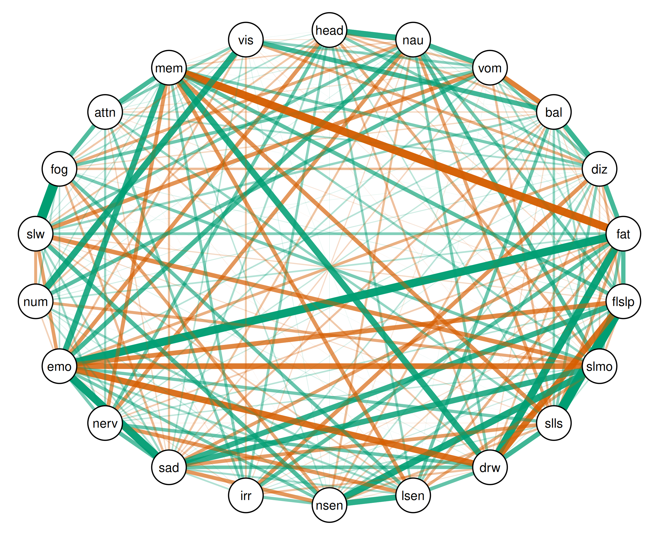

| Relation | Post.mean | Post.sd | Cred.lb | Cred.ub |
| --- | --- | --- | --- | --- |
| Trouble Falling Asleep--Sleeping Less Than Usual | 0.79 | 0.00 | 0.78 | 0.80 |
| Feeling Slowed Down--Feeling Mentally “Foggy” | 0.79 | 0.00 | 0.78 | 0.80 |
| Fatigue--Feeling More Emotional | 0.65 | 0.01 | 0.64 | 0.67 |
| Fatigue--Difficulty Remembering | -0.64 | 0.01 | -0.65 | -0.62 |
| Sadness--Feeling More Emotional | 0.62 | 0.01 | 0.60 | 0.63 |
| Fatigue--Drowsiness | 0.61 | 0.01 | 0.59 | 0.62 |
| Sleeping More Than Usual--Sensitivity to Noise | 0.54 | 0.01 | 0.53 | 0.56 |
| Numbness or Tingling--Visual Problems | 0.52 | 0.01 | 0.50 | 0.54 |
| Trouble Falling Asleep--Drowsiness | -0.51 | 0.01 | -0.53 | -0.50 |
| Drowsiness--Difficulty Remembering | 0.51 | 0.01 | 0.49 | 0.53 |
| Drowsiness--Feeling More Emotional | -0.51 | 0.01 | -0.53 | -0.49 |
| Headache--Nausea | 0.49 | 0.01 | 0.47 | 0.51 |
| Feeling More Emotional--Difficulty Remembering | 0.48 | 0.01 | 0.46 | 0.50 |
| Sensitivity to Light--Sensitivity to Noise | 0.47 | 0.01 | 0.45 | 0.48 |
| Sleeping More Than Usual--Feeling More Emotional | -0.46 | 0.01 | -0.48 | -0.44 |
| Sleeping More Than Usual--Sadness | 0.46 | 0.01 | 0.44 | 0.47 |
| Trouble Falling Asleep--Sadness | 0.44 | 0.01 | 0.42 | 0.46 |
| Vomiting--Balance Problems | -0.41 | 0.01 | -0.43 | -0.40 |
| Balance Problems--Dizziness | 0.41 | 0.01 | 0.39 | 0.43 |
| Sleeping Less Than Usual--Drowsiness | 0.40 | 0.01 | 0.38 | 0.42 |
| Nausea--Vomiting | 0.39 | 0.01 | 0.37 | 0.41 |
| Balance Problems--Visual Problems | 0.39 | 0.01 | 0.37 | 0.41 |
| Dizziness--Fatigue | 0.38 | 0.01 | 0.36 | 0.40 |
| Trouble Falling Asleep--Feeling More Emotional | -0.38 | 0.01 | -0.40 | -0.36 |
| Nausea--Feeling More Emotional | 0.38 | 0.01 | 0.36 | 0.40 |
| Difficulty Concentrating--Difficulty Remembering | 0.37 | 0.01 | 0.36 | 0.39 |
| Sleeping More Than Usual--Feeling Slowed Down | -0.36 | 0.01 | -0.38 | -0.34 |
| Sensitivity to Noise--Feeling Slowed Down | 0.35 | 0.01 | 0.33 | 0.37 |
| Fatigue--Trouble Falling Asleep | 0.35 | 0.01 | 0.33 | 0.37 |
| Feeling Mentally “Foggy”--Difficulty Concentrating | 0.35 | 0.01 | 0.33 | 0.37 |
| Nausea--Sleeping More Than Usual | 0.34 | 0.01 | 0.32 | 0.36 |
| Sleeping Less Than Usual--Difficulty Remembering | -0.34 | 0.01 | -0.36 | -0.32 |
| Vomiting--Feeling Slowed Down | -0.33 | 0.01 | -0.35 | -0.31 |
| Sadness--Nervousness | 0.33 | 0.01 | 0.31 | 0.35 |
| Dizziness--Irritability | -0.33 | 0.01 | -0.34 | -0.31 |
| Headache--Feeling More Emotional | -0.32 | 0.01 | -0.34 | -0.30 |
| Vomiting--Numbness or Tingling | 0.32 | 0.01 | 0.30 | 0.34 |
| Fatigue--Irritability | 0.32 | 0.01 | 0.30 | 0.34 |
| Trouble Falling Asleep--Difficulty Remembering | 0.32 | 0.01 | 0.30 | 0.34 |
| Sensitivity to Light--Difficulty Remembering | -0.32 | 0.01 | -0.34 | -0.30 |
| Sensitivity to Light--Nervousness | -0.32 | 0.01 | -0.34 | -0.30 |
| Sensitivity to Noise--Sadness | -0.32 | 0.01 | -0.34 | -0.29 |
| Nervousness--Difficulty Remembering | -0.31 | 0.01 | -0.33 | -0.29 |
| Nausea--Nervousness | -0.31 | 0.01 | -0.33 | -0.29 |
| Drowsiness--Sensitivity to Light | 0.30 | 0.01 | 0.28 | 0.32 |
| Sleeping Less Than Usual--Sadness | -0.29 | 0.01 | -0.31 | -0.27 |
| Sensitivity to Light--Feeling Mentally “Foggy” | 0.29 | 0.01 | 0.27 | 0.31 |
| Drowsiness--Sadness | 0.29 | 0.01 | 0.27 | 0.31 |
| Feeling More Emotional--Feeling Slowed Down | -0.28 | 0.01 | -0.30 | -0.26 |
| Drowsiness--Nervousness | 0.28 | 0.01 | 0.26 | 0.30 |
| Balance Problems--Sensitivity to Light | 0.28 | 0.01 | 0.26 | 0.30 |
| Headache--Nervousness | 0.28 | 0.01 | 0.25 | 0.30 |
| Fatigue--Sadness | -0.27 | 0.01 | -0.29 | -0.25 |
| Nausea--Trouble Falling Asleep | 0.27 | 0.01 | 0.25 | 0.29 |
| Vomiting--Feeling Mentally “Foggy” | 0.27 | 0.01 | 0.25 | 0.29 |
| Nausea--Sleeping Less Than Usual | -0.27 | 0.01 | -0.28 | -0.24 |
| Sensitivity to Noise--Feeling Mentally “Foggy” | -0.26 | 0.01 | -0.28 | -0.24 |
| Sleeping Less Than Usual--Feeling More Emotional | 0.26 | 0.01 | 0.24 | 0.28 |
| Vomiting--Dizziness | 0.26 | 0.01 | 0.23 | 0.28 |
| Fatigue--Sleeping More Than Usual | 0.26 | 0.01 | 0.23 | 0.28 |
| Sensitivity to Noise--Feeling More Emotional | 0.25 | 0.01 | 0.23 | 0.27 |
| Nervousness--Feeling More Emotional | 0.25 | 0.01 | 0.23 | 0.27 |
| Nausea--Feeling Slowed Down | 0.25 | 0.01 | 0.23 | 0.27 |
| Sleeping More Than Usual--Feeling Mentally “Foggy” | 0.25 | 0.01 | 0.23 | 0.27 |
| Dizziness--Difficulty Remembering | 0.24 | 0.01 | 0.22 | 0.27 |
| Sleeping More Than Usual--Numbness or Tingling | -0.24 | 0.01 | -0.27 | -0.22 |
| Sensitivity to Noise--Irritability | 0.24 | 0.01 | 0.22 | 0.26 |
| Numbness or Tingling--Feeling Slowed Down | -0.24 | 0.01 | -0.26 | -0.22 |
| Fatigue--Sleeping Less Than Usual | -0.24 | 0.01 | -0.26 | -0.22 |
| Nausea--Feeling Mentally “Foggy” | -0.24 | 0.01 | -0.26 | -0.22 |
| Sleeping More Than Usual--Sensitivity to Light | -0.24 | 0.01 | -0.26 | -0.22 |
| Headache--Sleeping More Than Usual | -0.23 | 0.01 | -0.26 | -0.21 |
| Headache--Dizziness | 0.23 | 0.01 | 0.21 | 0.25 |
| Nausea--Drowsiness | 0.23 | 0.01 | 0.21 | 0.25 |
| Dizziness--Feeling More Emotional | -0.23 | 0.01 | -0.25 | -0.21 |
| Irritability--Difficulty Remembering | 0.23 | 0.01 | 0.20 | 0.25 |
| Dizziness--Sleeping Less Than Usual | 0.23 | 0.01 | 0.20 | 0.25 |
| Fatigue--Feeling Slowed Down | 0.22 | 0.01 | 0.20 | 0.24 |
| Dizziness--Visual Problems | -0.22 | 0.01 | -0.24 | -0.20 |
| Difficulty Concentrating--Visual Problems | 0.22 | 0.01 | 0.20 | 0.24 |
| Irritability--Difficulty Concentrating | 0.22 | 0.01 | 0.20 | 0.24 |
| Fatigue--Sensitivity to Light | -0.21 | 0.01 | -0.23 | -0.19 |
| Vomiting--Visual Problems | 0.21 | 0.01 | 0.19 | 0.23 |
| Headache--Irritability | 0.21 | 0.01 | 0.18 | 0.23 |
| Sleeping Less Than Usual--Difficulty Concentrating | 0.20 | 0.01 | 0.17 | 0.22 |
| Dizziness--Trouble Falling Asleep | -0.20 | 0.01 | -0.22 | -0.17 |
| Balance Problems--Sleeping Less Than Usual | 0.20 | 0.01 | 0.17 | 0.22 |
| Dizziness--Sensitivity to Light | 0.20 | 0.01 | 0.17 | 0.22 |
| Dizziness--Feeling Mentally “Foggy” | -0.19 | 0.01 | -0.21 | -0.17 |
| Headache--Sensitivity to Light | 0.19 | 0.01 | 0.17 | 0.21 |
| Sadness--Feeling Mentally “Foggy” | -0.19 | 0.01 | -0.21 | -0.17 |
| Trouble Falling Asleep--Sensitivity to Noise | 0.19 | 0.01 | 0.17 | 0.21 |
| Sensitivity to Light--Numbness or Tingling | 0.19 | 0.01 | 0.17 | 0.21 |
| Sleeping More Than Usual--Difficulty Remembering | 0.19 | 0.01 | 0.16 | 0.21 |
| Balance Problems--Feeling Slowed Down | 0.18 | 0.01 | 0.16 | 0.21 |
| Vomiting--Sleeping Less Than Usual | -0.18 | 0.01 | -0.20 | -0.16 |
| Trouble Falling Asleep--Sleeping More Than Usual | -0.18 | 0.01 | -0.20 | -0.16 |
| Sleeping Less Than Usual--Sensitivity to Noise | -0.18 | 0.01 | -0.20 | -0.16 |
| Nausea--Sensitivity to Noise | -0.18 | 0.01 | -0.20 | -0.16 |
| Headache--Vomiting | -0.17 | 0.01 | -0.20 | -0.15 |
| Nervousness--Difficulty Concentrating | 0.17 | 0.01 | 0.15 | 0.20 |
| Headache--Balance Problems | -0.17 | 0.01 | -0.20 | -0.15 |
| Balance Problems--Sensitivity to Noise | -0.17 | 0.01 | -0.19 | -0.15 |
| Sensitivity to Light--Feeling More Emotional | 0.17 | 0.01 | 0.15 | 0.19 |
| Sadness--Difficulty Remembering | -0.17 | 0.01 | -0.19 | -0.15 |
| Balance Problems--Sadness | -0.17 | 0.01 | -0.19 | -0.14 |
| Sadness--Feeling Slowed Down | 0.17 | 0.01 | 0.14 | 0.19 |
| Headache--Drowsiness | -0.17 | 0.01 | -0.19 | -0.14 |
| Drowsiness--Irritability | -0.17 | 0.01 | -0.19 | -0.14 |
| Nervousness--Feeling Slowed Down | 0.17 | 0.01 | 0.14 | 0.19 |
| Feeling More Emotional--Visual Problems | -0.17 | 0.01 | -0.19 | -0.14 |
| Nausea--Sadness | -0.16 | 0.01 | -0.18 | -0.14 |
| Balance Problems--Sleeping More Than Usual | 0.16 | 0.01 | 0.14 | 0.18 |
| Dizziness--Drowsiness | -0.16 | 0.01 | -0.18 | -0.14 |
| Sensitivity to Light--Sadness | 0.16 | 0.01 | 0.14 | 0.18 |
| Vomiting--Trouble Falling Asleep | 0.16 | 0.01 | 0.13 | 0.18 |
| Headache--Numbness or Tingling | -0.15 | 0.01 | -0.18 | -0.13 |
| Headache--Feeling Slowed Down | -0.15 | 0.01 | -0.17 | -0.13 |
| Headache--Sadness | 0.15 | 0.01 | 0.13 | 0.17 |
| Feeling Mentally “Foggy”--Visual Problems | -0.15 | 0.01 | -0.17 | -0.13 |
| Sadness--Numbness or Tingling | 0.15 | 0.01 | 0.12 | 0.17 |
| Dizziness--Difficulty Concentrating | 0.15 | 0.01 | 0.12 | 0.17 |
| Drowsiness--Difficulty Concentrating | -0.15 | 0.01 | -0.17 | -0.13 |
| Irritability--Visual Problems | -0.15 | 0.01 | -0.17 | -0.12 |
| Numbness or Tingling--Feeling Mentally “Foggy” | 0.14 | 0.01 | 0.12 | 0.16 |
| Irritability--Sadness | 0.14 | 0.01 | 0.11 | 0.16 |
| Fatigue--Nervousness | -0.13 | 0.01 | -0.15 | -0.11 |
| Sensitivity to Light--Feeling Slowed Down | -0.13 | 0.01 | -0.15 | -0.11 |
| Fatigue--Numbness or Tingling | 0.13 | 0.01 | 0.11 | 0.15 |
| Vomiting--Nervousness | 0.13 | 0.01 | 0.11 | 0.15 |
| Vomiting--Difficulty Remembering | 0.13 | 0.01 | 0.11 | 0.15 |
| Headache--Feeling Mentally “Foggy” | 0.13 | 0.01 | 0.11 | 0.15 |
| Feeling More Emotional--Feeling Mentally “Foggy” | 0.13 | 0.01 | 0.10 | 0.15 |
| Balance Problems--Feeling More Emotional | 0.12 | 0.01 | 0.10 | 0.15 |
| Trouble Falling Asleep--Nervousness | 0.12 | 0.01 | 0.10 | 0.14 |
| Feeling More Emotional--Numbness or Tingling | -0.12 | 0.01 | -0.14 | -0.10 |
| Sadness--Visual Problems | 0.12 | 0.01 | 0.10 | 0.14 |
| Dizziness--Sleeping More Than Usual | -0.12 | 0.01 | -0.14 | -0.10 |
| Fatigue--Sensitivity to Noise | -0.12 | 0.01 | -0.14 | -0.10 |
| Balance Problems--Irritability | 0.12 | 0.01 | 0.10 | 0.14 |
| Balance Problems--Fatigue | -0.12 | 0.01 | -0.14 | -0.10 |
| Headache--Sleeping Less Than Usual | 0.12 | 0.01 | 0.09 | 0.14 |
| Dizziness--Sensitivity to Noise | 0.12 | 0.01 | 0.09 | 0.14 |
| Sleeping More Than Usual--Sleeping Less Than Usual | 0.11 | 0.01 | 0.09 | 0.14 |
| Sleeping Less Than Usual--Irritability | 0.11 | 0.01 | 0.09 | 0.14 |
| Nausea--Difficulty Remembering | -0.11 | 0.01 | -0.14 | -0.09 |
| Nausea--Balance Problems | 0.11 | 0.01 | 0.09 | 0.14 |
| Sensitivity to Noise--Difficulty Remembering | 0.11 | 0.01 | 0.09 | 0.13 |
| Sleeping More Than Usual--Nervousness | 0.11 | 0.01 | 0.09 | 0.13 |
| Vomiting--Sadness | -0.11 | 0.01 | -0.13 | -0.08 |
| Balance Problems--Nervousness | 0.10 | 0.01 | 0.08 | 0.12 |
| Balance Problems--Feeling Mentally “Foggy” | -0.10 | 0.01 | -0.12 | -0.08 |
| Balance Problems--Difficulty Concentrating | -0.10 | 0.01 | -0.12 | -0.08 |
| Numbness or Tingling--Difficulty Remembering | 0.10 | 0.01 | 0.08 | 0.12 |
| Sadness--Difficulty Concentrating | -0.10 | 0.01 | -0.12 | -0.08 |
| Trouble Falling Asleep--Feeling Slowed Down | -0.10 | 0.01 | -0.12 | -0.07 |
| Sensitivity to Noise--Numbness or Tingling | 0.09 | 0.01 | 0.07 | 0.11 |
| Nausea--Irritability | -0.09 | 0.01 | -0.11 | -0.07 |
| Balance Problems--Trouble Falling Asleep | -0.09 | 0.01 | -0.11 | -0.07 |
| Dizziness--Nervousness | 0.09 | 0.01 | 0.06 | 0.11 |
| Headache--Trouble Falling Asleep | -0.09 | 0.01 | -0.11 | -0.06 |
| Balance Problems--Drowsiness | -0.09 | 0.01 | -0.11 | -0.06 |
| Feeling Slowed Down--Difficulty Remembering | 0.09 | 0.01 | 0.06 | 0.11 |
| Feeling Mentally “Foggy”--Difficulty Remembering | 0.08 | 0.01 | 0.06 | 0.11 |
| Sleeping More Than Usual--Irritability | 0.08 | 0.01 | 0.06 | 0.11 |
| Irritability--Feeling More Emotional | -0.08 | 0.01 | -0.11 | -0.06 |
| Sleeping Less Than Usual--Feeling Slowed Down | -0.08 | 0.01 | -0.10 | -0.06 |
| Trouble Falling Asleep--Irritability | -0.08 | 0.01 | -0.10 | -0.06 |
| Vomiting--Sleeping More Than Usual | 0.08 | 0.01 | 0.06 | 0.10 |
| Headache--Difficulty Remembering | 0.08 | 0.01 | 0.06 | 0.10 |
| Dizziness--Numbness or Tingling | 0.08 | 0.01 | 0.06 | 0.10 |
| Vomiting--Difficulty Concentrating | -0.08 | 0.01 | -0.10 | -0.06 |
| Vomiting--Fatigue | -0.07 | 0.01 | -0.10 | -0.05 |
| Feeling Slowed Down--Visual Problems | 0.07 | 0.01 | 0.05 | 0.10 |
| Drowsiness--Sensitivity to Noise | -0.07 | 0.01 | -0.10 | -0.05 |
| Sleeping More Than Usual--Drowsiness | 0.07 | 0.01 | 0.05 | 0.10 |
| Nausea--Visual Problems | -0.07 | 0.01 | -0.09 | -0.05 |
| Nausea--Difficulty Concentrating | 0.06 | 0.01 | 0.04 | 0.09 |
| Trouble Falling Asleep--Difficulty Concentrating | -0.06 | 0.01 | -0.09 | -0.04 |
| Dizziness--Sadness | 0.06 | 0.01 | 0.04 | 0.09 |
| Drowsiness--Feeling Slowed Down | 0.06 | 0.01 | 0.04 | 0.09 |
| Trouble Falling Asleep--Feeling Mentally “Foggy” | 0.06 | 0.01 | 0.04 | 0.08 |
| Nausea--Numbness or Tingling | 0.06 | 0.01 | 0.04 | 0.08 |
| Nausea--Dizziness | 0.06 | 0.01 | 0.04 | 0.08 |
| Vomiting--Sensitivity to Noise | -0.06 | 0.01 | -0.08 | -0.04 |
| Balance Problems--Numbness or Tingling | 0.06 | 0.01 | 0.03 | 0.08 |
| Sensitivity to Noise--Visual Problems | 0.06 | 0.01 | 0.03 | 0.08 |
| Irritability--Feeling Mentally “Foggy” | -0.06 | 0.01 | -0.08 | -0.03 |
| Sleeping More Than Usual--Visual Problems | -0.06 | 0.01 | -0.08 | -0.03 |
| Irritability--Numbness or Tingling | 0.05 | 0.01 | 0.03 | 0.08 |
| Sleeping Less Than Usual--Nervousness | -0.05 | 0.01 | -0.07 | -0.03 |
| Sensitivity to Light--Irritability | 0.05 | 0.01 | 0.02 | 0.07 |
| Headache--Sensitivity to Noise | 0.04 | 0.01 | 0.02 | 0.07 |
| Difficulty Remembering--Visual Problems | -0.04 | 0.01 | -0.07 | -0.02 |
| Sensitivity to Light--Difficulty Concentrating | -0.04 | 0.01 | -0.07 | -0.02 |
| Irritability--Nervousness | -0.04 | 0.01 | -0.07 | -0.02 |
| Sleeping Less Than Usual--Visual Problems | -0.04 | 0.01 | -0.07 | -0.02 |
| Headache--Fatigue | 0.04 | 0.01 | 0.02 | 0.06 |
| Nausea--Fatigue | -0.04 | 0.01 | -0.06 | -0.02 |
| Dizziness--Feeling Slowed Down | 0.04 | 0.01 | 0.02 | 0.06 |
| Drowsiness--Feeling Mentally “Foggy” | -0.04 | 0.01 | -0.06 | -0.01 |
| Sensitivity to Light--Visual Problems | 0.04 | 0.01 | 0.01 | 0.06 |
| Vomiting--Sensitivity to Light | 0.04 | 0.01 | 0.01 | 0.06 |
| Headache--Visual Problems | 0.03 | 0.01 | 0.01 | 0.06 |
| Drowsiness--Numbness or Tingling | 0.03 | 0.01 | 0.01 | 0.05 |
| Fatigue--Difficulty Concentrating | 0.03 | 0.01 | 0.01 | 0.05 |
| Sleeping Less Than Usual--Feeling Mentally “Foggy” | 0.03 | 0.01 | 0.01 | 0.05 |
| Sleeping More Than Usual--Difficulty Concentrating | -0.03 | 0.01 | -0.05 | -0.01 |
| Sensitivity to Noise--Difficulty Concentrating | -0.03 | 0.01 | -0.05 | -0.01 |
| Balance Problems--Difficulty Remembering | 0.03 | 0.01 | 0.01 | 0.05 |
| Trouble Falling Asleep--Visual Problems | 0.03 | 0.01 | 0.01 | 0.05 |
| Numbness or Tingling--Difficulty Concentrating | 0.03 | 0.01 | 0.00 | 0.05 |
| Nervousness--Numbness or Tingling | -0.03 | 0.01 | -0.05 | -0.00 |
| Sleeping Less Than Usual--Numbness or Tingling | 0.02 | 0.01 | 0.00 | 0.05 |
| Headache--Difficulty Concentrating | -0.02 | 0.01 | -0.04 | 0.00 |
| Drowsiness--Visual Problems | 0.02 | 0.01 | -0.00 | 0.04 |
| Feeling More Emotional--Difficulty Concentrating | 0.02 | 0.01 | -0.00 | 0.04 |
| Trouble Falling Asleep--Sensitivity to Light | 0.02 | 0.01 | -0.00 | 0.04 |
| Vomiting--Feeling More Emotional | -0.02 | 0.01 | -0.04 | 0.00 |
| Trouble Falling Asleep--Numbness or Tingling | -0.02 | 0.01 | -0.04 | 0.00 |
| Vomiting--Irritability | 0.02 | 0.01 | -0.01 | 0.04 |
| Vomiting--Drowsiness | 0.01 | 0.01 | -0.01 | 0.04 |
| Sensitivity to Noise--Nervousness | 0.01 | 0.01 | -0.01 | 0.04 |
| Feeling Slowed Down--Difficulty Concentrating | -0.01 | 0.01 | -0.04 | 0.01 |
| Nervousness--Visual Problems | 0.01 | 0.01 | -0.01 | 0.03 |
| Fatigue--Feeling Mentally “Foggy” | -0.01 | 0.01 | -0.03 | 0.01 |
| Nervousness--Feeling Mentally “Foggy” | 0.01 | 0.01 | -0.01 | 0.03 |
| Nausea--Sensitivity to Light | 0.01 | 0.01 | -0.02 | 0.03 |
| Irritability--Feeling Slowed Down | -0.01 | 0.01 | -0.03 | 0.02 |
| Sleeping Less Than Usual--Sensitivity to Light | -0.00 | 0.01 | -0.03 | 0.02 |
| Fatigue--Visual Problems | 0.00 | 0.01 | -0.02 | 0.03 |

### Bridge strength

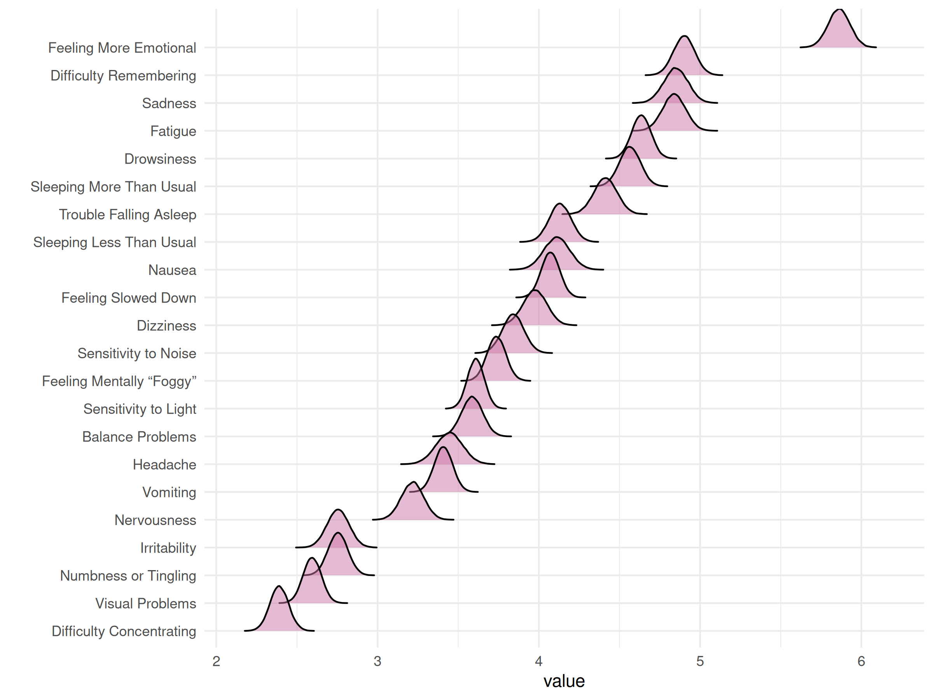

| Node | Post.mean | Post.sd | Cred.lb | Cred.ub |
| --- | --- | --- | --- | --- |
| Headache | 3.44 | 0.08 | 3.28 | 3.61 |
| Nausea | 4.11 | 0.08 | 3.95 | 4.27 |
| Vomiting | 3.41 | 0.06 | 3.29 | 3.52 |
| Balance Problems | 3.59 | 0.07 | 3.46 | 3.71 |
| Dizziness | 3.98 | 0.07 | 3.83 | 4.12 |
| Fatigue | 4.84 | 0.07 | 4.70 | 4.98 |
| Trouble Falling Asleep | 4.41 | 0.07 | 4.27 | 4.55 |
| Sleeping More Than Usual | 4.57 | 0.07 | 4.43 | 4.69 |
| Sleeping Less Than Usual | 4.13 | 0.07 | 4.00 | 4.26 |
| Drowsiness | 4.64 | 0.06 | 4.52 | 4.75 |
| Sensitivity to Light | 3.61 | 0.05 | 3.51 | 3.71 |
| Sensitivity to Noise | 3.84 | 0.07 | 3.71 | 3.97 |
| Irritability | 2.75 | 0.07 | 2.62 | 2.89 |
| Sadness | 4.85 | 0.07 | 4.70 | 5.00 |
| Nervousness | 3.22 | 0.07 | 3.08 | 3.35 |
| Feeling More Emotional | 5.86 | 0.07 | 5.73 | 5.99 |
| Numbness or Tingling | 2.75 | 0.06 | 2.63 | 2.88 |
| Feeling Slowed Down | 4.07 | 0.06 | 3.96 | 4.18 |
| Feeling Mentally “Foggy” | 3.74 | 0.06 | 3.62 | 3.85 |
| Difficulty Concentrating | 2.39 | 0.06 | 2.28 | 2.50 |
| Difficulty Remembering | 4.90 | 0.07 | 4.77 | 5.03 |
| Visual Problems | 2.60 | 0.06 | 2.48 | 2.71 |

### Control

### Edge weight

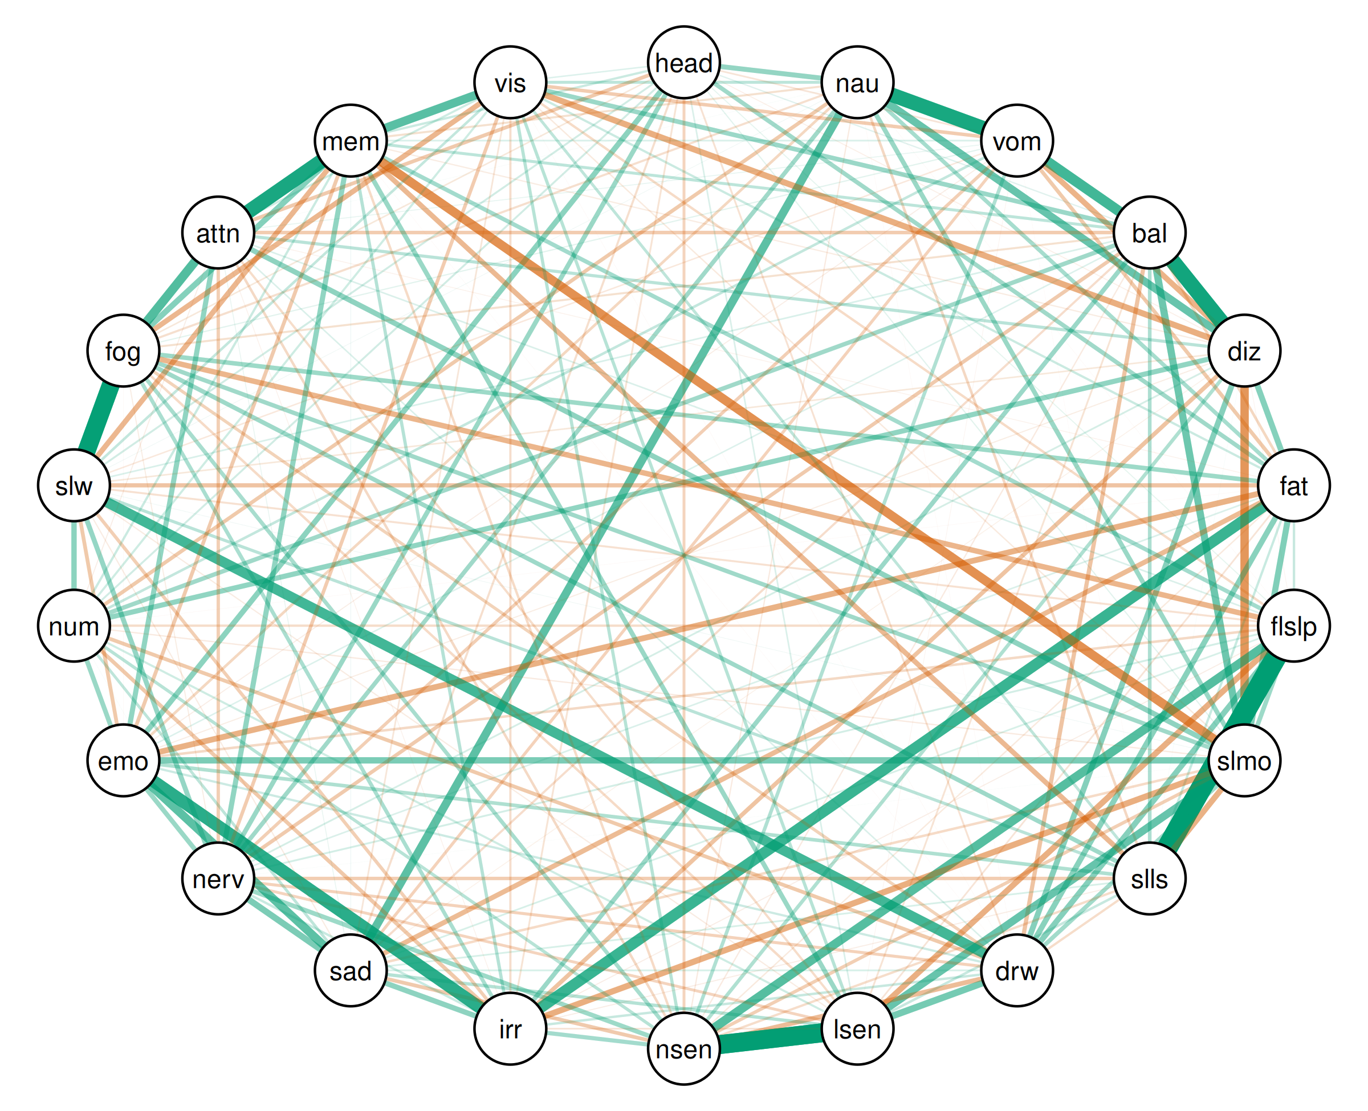

| Relation | Post.mean | Post.sd | Cred.lb | Cred.ub |
| --- | --- | --- | --- | --- |
| Trouble Falling Asleep--Sleeping Less Than Usual | 0.82 | 0.00 | 0.81 | 0.82 |
| Sensitivity to Light--Sensitivity to Noise | 0.75 | 0.00 | 0.74 | 0.75 |
| Feeling Slowed Down--Feeling Mentally “Foggy” | 0.70 | 0.00 | 0.70 | 0.71 |
| Balance Problems--Dizziness | 0.60 | 0.00 | 0.59 | 0.61 |
| Nausea--Vomiting | 0.57 | 0.00 | 0.56 | 0.58 |
| Difficulty Concentrating--Difficulty Remembering | 0.56 | 0.01 | 0.55 | 0.57 |
| Irritability--Feeling More Emotional | 0.48 | 0.01 | 0.47 | 0.49 |
| Fatigue--Irritability | 0.43 | 0.01 | 0.42 | 0.44 |
| Vomiting--Balance Problems | 0.40 | 0.01 | 0.39 | 0.41 |
| Drowsiness--Feeling Slowed Down | 0.40 | 0.01 | 0.39 | 0.41 |
| Sleeping More Than Usual--Difficulty Remembering | -0.35 | 0.01 | -0.36 | -0.34 |
| Feeling Mentally “Foggy”--Difficulty Concentrating | 0.35 | 0.01 | 0.34 | 0.36 |
| Trouble Falling Asleep--Sensitivity to Noise | 0.34 | 0.01 | 0.33 | 0.36 |
| Difficulty Remembering--Visual Problems | 0.34 | 0.01 | 0.32 | 0.35 |
| Dizziness--Sleeping More Than Usual | -0.33 | 0.01 | -0.34 | -0.32 |
| Sadness--Feeling More Emotional | 0.33 | 0.01 | 0.32 | 0.34 |
| Nausea--Sadness | 0.32 | 0.01 | 0.31 | 0.33 |
| Nausea--Dizziness | 0.30 | 0.01 | 0.29 | 0.31 |
| Sleeping More Than Usual--Sensitivity to Light | 0.30 | 0.01 | 0.29 | 0.31 |
| Balance Problems--Sleeping More Than Usual | 0.28 | 0.01 | 0.27 | 0.29 |
| Drowsiness--Sensitivity to Light | 0.26 | 0.01 | 0.25 | 0.28 |
| Sleeping More Than Usual--Feeling More Emotional | 0.25 | 0.01 | 0.24 | 0.26 |
| Sadness--Nervousness | 0.25 | 0.01 | 0.23 | 0.26 |
| Sleeping More Than Usual--Irritability | -0.24 | 0.01 | -0.25 | -0.23 |
| Fatigue--Sleeping More Than Usual | 0.24 | 0.01 | 0.23 | 0.25 |
| Dizziness--Visual Problems | -0.24 | 0.01 | -0.25 | -0.23 |
| Trouble Falling Asleep--Sensitivity to Light | -0.23 | 0.01 | -0.24 | -0.22 |
| Dizziness--Fatigue | 0.23 | 0.01 | 0.22 | 0.24 |
| Feeling Mentally “Foggy”--Difficulty Remembering | 0.23 | 0.01 | 0.22 | 0.24 |
| Sleeping More Than Usual--Sleeping Less Than Usual | -0.23 | 0.01 | -0.24 | -0.22 |
| Fatigue--Feeling More Emotional | -0.23 | 0.01 | -0.24 | -0.21 |
| Dizziness--Drowsiness | 0.22 | 0.01 | 0.21 | 0.24 |
| Trouble Falling Asleep--Drowsiness | 0.22 | 0.01 | 0.21 | 0.23 |
| Vomiting--Dizziness | -0.22 | 0.01 | -0.23 | -0.21 |
| Fatigue--Drowsiness | 0.22 | 0.01 | 0.21 | 0.23 |
| Headache--Feeling More Emotional | 0.21 | 0.01 | 0.20 | 0.23 |
| Trouble Falling Asleep--Feeling Mentally “Foggy” | -0.21 | 0.01 | -0.22 | -0.20 |
| Numbness or Tingling--Feeling Slowed Down | 0.21 | 0.01 | 0.20 | 0.22 |
| Irritability--Sadness | 0.21 | 0.01 | 0.20 | 0.22 |
| Sleeping More Than Usual--Difficulty Concentrating | 0.21 | 0.01 | 0.19 | 0.22 |
| Feeling Slowed Down--Difficulty Remembering | -0.21 | 0.01 | -0.22 | -0.19 |
| Feeling Mentally “Foggy”--Visual Problems | -0.20 | 0.01 | -0.22 | -0.19 |
| Nervousness--Difficulty Remembering | 0.20 | 0.01 | 0.19 | 0.21 |
| Dizziness--Numbness or Tingling | 0.20 | 0.01 | 0.19 | 0.21 |
| Feeling More Emotional--Difficulty Concentrating | 0.20 | 0.01 | 0.19 | 0.21 |
| Sleeping Less Than Usual--Difficulty Remembering | -0.20 | 0.01 | -0.21 | -0.19 |
| Headache--Nausea | 0.19 | 0.01 | 0.18 | 0.21 |
| Fatigue--Sadness | -0.19 | 0.01 | -0.21 | -0.18 |
| Nervousness--Feeling Slowed Down | 0.19 | 0.01 | 0.18 | 0.20 |
| Drowsiness--Sensitivity to Noise | -0.19 | 0.01 | -0.20 | -0.17 |
| Headache--Nervousness | 0.18 | 0.01 | 0.17 | 0.20 |
| Nervousness--Feeling More Emotional | 0.18 | 0.01 | 0.17 | 0.20 |
| Feeling More Emotional--Numbness or Tingling | 0.18 | 0.01 | 0.17 | 0.20 |
| Sensitivity to Light--Difficulty Remembering | 0.18 | 0.01 | 0.17 | 0.20 |
| Nausea--Sleeping More Than Usual | 0.18 | 0.01 | 0.17 | 0.19 |
| Balance Problems--Visual Problems | 0.18 | 0.01 | 0.17 | 0.19 |
| Balance Problems--Irritability | 0.18 | 0.01 | 0.17 | 0.19 |
| Sensitivity to Noise--Nervousness | 0.18 | 0.01 | 0.17 | 0.19 |
| Trouble Falling Asleep--Sleeping More Than Usual | 0.18 | 0.01 | 0.16 | 0.19 |
| Fatigue--Feeling Mentally “Foggy” | 0.18 | 0.01 | 0.16 | 0.19 |
| Sleeping Less Than Usual--Feeling Mentally “Foggy” | 0.17 | 0.01 | 0.16 | 0.19 |
| Balance Problems--Numbness or Tingling | 0.17 | 0.01 | 0.16 | 0.18 |
| Nausea--Nervousness | 0.17 | 0.01 | 0.16 | 0.18 |
| Sleeping More Than Usual--Feeling Mentally “Foggy” | 0.17 | 0.01 | 0.16 | 0.18 |
| Headache--Fatigue | 0.17 | 0.01 | 0.16 | 0.18 |
| Sleeping More Than Usual--Drowsiness | 0.17 | 0.01 | 0.15 | 0.18 |
| Dizziness--Irritability | -0.17 | 0.01 | -0.18 | -0.15 |
| Balance Problems--Drowsiness | -0.17 | 0.01 | -0.18 | -0.15 |
| Sensitivity to Noise--Irritability | 0.16 | 0.01 | 0.15 | 0.18 |
| Fatigue--Feeling Slowed Down | -0.16 | 0.01 | -0.18 | -0.15 |
| Trouble Falling Asleep--Difficulty Remembering | 0.16 | 0.01 | 0.15 | 0.18 |
| Nausea--Fatigue | 0.16 | 0.01 | 0.14 | 0.17 |
| Sensitivity to Noise--Feeling Mentally “Foggy” | 0.15 | 0.01 | 0.14 | 0.17 |
| Irritability--Numbness or Tingling | -0.15 | 0.01 | -0.16 | -0.14 |
| Feeling More Emotional--Feeling Slowed Down | -0.15 | 0.01 | -0.16 | -0.14 |
| Irritability--Feeling Mentally “Foggy” | 0.15 | 0.01 | 0.14 | 0.16 |
| Vomiting--Fatigue | -0.15 | 0.01 | -0.16 | -0.14 |
| Drowsiness--Numbness or Tingling | -0.15 | 0.01 | -0.16 | -0.14 |
| Sensitivity to Noise--Sadness | -0.15 | 0.01 | -0.16 | -0.13 |
| Nausea--Numbness or Tingling | -0.15 | 0.01 | -0.16 | -0.13 |
| Feeling More Emotional--Difficulty Remembering | -0.15 | 0.01 | -0.16 | -0.13 |
| Balance Problems--Sleeping Less Than Usual | 0.14 | 0.01 | 0.13 | 0.16 |
| Balance Problems--Nervousness | -0.14 | 0.01 | -0.16 | -0.13 |
| Headache--Difficulty Concentrating | -0.14 | 0.01 | -0.16 | -0.13 |
| Sleeping Less Than Usual--Feeling More Emotional | 0.14 | 0.01 | 0.13 | 0.15 |
| Dizziness--Sensitivity to Noise | 0.14 | 0.01 | 0.13 | 0.15 |
| Vomiting--Sensitivity to Noise | 0.14 | 0.01 | 0.13 | 0.15 |
| Balance Problems--Difficulty Concentrating | -0.14 | 0.01 | -0.15 | -0.13 |
| Nervousness--Visual Problems | -0.14 | 0.01 | -0.15 | -0.12 |
| Vomiting--Visual Problems | -0.14 | 0.01 | -0.15 | -0.12 |
| Sleeping Less Than Usual--Nervousness | -0.14 | 0.01 | -0.15 | -0.12 |
| Sleeping More Than Usual--Sensitivity to Noise | -0.13 | 0.01 | -0.14 | -0.12 |
| Irritability--Feeling Slowed Down | -0.13 | 0.01 | -0.14 | -0.12 |
| Nervousness--Difficulty Concentrating | -0.13 | 0.01 | -0.14 | -0.12 |
| Sensitivity to Light--Sadness | 0.13 | 0.01 | 0.12 | 0.14 |
| Vomiting--Nervousness | -0.13 | 0.01 | -0.14 | -0.12 |
| Irritability--Difficulty Remembering | 0.13 | 0.01 | 0.11 | 0.14 |
| Sensitivity to Light--Visual Problems | 0.13 | 0.01 | 0.11 | 0.14 |
| Sensitivity to Noise--Numbness or Tingling | 0.12 | 0.01 | 0.11 | 0.14 |
| Sensitivity to Noise--Visual Problems | 0.12 | 0.01 | 0.11 | 0.14 |
| Dizziness--Difficulty Concentrating | 0.12 | 0.01 | 0.11 | 0.14 |
| Drowsiness--Feeling Mentally “Foggy” | -0.12 | 0.01 | -0.14 | -0.11 |
| Sleeping Less Than Usual--Feeling Slowed Down | 0.12 | 0.01 | 0.11 | 0.13 |
| Vomiting--Sadness | -0.12 | 0.01 | -0.13 | -0.10 |
| Drowsiness--Nervousness | -0.12 | 0.01 | -0.13 | -0.10 |
| Nausea--Visual Problems | 0.12 | 0.01 | 0.10 | 0.13 |
| Balance Problems--Difficulty Remembering | 0.11 | 0.01 | 0.10 | 0.13 |
| Headache--Sensitivity to Noise | -0.11 | 0.01 | -0.12 | -0.10 |
| Sleeping Less Than Usual--Visual Problems | 0.11 | 0.01 | 0.10 | 0.12 |
| Sensitivity to Light--Nervousness | -0.11 | 0.01 | -0.12 | -0.10 |
| Sadness--Numbness or Tingling | 0.11 | 0.01 | 0.10 | 0.12 |
| Balance Problems--Fatigue | -0.11 | 0.01 | -0.12 | -0.09 |
| Nausea--Feeling More Emotional | -0.11 | 0.01 | -0.12 | -0.09 |
| Nausea--Sleeping Less Than Usual | -0.10 | 0.01 | -0.12 | -0.09 |
| Vomiting--Numbness or Tingling | 0.10 | 0.01 | 0.09 | 0.11 |
| Feeling Slowed Down--Visual Problems | 0.10 | 0.01 | 0.09 | 0.11 |
| Sensitivity to Noise--Difficulty Concentrating | -0.10 | 0.01 | -0.11 | -0.09 |
| Trouble Falling Asleep--Feeling More Emotional | -0.10 | 0.01 | -0.11 | -0.09 |
| Sleeping Less Than Usual--Sensitivity to Light | 0.10 | 0.01 | 0.09 | 0.11 |
| Sleeping More Than Usual--Sadness | -0.10 | 0.01 | -0.11 | -0.09 |
| Sensitivity to Light--Feeling Mentally “Foggy” | -0.10 | 0.01 | -0.11 | -0.09 |
| Sensitivity to Noise--Difficulty Remembering | -0.10 | 0.01 | -0.11 | -0.08 |
| Fatigue--Trouble Falling Asleep | 0.10 | 0.01 | 0.08 | 0.11 |
| Drowsiness--Irritability | 0.10 | 0.01 | 0.08 | 0.11 |
| Trouble Falling Asleep--Visual Problems | -0.10 | 0.01 | -0.11 | -0.08 |
| Irritability--Nervousness | 0.09 | 0.01 | 0.08 | 0.11 |
| Fatigue--Sleeping Less Than Usual | 0.09 | 0.01 | 0.08 | 0.10 |
| Sleeping Less Than Usual--Sensitivity to Noise | -0.09 | 0.01 | -0.10 | -0.08 |
| Trouble Falling Asleep--Numbness or Tingling | -0.09 | 0.01 | -0.10 | -0.08 |
| Sleeping Less Than Usual--Drowsiness | -0.09 | 0.01 | -0.10 | -0.08 |
| Sensitivity to Light--Difficulty Concentrating | -0.09 | 0.01 | -0.10 | -0.08 |
| Numbness or Tingling--Difficulty Remembering | 0.09 | 0.01 | 0.08 | 0.10 |
| Headache--Difficulty Remembering | 0.09 | 0.01 | 0.08 | 0.10 |
| Fatigue--Visual Problems | 0.09 | 0.01 | 0.08 | 0.10 |
| Drowsiness--Feeling More Emotional | 0.09 | 0.01 | 0.07 | 0.10 |
| Balance Problems--Sadness | -0.09 | 0.01 | -0.10 | -0.07 |
| Irritability--Visual Problems | -0.09 | 0.01 | -0.10 | -0.07 |
| Numbness or Tingling--Visual Problems | 0.09 | 0.01 | 0.07 | 0.10 |
| Headache--Sadness | -0.08 | 0.01 | -0.10 | -0.07 |
| Sensitivity to Light--Numbness or Tingling | 0.08 | 0.01 | 0.07 | 0.10 |
| Nausea--Feeling Mentally “Foggy” | -0.08 | 0.01 | -0.10 | -0.07 |
| Difficulty Concentrating--Visual Problems | 0.08 | 0.01 | 0.07 | 0.10 |
| Nausea--Difficulty Remembering | -0.08 | 0.01 | -0.09 | -0.07 |
| Balance Problems--Feeling Mentally “Foggy” | -0.08 | 0.01 | -0.09 | -0.07 |
| Headache--Feeling Slowed Down | 0.08 | 0.01 | 0.06 | 0.09 |
| Headache--Numbness or Tingling | 0.08 | 0.01 | 0.06 | 0.09 |
| Trouble Falling Asleep--Feeling Slowed Down | -0.08 | 0.01 | -0.09 | -0.06 |
| Headache--Drowsiness | -0.07 | 0.01 | -0.09 | -0.06 |
| Trouble Falling Asleep--Nervousness | 0.07 | 0.01 | 0.06 | 0.09 |
| Headache--Irritability | -0.07 | 0.01 | -0.08 | -0.06 |
| Balance Problems--Sensitivity to Light | -0.07 | 0.01 | -0.08 | -0.06 |
| Drowsiness--Sadness | 0.07 | 0.01 | 0.06 | 0.08 |
| Dizziness--Nervousness | 0.07 | 0.01 | 0.06 | 0.08 |
| Sensitivity to Light--Irritability | -0.07 | 0.01 | -0.08 | -0.05 |
| Headache--Vomiting | -0.07 | 0.01 | -0.08 | -0.05 |
| Fatigue--Sensitivity to Light | -0.07 | 0.01 | -0.08 | -0.05 |
| Trouble Falling Asleep--Sadness | 0.07 | 0.01 | 0.05 | 0.08 |
| Sleeping Less Than Usual--Sadness | 0.07 | 0.01 | 0.05 | 0.08 |
| Vomiting--Difficulty Remembering | 0.07 | 0.01 | 0.05 | 0.08 |
| Sadness--Visual Problems | -0.07 | 0.01 | -0.08 | -0.05 |
| Balance Problems--Feeling Slowed Down | 0.06 | 0.01 | 0.05 | 0.08 |
| Headache--Sensitivity to Light | 0.06 | 0.01 | 0.05 | 0.08 |
| Fatigue--Nervousness | 0.06 | 0.01 | 0.05 | 0.07 |
| Trouble Falling Asleep--Difficulty Concentrating | 0.06 | 0.01 | 0.05 | 0.07 |
| Dizziness--Feeling Slowed Down | -0.06 | 0.01 | -0.07 | -0.05 |
| Drowsiness--Difficulty Concentrating | 0.06 | 0.01 | 0.05 | 0.07 |
| Headache--Feeling Mentally “Foggy” | -0.06 | 0.01 | -0.07 | -0.05 |
| Balance Problems--Feeling More Emotional | 0.06 | 0.01 | 0.04 | 0.07 |
| Headache--Visual Problems | 0.06 | 0.01 | 0.04 | 0.07 |
| Vomiting--Feeling Slowed Down | -0.06 | 0.01 | -0.07 | -0.04 |
| Fatigue--Sensitivity to Noise | -0.06 | 0.01 | -0.07 | -0.04 |
| Sleeping More Than Usual--Visual Problems | -0.06 | 0.01 | -0.07 | -0.04 |
| Headache--Balance Problems | 0.05 | 0.01 | 0.04 | 0.07 |
| Balance Problems--Sensitivity to Noise | -0.05 | 0.01 | -0.07 | -0.04 |
| Sleeping More Than Usual--Numbness or Tingling | -0.05 | 0.01 | -0.06 | -0.04 |
| Nausea--Sensitivity to Noise | -0.05 | 0.01 | -0.06 | -0.04 |
| Sensitivity to Light--Feeling Slowed Down | -0.05 | 0.01 | -0.06 | -0.04 |
| Dizziness--Difficulty Remembering | -0.05 | 0.01 | -0.06 | -0.04 |
| Headache--Sleeping More Than Usual | 0.05 | 0.01 | 0.04 | 0.06 |
| Sadness--Feeling Slowed Down | -0.05 | 0.01 | -0.06 | -0.04 |
| Vomiting--Feeling Mentally “Foggy” | 0.05 | 0.01 | 0.03 | 0.06 |
| Dizziness--Feeling More Emotional | -0.04 | 0.01 | -0.06 | -0.03 |
| Nervousness--Feeling Mentally “Foggy” | -0.04 | 0.01 | -0.06 | -0.03 |
| Sleeping Less Than Usual--Irritability | -0.04 | 0.01 | -0.06 | -0.03 |
| Headache--Trouble Falling Asleep | 0.04 | 0.01 | 0.03 | 0.06 |
| Trouble Falling Asleep--Irritability | -0.04 | 0.01 | -0.05 | -0.03 |
| Vomiting--Feeling More Emotional | -0.04 | 0.01 | -0.05 | -0.03 |
| Numbness or Tingling--Difficulty Concentrating | -0.04 | 0.01 | -0.05 | -0.03 |
| Headache--Dizziness | -0.04 | 0.01 | -0.05 | -0.03 |
| Vomiting--Difficulty Concentrating | 0.04 | 0.01 | 0.03 | 0.05 |
| Dizziness--Sadness | -0.04 | 0.01 | -0.05 | -0.02 |
| Sadness--Difficulty Concentrating | 0.04 | 0.01 | 0.02 | 0.05 |
| Fatigue--Difficulty Concentrating | -0.03 | 0.01 | -0.04 | -0.02 |
| Irritability--Difficulty Concentrating | -0.03 | 0.01 | -0.04 | -0.02 |
| Sadness--Difficulty Remembering | 0.03 | 0.01 | 0.02 | 0.04 |
| Dizziness--Trouble Falling Asleep | -0.03 | 0.01 | -0.04 | -0.01 |
| Nausea--Feeling Slowed Down | 0.03 | 0.01 | 0.01 | 0.04 |
| Vomiting--Sensitivity to Light | -0.02 | 0.01 | -0.04 | -0.01 |
| Sleeping More Than Usual--Feeling Slowed Down | 0.02 | 0.01 | 0.01 | 0.04 |
| Dizziness--Sleeping Less Than Usual | 0.02 | 0.01 | 0.00 | 0.03 |
| Fatigue--Numbness or Tingling | -0.02 | 0.01 | -0.03 | -0.01 |
| Feeling More Emotional--Feeling Mentally “Foggy” | -0.02 | 0.01 | -0.03 | -0.01 |
| Drowsiness--Visual Problems | -0.02 | 0.01 | -0.03 | -0.00 |
| Nausea--Trouble Falling Asleep | -0.02 | 0.01 | -0.03 | -0.00 |
| Nausea--Drowsiness | -0.02 | 0.01 | -0.03 | -0.00 |
| Nervousness--Numbness or Tingling | 0.02 | 0.01 | 0.00 | 0.03 |
| Nausea--Difficulty Concentrating | 0.02 | 0.01 | 0.00 | 0.03 |
| Vomiting--Sleeping Less Than Usual | -0.01 | 0.01 | -0.03 | -0.00 |
| Drowsiness--Difficulty Remembering | -0.01 | 0.01 | -0.03 | -0.00 |
| Sleeping More Than Usual--Nervousness | 0.01 | 0.01 | 0.00 | 0.03 |
| Fatigue--Difficulty Remembering | -0.01 | 0.01 | -0.03 | 0.00 |
| Vomiting--Drowsiness | -0.01 | 0.01 | -0.02 | 0.00 |
| Balance Problems--Trouble Falling Asleep | -0.01 | 0.01 | -0.02 | 0.00 |
| Dizziness--Sensitivity to Light | 0.01 | 0.01 | -0.00 | 0.02 |
| Dizziness--Feeling Mentally “Foggy” | 0.01 | 0.01 | -0.00 | 0.02 |
| Nausea--Balance Problems | -0.01 | 0.01 | -0.02 | 0.00 |
| Sensitivity to Light--Feeling More Emotional | -0.01 | 0.01 | -0.02 | 0.00 |
| Sleeping Less Than Usual--Difficulty Concentrating | -0.01 | 0.01 | -0.02 | 0.00 |
| Vomiting--Trouble Falling Asleep | 0.01 | 0.01 | -0.01 | 0.02 |
| Sensitivity to Noise--Feeling Slowed Down | 0.01 | 0.01 | -0.01 | 0.02 |
| Vomiting--Sleeping More Than Usual | 0.01 | 0.01 | -0.01 | 0.02 |
| Nausea--Irritability | -0.01 | 0.01 | -0.02 | 0.01 |
| Numbness or Tingling--Feeling Mentally “Foggy” | -0.01 | 0.01 | -0.02 | 0.01 |
| Feeling More Emotional--Visual Problems | -0.01 | 0.01 | -0.02 | 0.01 |
| Vomiting--Irritability | -0.00 | 0.01 | -0.02 | 0.01 |
| Sadness--Feeling Mentally “Foggy” | 0.00 | 0.01 | -0.01 | 0.02 |
| Feeling Slowed Down--Difficulty Concentrating | -0.00 | 0.01 | -0.02 | 0.01 |
| Headache--Sleeping Less Than Usual | 0.00 | 0.01 | -0.01 | 0.02 |
| Sleeping Less Than Usual--Numbness or Tingling | -0.00 | 0.01 | -0.01 | 0.01 |
| Nausea--Sensitivity to Light | 0.00 | 0.01 | -0.01 | 0.01 |
| Sensitivity to Noise--Feeling More Emotional | -0.00 | 0.01 | -0.01 | 0.01 |

### Bridge strength

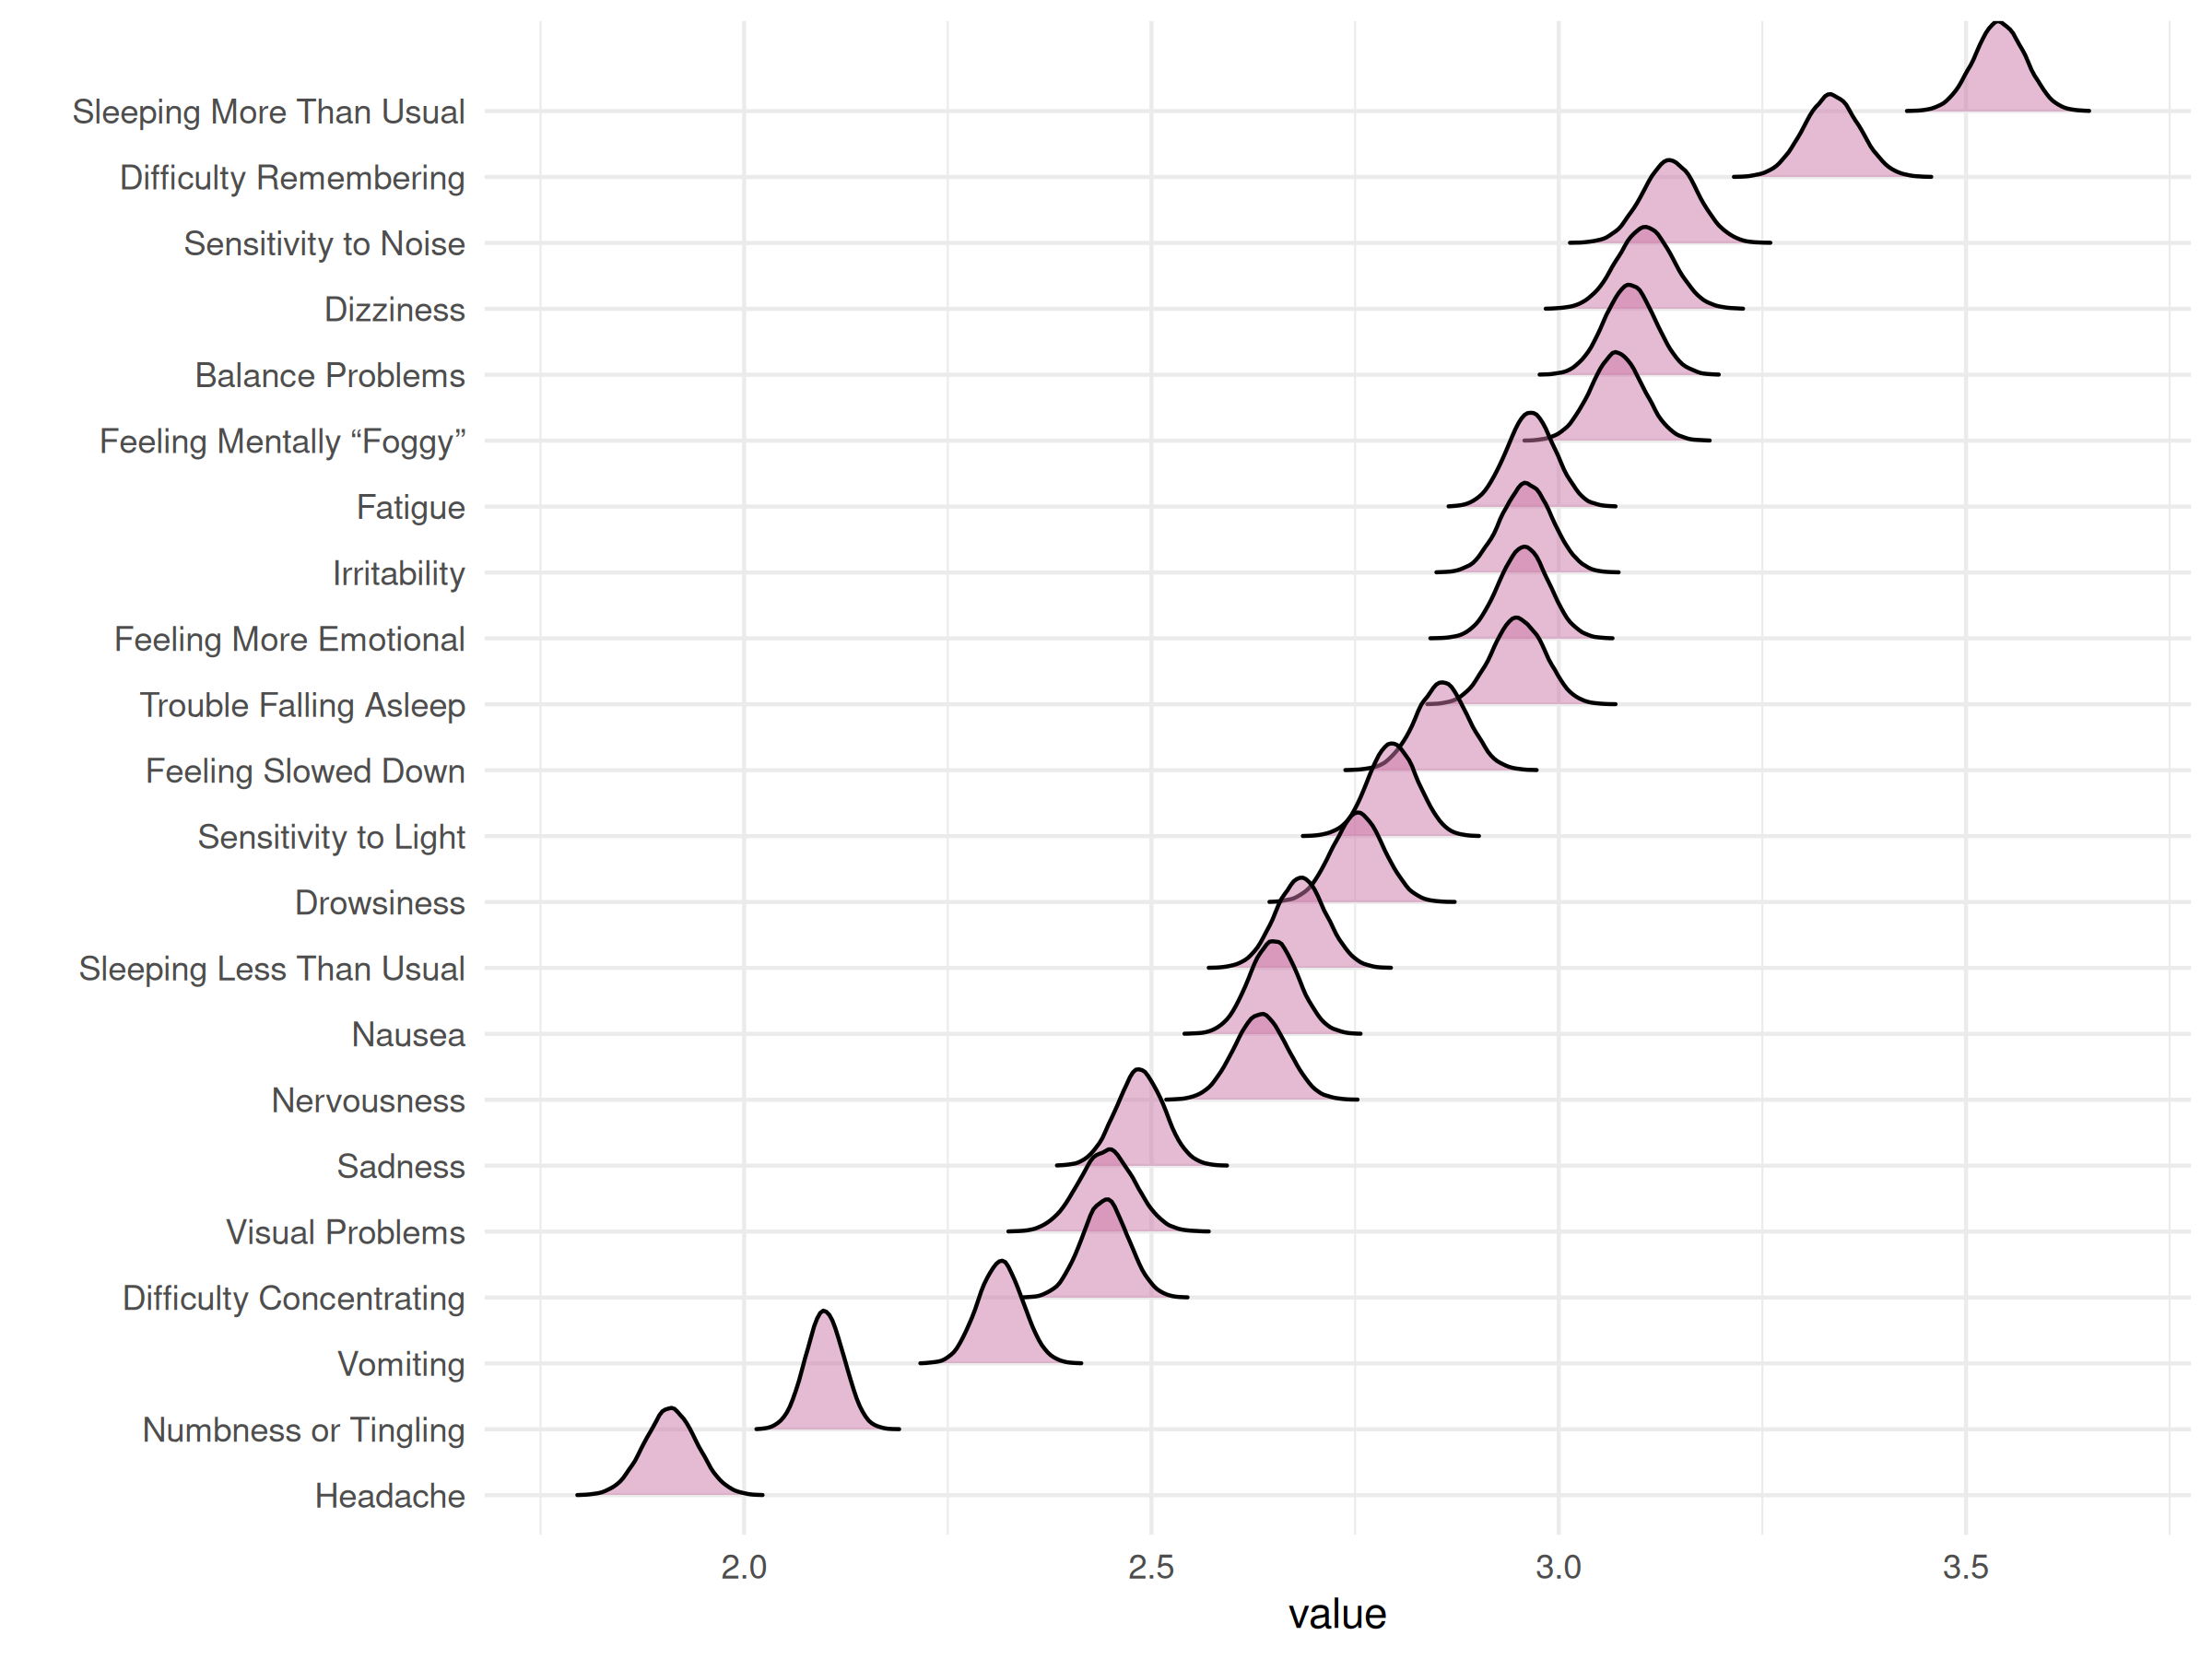

| Node | Post.mean | Post.sd | Cred.lb | Cred.ub |
| --- | --- | --- | --- | --- |
| Headache | 1.91 | 0.03 | 1.85 | 1.97 |
| Nausea | 2.65 | 0.03 | 2.59 | 2.71 |
| Vomiting | 2.31 | 0.03 | 2.26 | 2.37 |
| Balance Problems | 3.09 | 0.03 | 3.03 | 3.15 |
| Dizziness | 3.11 | 0.03 | 3.04 | 3.17 |
| Fatigue | 2.97 | 0.03 | 2.91 | 3.02 |
| Trouble Falling Asleep | 2.95 | 0.03 | 2.89 | 3.01 |
| Sleeping More Than Usual | 3.54 | 0.03 | 3.48 | 3.60 |
| Sleeping Less Than Usual | 2.68 | 0.03 | 2.62 | 2.74 |
| Drowsiness | 2.75 | 0.03 | 2.69 | 2.82 |
| Sensitivity to Light | 2.80 | 0.03 | 2.74 | 2.85 |
| Sensitivity to Noise | 3.14 | 0.03 | 3.07 | 3.20 |
| Irritability | 2.96 | 0.03 | 2.90 | 3.02 |
| Sadness | 2.49 | 0.03 | 2.43 | 2.54 |
| Nervousness | 2.63 | 0.03 | 2.57 | 2.70 |
| Feeling More Emotional | 2.96 | 0.03 | 2.90 | 3.02 |
| Numbness or Tingling | 2.10 | 0.02 | 2.05 | 2.15 |
| Feeling Slowed Down | 2.86 | 0.03 | 2.79 | 2.92 |
| Feeling Mentally “Foggy” | 3.07 | 0.03 | 3.01 | 3.13 |
| Difficulty Concentrating | 2.44 | 0.03 | 2.39 | 2.50 |
| Difficulty Remembering | 3.33 | 0.03 | 3.27 | 3.40 |
| Visual Problems | 2.44 | 0.03 | 2.38 | 2.51 |

## Within networks

### Total sample

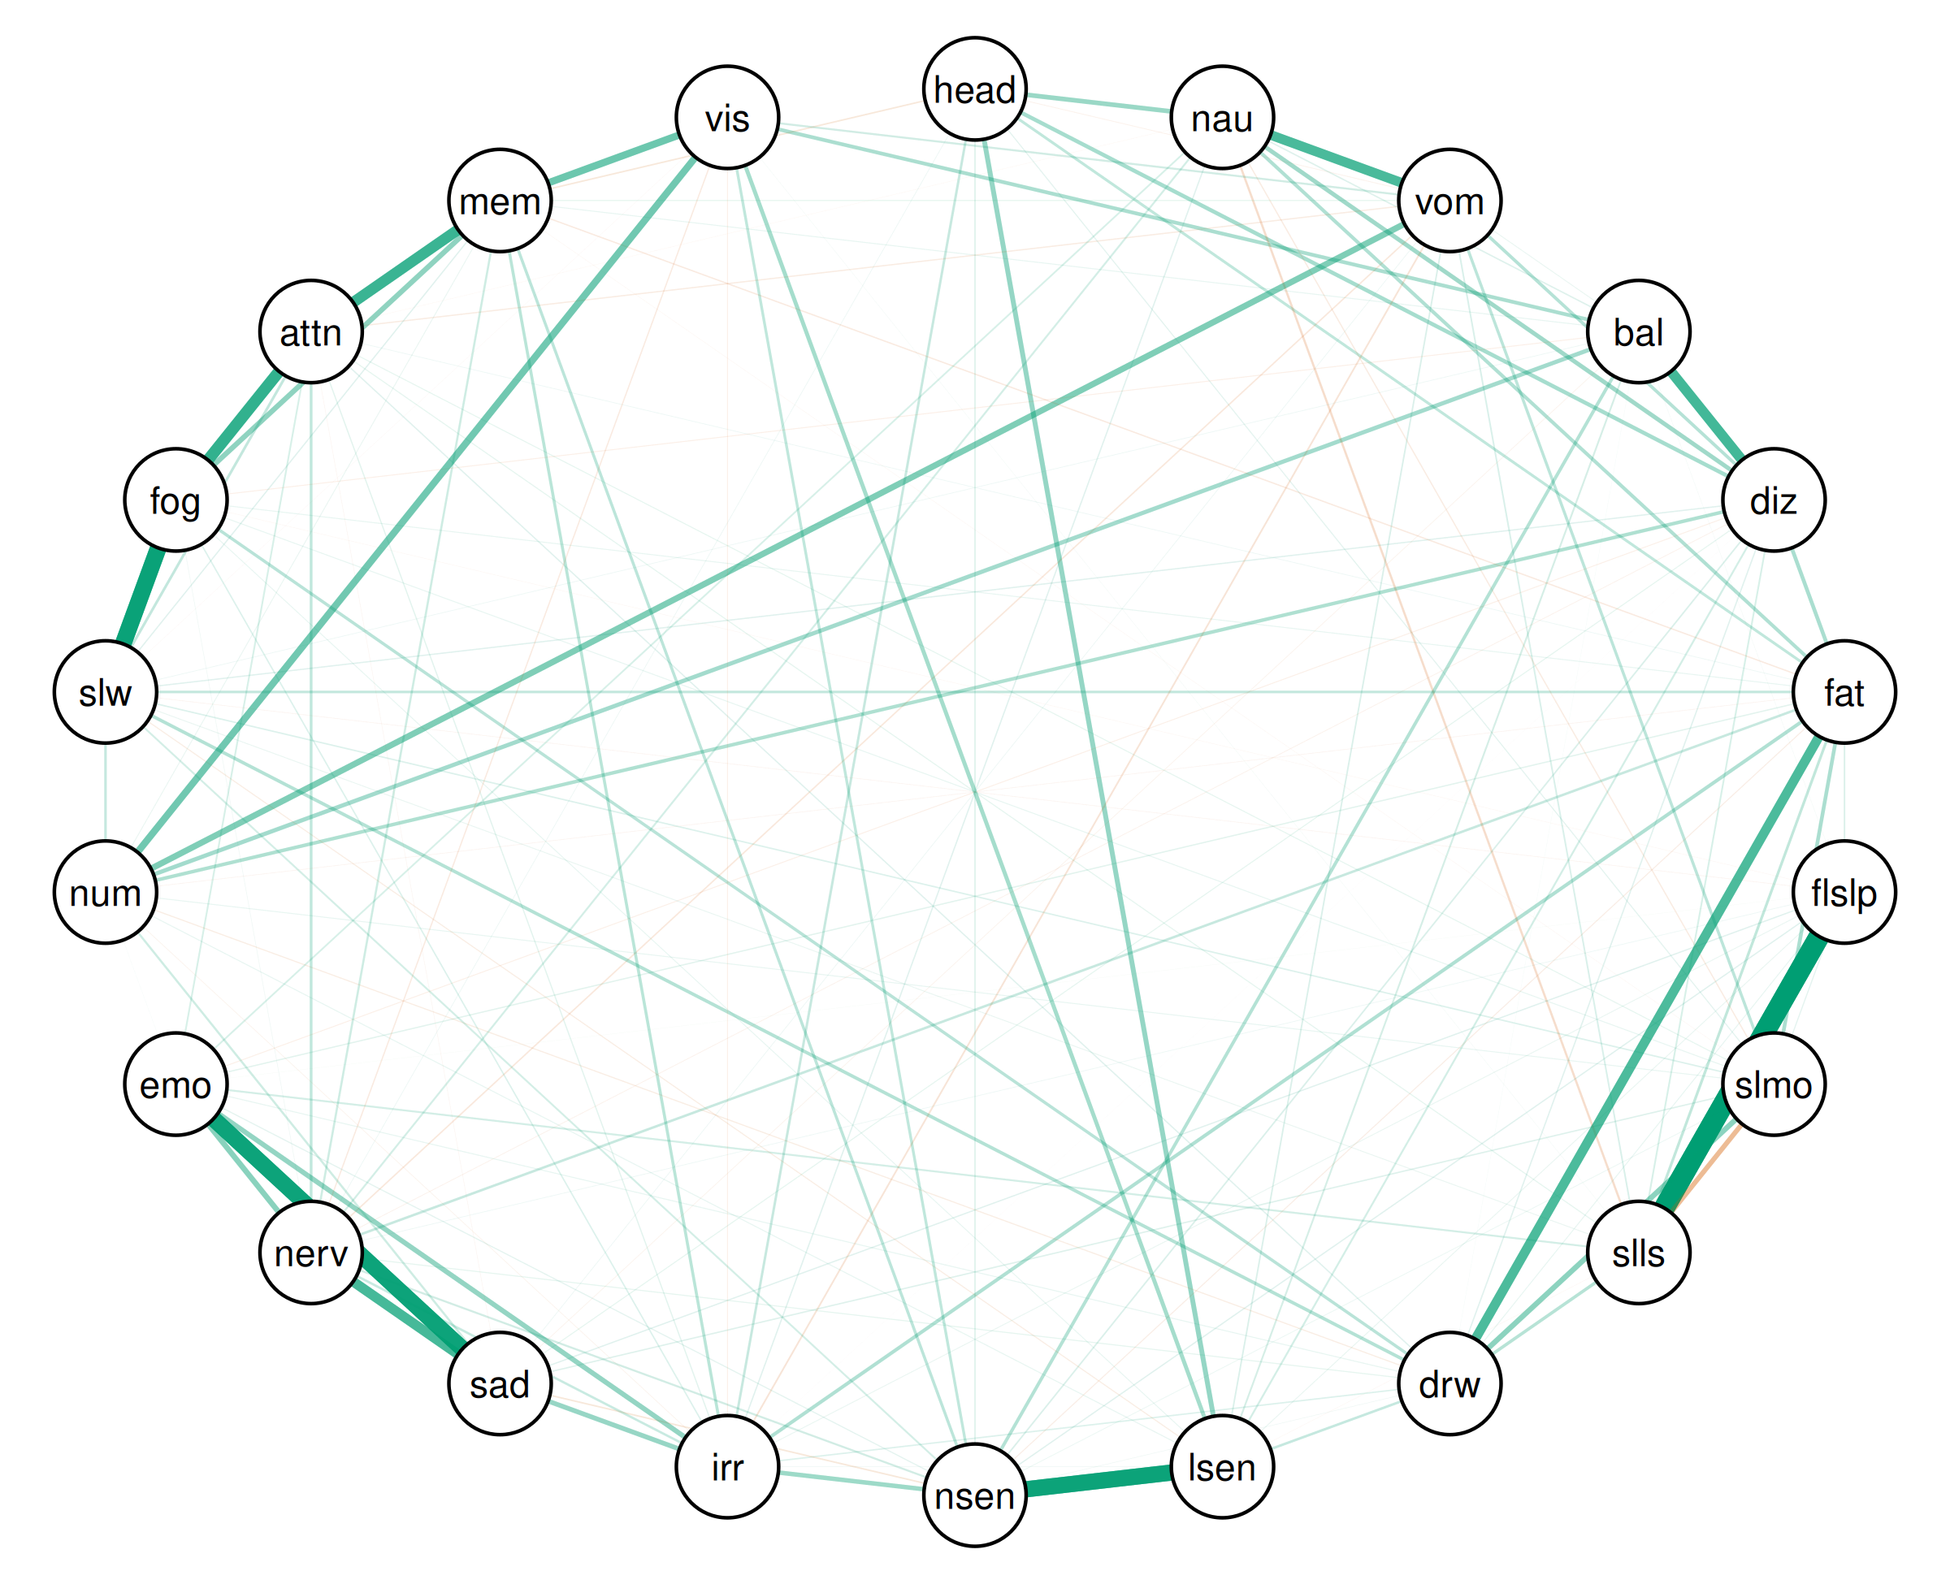

| Relation | Post.mean | Post.sd | Cred.lb | Cred.ub |
| --- | --- | --- | --- | --- |
| Trouble Falling Asleep--Sleeping Less Than Usual | 0.57 | 0.01 | 0.55 | 0.58 |
| Feeling Slowed Down--Feeling Mentally “Foggy” | 0.46 | 0.01 | 0.44 | 0.47 |
| Sensitivity to Light--Sensitivity to Noise | 0.45 | 0.01 | 0.43 | 0.47 |
| Sadness--Feeling More Emotional | 0.45 | 0.01 | 0.43 | 0.46 |
| Feeling Mentally “Foggy”--Difficulty Concentrating | 0.32 | 0.01 | 0.30 | 0.33 |
| Difficulty Concentrating--Difficulty Remembering | 0.30 | 0.01 | 0.29 | 0.33 |
| Balance Problems--Dizziness | 0.28 | 0.01 | 0.25 | 0.29 |
| Sadness--Nervousness | 0.27 | 0.01 | 0.25 | 0.29 |
| Nausea--Vomiting | 0.27 | 0.01 | 0.25 | 0.30 |
| Fatigue--Drowsiness | 0.26 | 0.01 | 0.25 | 0.28 |
| Difficulty Remembering--Visual Problems | 0.20 | 0.01 | 0.15 | 0.20 |
| Numbness or Tingling--Visual Problems | 0.19 | 0.02 | 0.15 | 0.23 |
| Vomiting--Numbness or Tingling | 0.17 | 0.01 | 0.15 | 0.21 |
| Nervousness--Feeling More Emotional | 0.15 | 0.01 | 0.14 | 0.17 |
| Sleeping More Than Usual--Drowsiness | 0.15 | 0.01 | 0.14 | 0.17 |
| Feeling Mentally “Foggy”--Difficulty Remembering | 0.14 | 0.01 | 0.13 | 0.16 |
| Irritability--Feeling More Emotional | 0.14 | 0.01 | 0.11 | 0.15 |
| Sleeping More Than Usual--Sleeping Less Than Usual | -0.14 | 0.01 | -0.14 | -0.12 |
| Headache--Sensitivity to Light | 0.13 | 0.01 | 0.12 | 0.15 |
| Irritability--Sadness | 0.13 | 0.01 | 0.12 | 0.15 |
| Headache--Nausea | 0.13 | 0.01 | 0.10 | 0.14 |
| Sensitivity to Noise--Irritability | 0.12 | 0.01 | 0.11 | 0.14 |
| Nausea--Dizziness | 0.12 | 0.01 | 0.10 | 0.13 |
| Balance Problems--Numbness or Tingling | 0.12 | 0.01 | 0.11 | 0.14 |
| Sensitivity to Light--Visual Problems | 0.11 | 0.01 | 0.10 | 0.14 |
| Headache--Dizziness | 0.11 | 0.01 | 0.08 | 0.12 |
| Dizziness--Fatigue | 0.10 | 0.01 | 0.08 | 0.12 |
| Fatigue--Sleeping More Than Usual | 0.10 | 0.01 | 0.08 | 0.12 |
| Balance Problems--Visual Problems | 0.10 | 0.01 | 0.08 | 0.13 |
| Dizziness--Numbness or Tingling | 0.10 | 0.01 | 0.07 | 0.11 |
| Nausea--Fatigue | 0.10 | 0.01 | 0.08 | 0.11 |
| Fatigue--Irritability | 0.10 | 0.01 | 0.07 | 0.11 |
| Drowsiness--Feeling Slowed Down | 0.09 | 0.01 | 0.08 | 0.11 |
| Balance Problems--Sensitivity to Noise | 0.09 | 0.01 | 0.05 | 0.09 |
| Vomiting--Dizziness | 0.09 | 0.01 | 0.07 | 0.11 |
| Sleeping Less Than Usual--Drowsiness | 0.09 | 0.01 | 0.07 | 0.10 |
| Drowsiness--Feeling Mentally “Foggy” | 0.09 | 0.01 | 0.06 | 0.09 |
| Irritability--Difficulty Remembering | 0.08 | 0.01 | 0.07 | 0.10 |
| Vomiting--Sleeping More Than Usual | 0.08 | 0.01 | 0.06 | 0.09 |
| Sensitivity to Noise--Difficulty Remembering | 0.08 | 0.01 | 0.07 | 0.11 |
| Headache--Fatigue | 0.08 | 0.01 | 0.07 | 0.10 |
| Sensitivity to Noise--Visual Problems | 0.08 | 0.01 | 0.06 | 0.10 |
| Fatigue--Sleeping Less Than Usual | 0.07 | 0.01 | 0.06 | 0.10 |
| Nervousness--Difficulty Concentrating | 0.07 | 0.01 | 0.06 | 0.09 |
| Feeling Slowed Down--Difficulty Concentrating | 0.07 | 0.01 | 0.06 | 0.09 |
| Fatigue--Feeling Slowed Down | 0.07 | 0.01 | 0.05 | 0.09 |
| Numbness or Tingling--Feeling Slowed Down | 0.07 | 0.01 | 0.06 | 0.09 |
| Drowsiness--Sensitivity to Light | 0.07 | 0.01 | 0.04 | 0.07 |
| Headache--Irritability | 0.07 | 0.01 | 0.06 | 0.08 |
| Fatigue--Nervousness | 0.07 | 0.01 | 0.05 | 0.08 |
| Irritability--Nervousness | 0.07 | 0.01 | 0.05 | 0.08 |
| Nausea--Sleeping Less Than Usual | -0.06 | 0.01 | -0.07 | -0.04 |
| Sadness--Numbness or Tingling | 0.06 | 0.01 | 0.04 | 0.07 |
| Nervousness--Difficulty Remembering | 0.06 | 0.01 | 0.03 | 0.07 |
| Vomiting--Visual Problems | 0.06 | 0.01 | 0.02 | 0.07 |
| Sensitivity to Noise--Nervousness | 0.05 | 0.01 | 0.04 | 0.07 |
| Dizziness--Sensitivity to Light | 0.05 | 0.01 | 0.04 | 0.07 |
| Nausea--Nervousness | 0.05 | 0.01 | 0.03 | 0.07 |
| Sleeping Less Than Usual--Feeling More Emotional | 0.05 | 0.01 | 0.03 | 0.06 |
| Sensitivity to Noise--Feeling Slowed Down | 0.05 | 0.01 | 0.03 | 0.07 |
| Balance Problems--Sensitivity to Light | 0.05 | 0.01 | 0.02 | 0.06 |
| Nausea--Feeling More Emotional | 0.05 | 0.01 | 0.03 | 0.06 |
| Feeling More Emotional--Difficulty Concentrating | 0.05 | 0.01 | 0.03 | 0.06 |
| Dizziness--Sleeping Less Than Usual | 0.05 | 0.01 | 0.03 | 0.07 |
| Vomiting--Irritability | -0.05 | 0.01 | -0.06 | -0.03 |
| Vomiting--Sleeping Less Than Usual | 0.04 | 0.01 | 0.02 | 0.05 |
| Dizziness--Sensitivity to Noise | 0.04 | 0.01 | 0.03 | 0.07 |
| Fatigue--Trouble Falling Asleep | 0.04 | 0.01 | 0.02 | 0.05 |
| Vomiting--Sensitivity to Light | 0.04 | 0.01 | 0.03 | 0.06 |
| Sensitivity to Noise--Sadness | -0.04 | 0.01 | -0.05 | -0.02 |
| Headache--Difficulty Remembering | -0.04 | 0.01 | -0.06 | -0.03 |
| Drowsiness--Irritability | 0.04 | 0.01 | 0.01 | 0.05 |
| Vomiting--Nervousness | -0.04 | 0.01 | -0.05 | -0.02 |
| Sleeping More Than Usual--Feeling Slowed Down | 0.04 | 0.01 | 0.03 | 0.06 |
| Nausea--Balance Problems | 0.04 | 0.01 | 0.02 | 0.06 |
| Headache--Sensitivity to Noise | 0.04 | 0.01 | 0.01 | 0.04 |
| Irritability--Feeling Mentally “Foggy” | 0.04 | 0.01 | 0.03 | 0.06 |
| Sleeping More Than Usual--Sadness | 0.04 | 0.01 | 0.02 | 0.05 |
| Dizziness--Drowsiness | 0.04 | 0.01 | 0.01 | 0.05 |
| Nausea--Irritability | 0.04 | 0.01 | 0.03 | 0.06 |
| Fatigue--Difficulty Remembering | -0.04 | 0.01 | -0.06 | -0.03 |
| Dizziness--Feeling Slowed Down | 0.04 | 0.01 | 0.01 | 0.05 |
| Drowsiness--Difficulty Concentrating | 0.04 | 0.01 | 0.03 | 0.06 |
| Feeling Slowed Down--Difficulty Remembering | 0.04 | 0.01 | 0.01 | 0.05 |
| Nausea--Sleeping More Than Usual | -0.04 | 0.01 | -0.05 | -0.02 |
| Trouble Falling Asleep--Sensitivity to Noise | 0.04 | 0.01 | 0.03 | 0.06 |
| Trouble Falling Asleep--Sadness | 0.04 | 0.01 | 0.01 | 0.04 |
| Fatigue--Feeling More Emotional | 0.04 | 0.01 | 0.02 | 0.05 |
| Nervousness--Visual Problems | -0.04 | 0.01 | -0.05 | -0.01 |
| Vomiting--Difficulty Concentrating | -0.03 | 0.01 | -0.05 | -0.01 |
| Irritability--Difficulty Concentrating | 0.03 | 0.01 | 0.02 | 0.05 |
| Trouble Falling Asleep--Sleeping More Than Usual | 0.03 | 0.01 | 0.01 | 0.04 |
| Drowsiness--Numbness or Tingling | -0.03 | 0.01 | -0.04 | -0.01 |
| Headache--Sleeping More Than Usual | 0.03 | 0.01 | 0.00 | 0.04 |
| Sensitivity to Noise--Feeling More Emotional | 0.03 | 0.01 | 0.01 | 0.04 |
| Sensitivity to Light--Feeling Slowed Down | -0.03 | 0.01 | -0.03 | -0.00 |
| Feeling Mentally “Foggy”--Visual Problems | -0.03 | 0.01 | -0.04 | 0.01 |
| Fatigue--Sensitivity to Noise | -0.03 | 0.01 | -0.05 | -0.02 |
| Sleeping Less Than Usual--Difficulty Concentrating | 0.03 | 0.01 | 0.01 | 0.05 |
| Vomiting--Difficulty Remembering | 0.03 | 0.01 | 0.02 | 0.05 |
| Dizziness--Sadness | 0.03 | 0.01 | 0.01 | 0.04 |
| Drowsiness--Nervousness | 0.03 | 0.01 | 0.01 | 0.04 |
| Drowsiness--Feeling More Emotional | 0.03 | 0.01 | 0.01 | 0.05 |
| Sensitivity to Light--Numbness or Tingling | 0.03 | 0.01 | 0.00 | 0.03 |
| Sleeping More Than Usual--Difficulty Concentrating | 0.03 | 0.01 | 0.02 | 0.05 |
| Fatigue--Feeling Mentally “Foggy” | 0.03 | 0.01 | 0.02 | 0.06 |
| Sleeping More Than Usual--Feeling Mentally “Foggy” | 0.03 | 0.01 | 0.01 | 0.03 |
| Balance Problems--Difficulty Remembering | 0.03 | 0.01 | 0.00 | 0.04 |
| Trouble Falling Asleep--Drowsiness | 0.03 | 0.01 | 0.01 | 0.04 |
| Dizziness--Feeling More Emotional | -0.03 | 0.01 | -0.04 | -0.00 |
| Sleeping More Than Usual--Numbness or Tingling | 0.03 | 0.01 | 0.01 | 0.04 |
| Balance Problems--Feeling Mentally “Foggy” | -0.03 | 0.01 | -0.03 | -0.00 |
| Sensitivity to Light--Feeling Mentally “Foggy” | 0.03 | 0.01 | 0.01 | 0.04 |
| Trouble Falling Asleep--Difficulty Remembering | 0.03 | 0.01 | -0.00 | 0.04 |
| Irritability--Visual Problems | -0.03 | 0.01 | -0.05 | -0.02 |
| Vomiting--Balance Problems | 0.03 | 0.01 | 0.01 | 0.05 |
| Trouble Falling Asleep--Sensitivity to Light | 0.03 | 0.01 | 0.01 | 0.04 |
| Sleeping Less Than Usual--Feeling Slowed Down | 0.03 | 0.01 | 0.01 | 0.04 |
| Vomiting--Drowsiness | -0.02 | 0.01 | -0.03 | 0.00 |
| Trouble Falling Asleep--Irritability | 0.02 | 0.01 | 0.01 | 0.04 |
| Numbness or Tingling--Difficulty Remembering | 0.02 | 0.01 | 0.01 | 0.05 |
| Sensitivity to Light--Sadness | 0.02 | 0.01 | -0.00 | 0.03 |
| Headache--Vomiting | -0.02 | 0.01 | -0.03 | -0.00 |
| Sleeping More Than Usual--Sensitivity to Noise | 0.02 | 0.01 | 0.00 | 0.04 |
| Dizziness--Nervousness | -0.02 | 0.01 | -0.04 | -0.00 |
| Nausea--Sadness | 0.02 | 0.01 | -0.00 | 0.03 |
| Balance Problems--Sadness | -0.02 | 0.01 | -0.04 | -0.01 |
| Irritability--Numbness or Tingling | -0.02 | 0.01 | -0.04 | -0.01 |
| Headache--Feeling Slowed Down | 0.02 | 0.01 | -0.00 | 0.03 |
| Headache--Difficulty Concentrating | 0.02 | 0.01 | -0.00 | 0.03 |
| Vomiting--Sadness | 0.02 | 0.01 | 0.01 | 0.04 |
| Headache--Nervousness | 0.02 | 0.01 | 0.01 | 0.04 |
| Trouble Falling Asleep--Nervousness | 0.02 | 0.01 | 0.00 | 0.04 |
| Balance Problems--Feeling Slowed Down | 0.02 | 0.01 | 0.01 | 0.04 |
| Fatigue--Difficulty Concentrating | 0.02 | 0.01 | 0.00 | 0.03 |
| Sadness--Feeling Mentally “Foggy” | 0.02 | 0.01 | -0.00 | 0.03 |
| Sensitivity to Light--Irritability | 0.02 | 0.01 | 0.00 | 0.03 |
| Fatigue--Sadness | -0.02 | 0.01 | -0.03 | 0.00 |
| Fatigue--Numbness or Tingling | -0.02 | 0.01 | -0.04 | -0.01 |
| Trouble Falling Asleep--Feeling Slowed Down | -0.02 | 0.01 | -0.04 | -0.01 |
| Fatigue--Visual Problems | 0.02 | 0.01 | -0.00 | 0.03 |
| Drowsiness--Sensitivity to Noise | 0.02 | 0.01 | 0.00 | 0.04 |
| Sensitivity to Light--Nervousness | -0.02 | 0.01 | -0.02 | 0.01 |
| Sensitivity to Noise--Numbness or Tingling | 0.02 | 0.01 | -0.00 | 0.03 |
| Nervousness--Feeling Mentally “Foggy” | 0.02 | 0.01 | 0.01 | 0.04 |
| Sadness--Difficulty Remembering | 0.02 | 0.01 | -0.00 | 0.03 |
| Sadness--Difficulty Concentrating | -0.02 | 0.01 | -0.03 | -0.00 |
| Nervousness--Numbness or Tingling | 0.01 | 0.01 | -0.01 | 0.03 |
| Sensitivity to Light--Difficulty Concentrating | 0.01 | 0.01 | -0.01 | 0.03 |
| Balance Problems--Fatigue | 0.01 | 0.01 | -0.00 | 0.03 |
| Headache--Trouble Falling Asleep | 0.01 | 0.01 | -0.00 | 0.03 |
| Sleeping Less Than Usual--Sensitivity to Light | -0.01 | 0.01 | -0.04 | -0.00 |
| Sleeping More Than Usual--Feeling More Emotional | 0.01 | 0.01 | -0.00 | 0.03 |
| Trouble Falling Asleep--Feeling Mentally “Foggy” | -0.01 | 0.01 | -0.04 | -0.01 |
| Nausea--Difficulty Remembering | -0.01 | 0.01 | -0.02 | 0.01 |
| Sleeping More Than Usual--Difficulty Remembering | -0.01 | 0.01 | -0.04 | -0.01 |
| Difficulty Concentrating--Visual Problems | 0.01 | 0.01 | -0.01 | 0.03 |
| Balance Problems--Trouble Falling Asleep | 0.01 | 0.01 | 0.00 | 0.04 |
| Nausea--Difficulty Concentrating | -0.01 | 0.01 | -0.03 | -0.00 |
| Dizziness--Difficulty Concentrating | 0.01 | 0.01 | -0.01 | 0.03 |
| Sensitivity to Noise--Difficulty Concentrating | -0.01 | 0.01 | -0.02 | 0.01 |
| Sleeping Less Than Usual--Visual Problems | 0.01 | 0.01 | 0.01 | 0.05 |
| Drowsiness--Visual Problems | 0.01 | 0.01 | -0.01 | 0.03 |
| Nausea--Trouble Falling Asleep | 0.01 | 0.01 | -0.01 | 0.02 |
| Vomiting--Trouble Falling Asleep | 0.01 | 0.01 | -0.00 | 0.03 |
| Sleeping Less Than Usual--Numbness or Tingling | 0.01 | 0.01 | -0.00 | 0.03 |
| Feeling More Emotional--Feeling Mentally “Foggy” | 0.01 | 0.01 | -0.01 | 0.03 |
| Balance Problems--Sleeping More Than Usual | 0.01 | 0.01 | -0.01 | 0.03 |
| Balance Problems--Sleeping Less Than Usual | 0.01 | 0.01 | -0.01 | 0.02 |
| Balance Problems--Drowsiness | 0.01 | 0.01 | 0.00 | 0.03 |
| Nausea--Sensitivity to Light | 0.01 | 0.01 | -0.01 | 0.02 |
| Drowsiness--Sadness | -0.01 | 0.01 | -0.02 | 0.01 |
| Feeling More Emotional--Numbness or Tingling | 0.01 | 0.01 | 0.00 | 0.03 |
| Drowsiness--Difficulty Remembering | -0.01 | 0.01 | -0.03 | 0.00 |
| Nausea--Visual Problems | 0.01 | 0.01 | -0.01 | 0.02 |
| Headache--Balance Problems | -0.01 | 0.01 | -0.01 | 0.02 |
| Trouble Falling Asleep--Feeling More Emotional | 0.01 | 0.01 | 0.00 | 0.03 |
| Nausea--Numbness or Tingling | 0.01 | 0.01 | -0.01 | 0.03 |
| Feeling Slowed Down--Visual Problems | -0.01 | 0.01 | -0.04 | -0.00 |
| Fatigue--Sensitivity to Light | -0.01 | 0.01 | -0.02 | 0.01 |
| Balance Problems--Nervousness | -0.01 | 0.01 | -0.02 | 0.01 |
| Sleeping Less Than Usual--Feeling Mentally “Foggy” | 0.01 | 0.01 | -0.00 | 0.03 |
| Sleeping Less Than Usual--Irritability | 0.01 | 0.01 | -0.01 | 0.02 |
| Headache--Sadness | -0.01 | 0.01 | -0.02 | 0.01 |
| Sleeping Less Than Usual--Nervousness | -0.01 | 0.01 | -0.01 | 0.01 |
| Sadness--Feeling Slowed Down | -0.01 | 0.01 | -0.01 | 0.02 |
| Dizziness--Feeling Mentally “Foggy” | -0.01 | 0.01 | -0.02 | 0.01 |
| Dizziness--Irritability | -0.01 | 0.01 | -0.03 | -0.00 |
| Sleeping More Than Usual--Nervousness | 0.01 | 0.01 | -0.01 | 0.02 |
| Headache--Feeling More Emotional | 0.01 | 0.01 | -0.01 | 0.02 |
| Irritability--Feeling Slowed Down | -0.01 | 0.01 | -0.02 | 0.01 |
| Nausea--Feeling Mentally “Foggy” | 0.01 | 0.01 | -0.01 | 0.02 |
| Trouble Falling Asleep--Difficulty Concentrating | 0.01 | 0.01 | -0.00 | 0.03 |
| Dizziness--Visual Problems | 0.01 | 0.01 | -0.00 | 0.04 |
| Trouble Falling Asleep--Numbness or Tingling | 0.01 | 0.01 | -0.00 | 0.03 |
| Vomiting--Feeling Slowed Down | -0.01 | 0.01 | -0.02 | 0.01 |
| Sleeping More Than Usual--Visual Problems | 0.01 | 0.01 | -0.01 | 0.03 |
| Nausea--Drowsiness | -0.01 | 0.01 | -0.02 | 0.01 |
| Headache--Feeling Mentally “Foggy” | 0.01 | 0.01 | -0.01 | 0.02 |
| Sensitivity to Noise--Feeling Mentally “Foggy” | -0.01 | 0.01 | -0.03 | 0.00 |
| Numbness or Tingling--Difficulty Concentrating | -0.01 | 0.01 | -0.04 | -0.00 |
| Sleeping More Than Usual--Sensitivity to Light | 0.00 | 0.01 | -0.01 | 0.03 |
| Headache--Numbness or Tingling | -0.00 | 0.01 | -0.01 | 0.02 |
| Feeling More Emotional--Feeling Slowed Down | -0.00 | 0.01 | -0.01 | 0.02 |
| Vomiting--Feeling Mentally “Foggy” | -0.00 | 0.01 | -0.02 | 0.01 |
| Feeling More Emotional--Difficulty Remembering | -0.00 | 0.01 | -0.02 | 0.01 |
| Trouble Falling Asleep--Visual Problems | 0.00 | 0.01 | -0.01 | 0.03 |
| Dizziness--Trouble Falling Asleep | -0.00 | 0.01 | -0.02 | 0.01 |
| Dizziness--Sleeping More Than Usual | 0.00 | 0.01 | -0.01 | 0.02 |
| Nausea--Sensitivity to Noise | -0.00 | 0.01 | -0.01 | 0.03 |
| Vomiting--Feeling More Emotional | 0.00 | 0.01 | -0.02 | 0.01 |
| Balance Problems--Difficulty Concentrating | -0.00 | 0.01 | -0.01 | 0.02 |
| Sadness--Visual Problems | -0.00 | 0.01 | -0.01 | 0.02 |
| Headache--Sleeping Less Than Usual | -0.00 | 0.01 | -0.02 | 0.01 |
| Headache--Drowsiness | 0.00 | 0.01 | -0.00 | 0.03 |
| Vomiting--Sensitivity to Noise | 0.00 | 0.01 | -0.03 | 0.01 |
| Balance Problems--Feeling More Emotional | -0.00 | 0.01 | -0.02 | 0.01 |
| Nausea--Feeling Slowed Down | 0.00 | 0.01 | -0.01 | 0.02 |
| Nervousness--Feeling Slowed Down | 0.00 | 0.01 | -0.02 | 0.01 |
| Headache--Visual Problems | -0.00 | 0.01 | -0.03 | 0.01 |
| Vomiting--Fatigue | -0.00 | 0.01 | -0.02 | 0.01 |
| Balance Problems--Irritability | -0.00 | 0.01 | -0.01 | 0.02 |
| Sleeping More Than Usual--Irritability | -0.00 | 0.01 | -0.02 | 0.01 |
| Sleeping Less Than Usual--Sadness | -0.00 | 0.01 | -0.01 | 0.02 |
| Sensitivity to Light--Feeling More Emotional | -0.00 | 0.01 | -0.01 | 0.02 |
| Numbness or Tingling--Feeling Mentally “Foggy” | -0.00 | 0.01 | -0.01 | 0.03 |
| Sleeping Less Than Usual--Difficulty Remembering | 0.00 | 0.01 | -0.03 | 0.01 |
| Sleeping Less Than Usual--Sensitivity to Noise | -0.00 | 0.01 | -0.02 | 0.01 |
| Dizziness--Difficulty Remembering | -0.00 | 0.01 | -0.02 | 0.02 |
| Sensitivity to Light--Difficulty Remembering | -0.00 | 0.01 | -0.02 | 0.02 |
| Feeling More Emotional--Visual Problems | -0.00 | 0.01 | -0.03 | 0.01 |

### Bridge strength

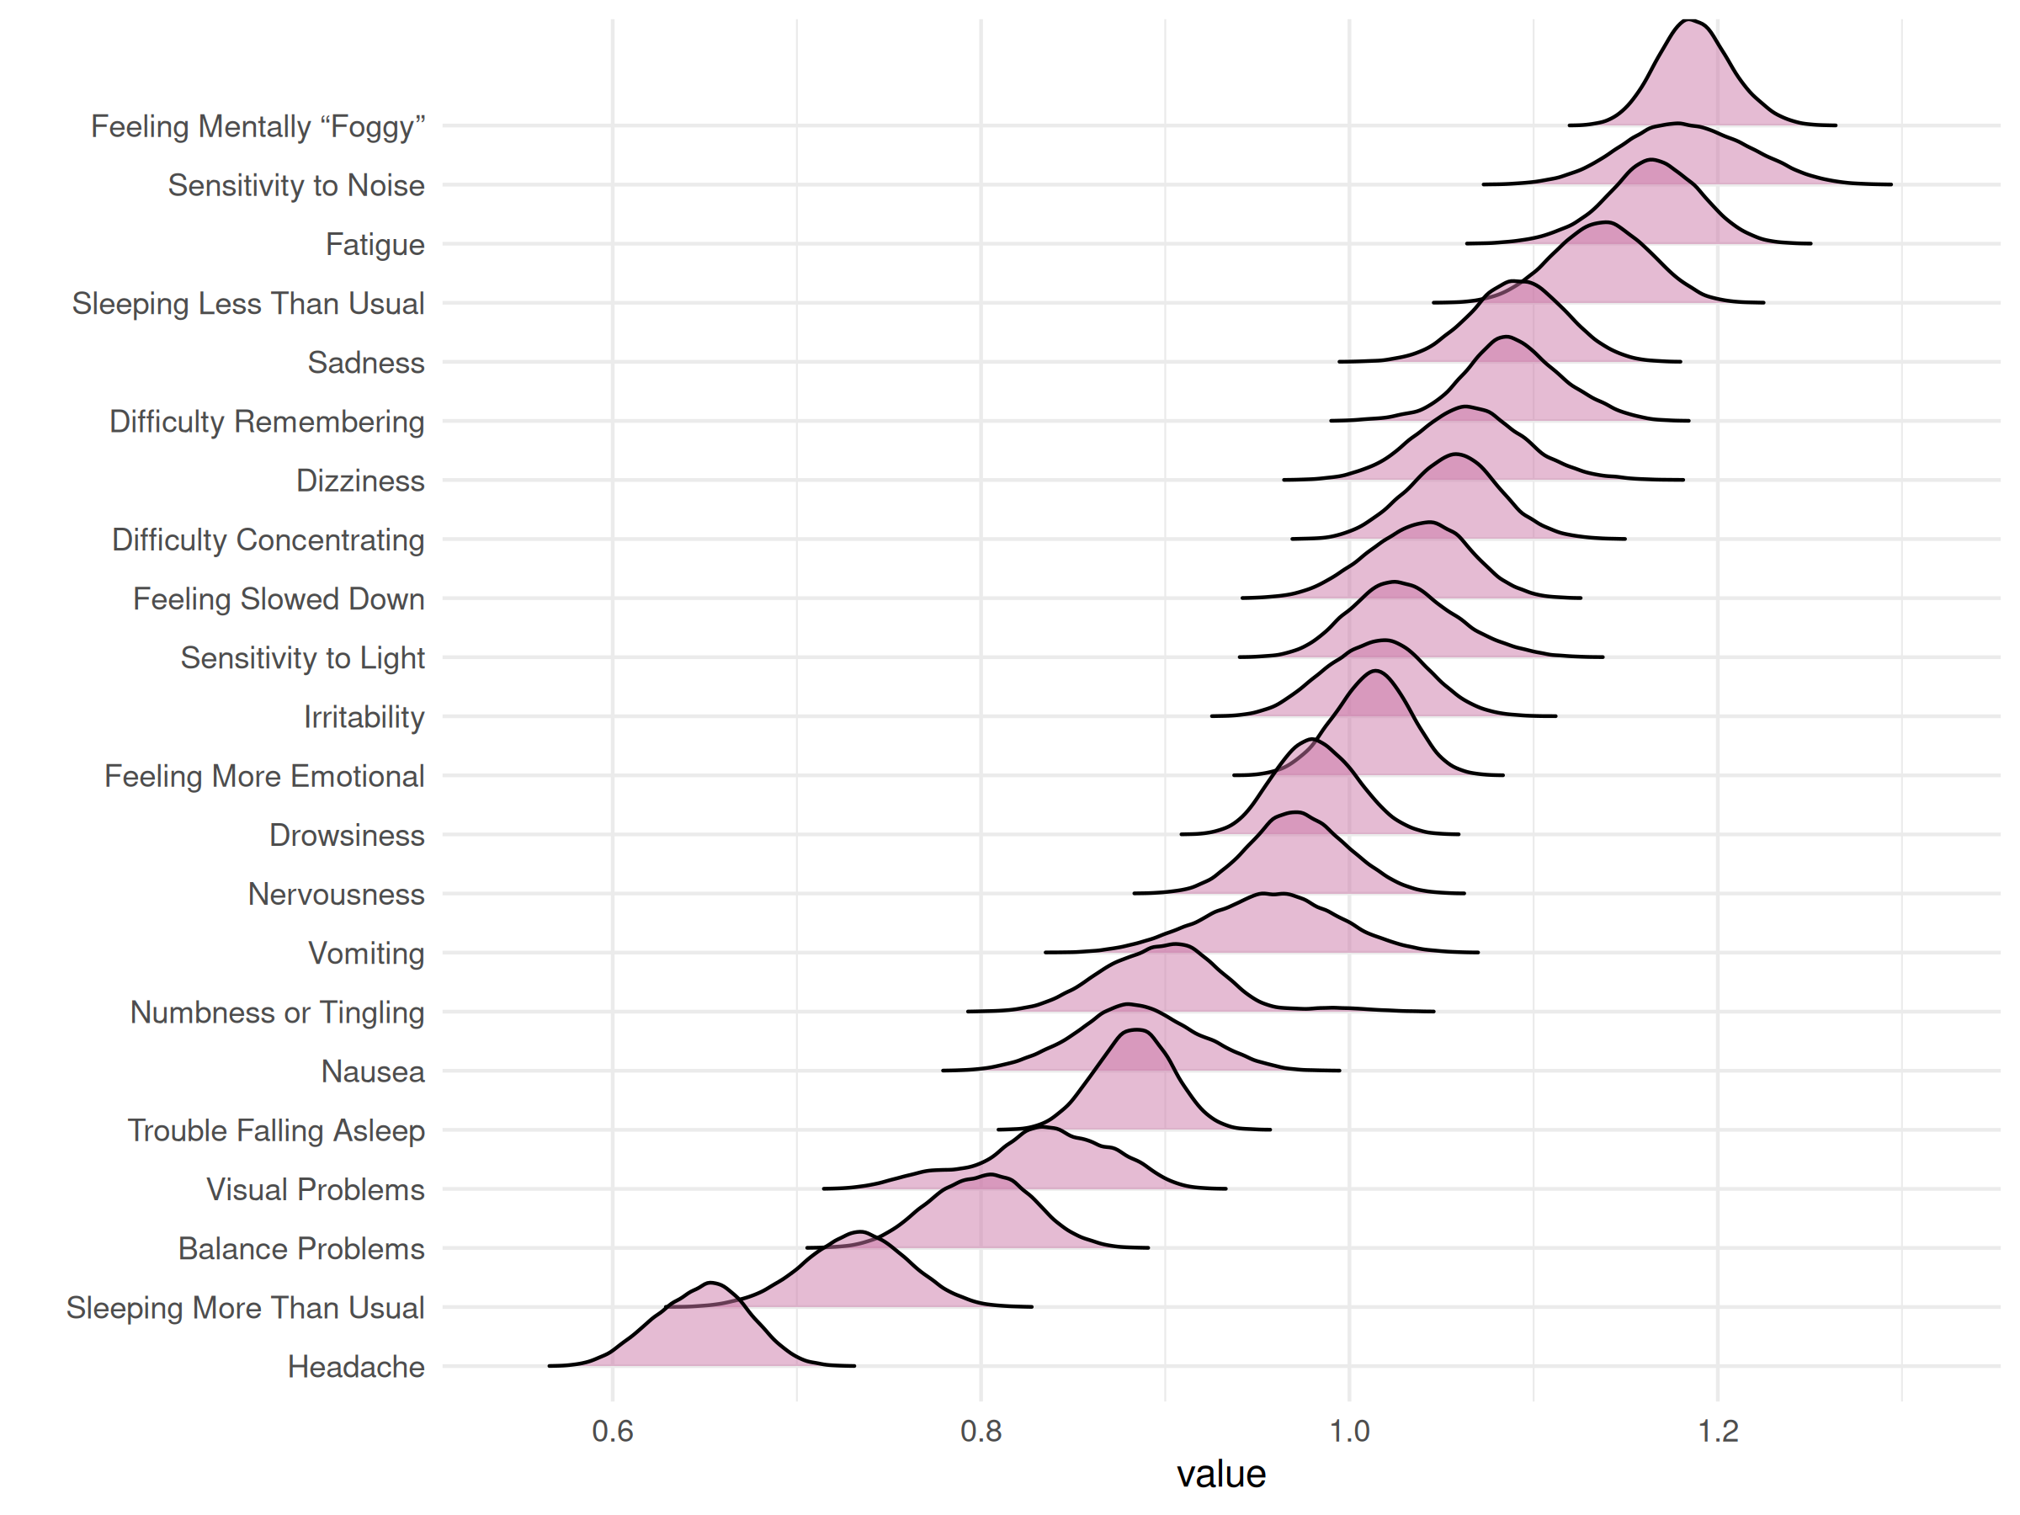

| Node | Post.mean | Post.sd | Cred.lb | Cred.ub |
| --- | --- | --- | --- | --- |
| Headache | 0.65 | 0.03 | 0.60 | 0.69 |
| Nausea | 0.88 | 0.03 | 0.82 | 0.95 |
| Vomiting | 0.96 | 0.04 | 0.89 | 1.02 |
| Balance Problems | 0.80 | 0.03 | 0.75 | 0.85 |
| Dizziness | 1.06 | 0.03 | 1.01 | 1.13 |
| Fatigue | 1.16 | 0.03 | 1.11 | 1.21 |
| Trouble Falling Asleep | 0.88 | 0.02 | 0.84 | 0.92 |
| Sleeping More Than Usual | 0.73 | 0.03 | 0.67 | 0.79 |
| Sleeping Less Than Usual | 1.14 | 0.03 | 1.09 | 1.19 |
| Drowsiness | 0.98 | 0.02 | 0.94 | 1.02 |
| Sensitivity to Light | 1.03 | 0.03 | 0.98 | 1.09 |
| Sensitivity to Noise | 1.18 | 0.03 | 1.12 | 1.25 |
| Irritability | 1.01 | 0.03 | 0.96 | 1.07 |
| Sadness | 1.09 | 0.03 | 1.04 | 1.14 |
| Nervousness | 0.97 | 0.03 | 0.92 | 1.02 |
| Feeling More Emotional | 1.01 | 0.02 | 0.97 | 1.05 |
| Numbness or Tingling | 0.90 | 0.03 | 0.84 | 0.98 |
| Feeling Slowed Down | 1.04 | 0.03 | 0.98 | 1.09 |
| Feeling Mentally “Foggy” | 1.19 | 0.02 | 1.15 | 1.23 |
| Difficulty Concentrating | 1.06 | 0.03 | 1.01 | 1.11 |
| Difficulty Remembering | 1.09 | 0.03 | 1.03 | 1.14 |
| Visual Problems | 0.83 | 0.04 | 0.75 | 0.90 |

### Concussion

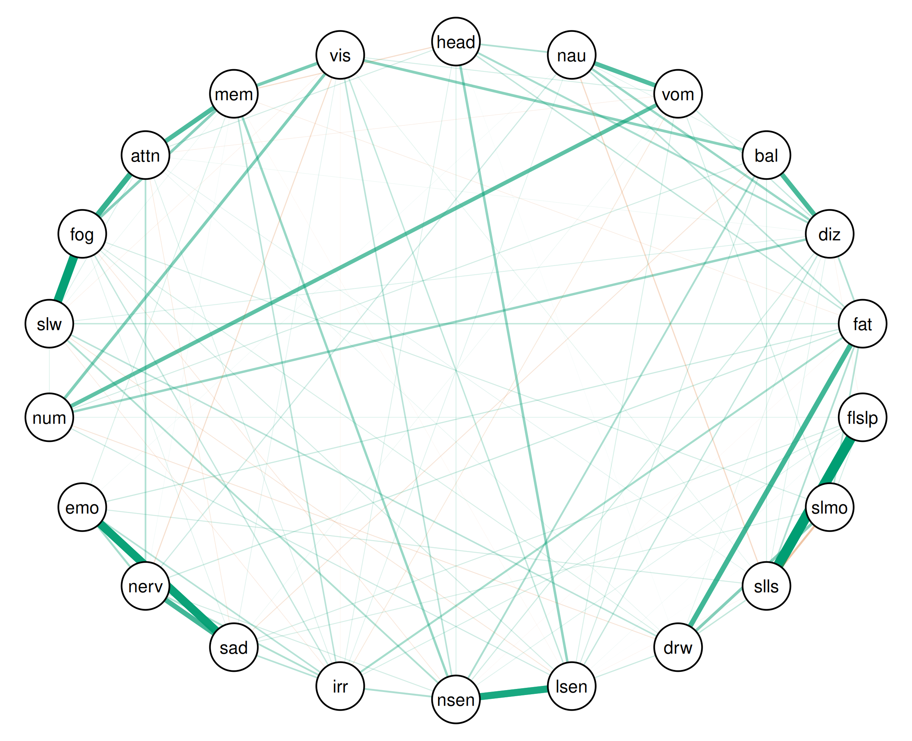

| Relation | Post.mean | Post.sd | Cred.lb | Cred.ub |
| --- | --- | --- | --- | --- |
| Trouble Falling Asleep--Sleeping Less Than Usual | 0.60 | 0.01 | 0.55 | 0.60 |
| Feeling Slowed Down--Feeling Mentally “Foggy” | 0.51 | 0.01 | 0.46 | 0.52 |
| Sadness--Feeling More Emotional | 0.48 | 0.01 | 0.45 | 0.50 |
| Sensitivity to Light--Sensitivity to Noise | 0.42 | 0.02 | 0.40 | 0.47 |
| Feeling Mentally “Foggy”--Difficulty Concentrating | 0.32 | 0.02 | 0.28 | 0.34 |
| Fatigue--Drowsiness | 0.30 | 0.02 | 0.28 | 0.34 |
| Sadness--Nervousness | 0.29 | 0.02 | 0.23 | 0.30 |
| Balance Problems--Dizziness | 0.28 | 0.02 | 0.24 | 0.30 |
| Difficulty Concentrating--Difficulty Remembering | 0.27 | 0.02 | 0.25 | 0.31 |
| Nausea--Vomiting | 0.26 | 0.02 | 0.23 | 0.31 |
| Vomiting--Numbness or Tingling | 0.23 | 0.03 | 0.20 | 0.30 |
| Difficulty Remembering--Visual Problems | 0.19 | 0.03 | 0.14 | 0.24 |
| Numbness or Tingling--Visual Problems | 0.17 | 0.03 | 0.11 | 0.22 |
| Sleeping More Than Usual--Drowsiness | 0.17 | 0.02 | 0.13 | 0.20 |
| Feeling Mentally “Foggy”--Difficulty Remembering | 0.16 | 0.02 | 0.13 | 0.19 |
| Balance Problems--Visual Problems | 0.16 | 0.03 | 0.08 | 0.20 |
| Headache--Sensitivity to Light | 0.14 | 0.01 | 0.12 | 0.18 |
| Dizziness--Numbness or Tingling | 0.14 | 0.02 | 0.07 | 0.15 |
| Sensitivity to Noise--Difficulty Remembering | 0.14 | 0.02 | 0.10 | 0.17 |
| Nausea--Dizziness | 0.14 | 0.02 | 0.09 | 0.16 |
| Sleeping More Than Usual--Sleeping Less Than Usual | -0.12 | 0.01 | -0.13 | -0.08 |
| Nervousness--Feeling More Emotional | 0.12 | 0.02 | 0.09 | 0.16 |
| Fatigue--Irritability | 0.12 | 0.02 | 0.07 | 0.13 |
| Headache--Dizziness | 0.12 | 0.02 | 0.09 | 0.15 |
| Balance Problems--Sensitivity to Noise | 0.11 | 0.02 | 0.04 | 0.11 |
| Sensitivity to Noise--Irritability | 0.11 | 0.01 | 0.07 | 0.13 |
| Irritability--Nervousness | 0.10 | 0.02 | 0.08 | 0.15 |
| Sensitivity to Noise--Feeling Slowed Down | 0.10 | 0.02 | 0.05 | 0.12 |
| Headache--Nausea | 0.10 | 0.01 | 0.07 | 0.12 |
| Dizziness--Fatigue | 0.10 | 0.02 | 0.06 | 0.12 |
| Fatigue--Sleeping Less Than Usual | 0.10 | 0.01 | 0.06 | 0.12 |
| Nervousness--Difficulty Concentrating | 0.10 | 0.02 | 0.05 | 0.11 |
| Fatigue--Sleeping More Than Usual | 0.10 | 0.01 | 0.07 | 0.13 |
| Irritability--Feeling More Emotional | 0.10 | 0.02 | 0.05 | 0.12 |
| Irritability--Sadness | 0.09 | 0.02 | 0.07 | 0.14 |
| Nausea--Fatigue | 0.09 | 0.02 | 0.08 | 0.14 |
| Drowsiness--Feeling Slowed Down | 0.09 | 0.02 | 0.07 | 0.14 |
| Sensitivity to Noise--Visual Problems | 0.09 | 0.02 | 0.04 | 0.12 |
| Irritability--Difficulty Remembering | 0.09 | 0.02 | 0.04 | 0.11 |
| Headache--Fatigue | 0.08 | 0.02 | 0.05 | 0.12 |
| Sensitivity to Light--Visual Problems | 0.08 | 0.02 | 0.07 | 0.16 |
| Sleeping Less Than Usual--Drowsiness | 0.08 | 0.02 | 0.06 | 0.12 |
| Fatigue--Feeling Slowed Down | 0.08 | 0.01 | 0.04 | 0.09 |
| Irritability--Feeling Mentally “Foggy” | 0.08 | 0.01 | 0.05 | 0.11 |
| Vomiting--Dizziness | 0.07 | 0.02 | 0.05 | 0.12 |
| Dizziness--Sensitivity to Light | 0.07 | 0.02 | 0.04 | 0.10 |
| Nausea--Sleeping Less Than Usual | -0.07 | 0.01 | -0.09 | -0.03 |
| Fatigue--Nervousness | 0.07 | 0.01 | 0.03 | 0.09 |
| Drowsiness--Sensitivity to Light | 0.07 | 0.02 | 0.01 | 0.07 |
| Nausea--Nervousness | 0.07 | 0.02 | 0.01 | 0.07 |
| Fatigue--Feeling More Emotional | 0.07 | 0.02 | 0.03 | 0.10 |
| Sensitivity to Light--Numbness or Tingling | 0.06 | 0.02 | 0.00 | 0.07 |
| Headache--Difficulty Remembering | -0.06 | 0.01 | -0.07 | -0.02 |
| Dizziness--Sensitivity to Noise | 0.06 | 0.01 | 0.03 | 0.08 |
| Nervousness--Visual Problems | -0.06 | 0.02 | -0.06 | -0.00 |
| Sensitivity to Light--Feeling Mentally “Foggy” | 0.06 | 0.01 | 0.04 | 0.09 |
| Balance Problems--Sensitivity to Light | 0.06 | 0.02 | 0.02 | 0.09 |
| Sensitivity to Noise--Nervousness | 0.06 | 0.02 | 0.02 | 0.08 |
| Sleeping Less Than Usual--Feeling More Emotional | 0.06 | 0.02 | 0.01 | 0.08 |
| Balance Problems--Numbness or Tingling | 0.06 | 0.02 | 0.03 | 0.12 |
| Sleeping More Than Usual--Feeling Mentally “Foggy” | 0.06 | 0.01 | 0.01 | 0.07 |
| Headache--Difficulty Concentrating | 0.06 | 0.01 | 0.01 | 0.07 |
| Vomiting--Sleeping More Than Usual | 0.06 | 0.01 | 0.02 | 0.08 |
| Trouble Falling Asleep--Sadness | 0.06 | 0.01 | 0.01 | 0.07 |
| Trouble Falling Asleep--Irritability | 0.05 | 0.02 | 0.01 | 0.07 |
| Vomiting--Visual Problems | 0.05 | 0.02 | 0.03 | 0.12 |
| Trouble Falling Asleep--Sleeping More Than Usual | 0.05 | 0.01 | 0.02 | 0.07 |
| Balance Problems--Sleeping Less Than Usual | 0.05 | 0.01 | 0.02 | 0.07 |
| Sleeping More Than Usual--Sadness | 0.05 | 0.01 | 0.02 | 0.07 |
| Drowsiness--Feeling Mentally “Foggy” | 0.05 | 0.01 | 0.01 | 0.07 |
| Vomiting--Sensitivity to Light | 0.05 | 0.01 | 0.03 | 0.09 |
| Headache--Sensitivity to Noise | 0.05 | 0.01 | 0.01 | 0.07 |
| Drowsiness--Numbness or Tingling | -0.05 | 0.01 | -0.07 | -0.01 |
| Balance Problems--Sadness | -0.05 | 0.01 | -0.07 | -0.01 |
| Sensitivity to Light--Feeling Slowed Down | -0.05 | 0.01 | -0.06 | -0.00 |
| Feeling More Emotional--Difficulty Remembering | 0.05 | 0.01 | 0.01 | 0.07 |
| Dizziness--Feeling Slowed Down | 0.05 | 0.02 | 0.00 | 0.07 |
| Feeling Slowed Down--Difficulty Concentrating | 0.05 | 0.01 | 0.02 | 0.08 |
| Headache--Irritability | 0.04 | 0.01 | 0.03 | 0.09 |
| Irritability--Difficulty Concentrating | 0.04 | 0.01 | 0.00 | 0.06 |
| Vomiting--Irritability | -0.04 | 0.02 | -0.07 | -0.00 |
| Dizziness--Sleeping Less Than Usual | 0.04 | 0.01 | 0.02 | 0.08 |
| Trouble Falling Asleep--Sensitivity to Noise | 0.04 | 0.01 | 0.01 | 0.07 |
| Trouble Falling Asleep--Numbness or Tingling | 0.04 | 0.01 | 0.00 | 0.06 |
| Sensitivity to Noise--Feeling Mentally “Foggy” | -0.04 | 0.01 | -0.06 | -0.00 |
| Nausea--Irritability | 0.04 | 0.01 | 0.03 | 0.08 |
| Nervousness--Feeling Slowed Down | 0.04 | 0.02 | -0.01 | 0.05 |
| Numbness or Tingling--Feeling Slowed Down | 0.04 | 0.02 | 0.01 | 0.07 |
| Sadness--Feeling Mentally “Foggy” | 0.04 | 0.02 | 0.00 | 0.07 |
| Nausea--Balance Problems | 0.04 | 0.01 | 0.01 | 0.07 |
| Sadness--Difficulty Concentrating | -0.04 | 0.01 | -0.06 | -0.00 |
| Sadness--Visual Problems | 0.04 | 0.02 | 0.01 | 0.08 |
| Balance Problems--Sleeping More Than Usual | 0.04 | 0.01 | -0.00 | 0.06 |
| Irritability--Feeling Slowed Down | -0.04 | 0.01 | -0.06 | -0.00 |
| Sleeping Less Than Usual--Difficulty Concentrating | 0.04 | 0.01 | 0.02 | 0.07 |
| Drowsiness--Visual Problems | 0.04 | 0.02 | -0.00 | 0.07 |
| Numbness or Tingling--Difficulty Remembering | 0.04 | 0.02 | -0.02 | 0.06 |
| Sleeping Less Than Usual--Visual Problems | 0.04 | 0.02 | 0.00 | 0.07 |
| Dizziness--Drowsiness | 0.04 | 0.02 | 0.00 | 0.07 |
| Sleeping Less Than Usual--Numbness or Tingling | -0.04 | 0.02 | -0.06 | 0.01 |
| Fatigue--Difficulty Remembering | -0.04 | 0.01 | -0.07 | -0.01 |
| Sleeping More Than Usual--Feeling More Emotional | 0.03 | 0.02 | -0.00 | 0.06 |
| Sensitivity to Light--Feeling More Emotional | 0.03 | 0.01 | -0.01 | 0.05 |
| Sleeping Less Than Usual--Sadness | -0.03 | 0.02 | -0.06 | 0.00 |
| Dizziness--Sleeping More Than Usual | -0.03 | 0.01 | -0.05 | 0.01 |
| Headache--Feeling Slowed Down | 0.03 | 0.01 | -0.01 | 0.04 |
| Drowsiness--Difficulty Concentrating | 0.03 | 0.01 | 0.01 | 0.07 |
| Vomiting--Difficulty Concentrating | -0.03 | 0.01 | -0.06 | -0.01 |
| Drowsiness--Feeling More Emotional | 0.03 | 0.02 | -0.01 | 0.06 |
| Sadness--Feeling Slowed Down | -0.03 | 0.02 | -0.04 | 0.02 |
| Headache--Sleeping More Than Usual | 0.03 | 0.01 | -0.03 | 0.03 |
| Feeling Slowed Down--Difficulty Remembering | 0.03 | 0.02 | 0.01 | 0.08 |
| Nausea--Visual Problems | 0.03 | 0.01 | -0.01 | 0.05 |
| Feeling Slowed Down--Visual Problems | -0.03 | 0.02 | -0.07 | -0.00 |
| Nausea--Sensitivity to Noise | -0.03 | 0.02 | -0.04 | 0.02 |
| Vomiting--Sadness | 0.03 | 0.01 | 0.00 | 0.06 |
| Nervousness--Feeling Mentally “Foggy” | -0.03 | 0.02 | -0.04 | 0.03 |
| Dizziness--Difficulty Remembering | -0.03 | 0.02 | -0.05 | 0.01 |
| Dizziness--Trouble Falling Asleep | -0.03 | 0.01 | -0.07 | -0.01 |
| Balance Problems--Nervousness | 0.03 | 0.02 | -0.02 | 0.04 |
| Sensitivity to Light--Nervousness | -0.03 | 0.01 | -0.05 | 0.01 |
| Sleeping More Than Usual--Numbness or Tingling | 0.03 | 0.01 | -0.00 | 0.06 |
| Sadness--Numbness or Tingling | 0.03 | 0.02 | -0.01 | 0.05 |
| Dizziness--Difficulty Concentrating | 0.03 | 0.02 | 0.00 | 0.07 |
| Fatigue--Sensitivity to Light | -0.02 | 0.01 | -0.04 | 0.02 |
| Sleeping Less Than Usual--Sensitivity to Light | -0.02 | 0.01 | -0.07 | -0.01 |
| Irritability--Visual Problems | -0.02 | 0.02 | -0.07 | -0.00 |
| Headache--Balance Problems | -0.02 | 0.01 | -0.04 | 0.02 |
| Nausea--Sleeping More Than Usual | -0.02 | 0.01 | -0.05 | 0.01 |
| Nausea--Sensitivity to Light | 0.02 | 0.02 | -0.03 | 0.04 |
| Sleeping More Than Usual--Feeling Slowed Down | -0.02 | 0.02 | -0.04 | 0.02 |
| Trouble Falling Asleep--Sensitivity to Light | 0.02 | 0.01 | 0.00 | 0.06 |
| Nervousness--Difficulty Remembering | 0.02 | 0.02 | 0.01 | 0.08 |
| Balance Problems--Drowsiness | 0.02 | 0.01 | -0.00 | 0.05 |
| Nausea--Feeling More Emotional | 0.02 | 0.02 | 0.00 | 0.07 |
| Sensitivity to Light--Difficulty Concentrating | 0.02 | 0.02 | -0.02 | 0.04 |
| Feeling Mentally “Foggy”--Visual Problems | -0.02 | 0.02 | -0.05 | 0.02 |
| Vomiting--Sensitivity to Noise | -0.02 | 0.01 | -0.05 | 0.01 |
| Sleeping More Than Usual--Difficulty Remembering | 0.02 | 0.01 | -0.01 | 0.05 |
| Sensitivity to Light--Difficulty Remembering | -0.02 | 0.02 | -0.07 | -0.01 |
| Vomiting--Feeling More Emotional | 0.02 | 0.01 | -0.02 | 0.04 |
| Headache--Numbness or Tingling | -0.02 | 0.01 | -0.04 | 0.01 |
| Nausea--Feeling Slowed Down | -0.02 | 0.01 | -0.04 | 0.02 |
| Nausea--Difficulty Remembering | 0.02 | 0.01 | -0.01 | 0.04 |
| Vomiting--Balance Problems | 0.02 | 0.02 | -0.01 | 0.06 |
| Fatigue--Sensitivity to Noise | -0.02 | 0.01 | -0.06 | -0.00 |
| Sensitivity to Noise--Sadness | -0.02 | 0.02 | -0.06 | 0.01 |
| Headache--Drowsiness | 0.02 | 0.01 | 0.00 | 0.06 |
| Fatigue--Sadness | -0.02 | 0.01 | -0.04 | 0.02 |
| Trouble Falling Asleep--Feeling More Emotional | -0.02 | 0.02 | -0.03 | 0.04 |
| Dizziness--Nervousness | -0.02 | 0.01 | -0.04 | 0.01 |
| Numbness or Tingling--Difficulty Concentrating | 0.02 | 0.02 | -0.04 | 0.03 |
| Vomiting--Difficulty Remembering | 0.02 | 0.02 | -0.01 | 0.06 |
| Dizziness--Sadness | 0.01 | 0.01 | -0.02 | 0.04 |
| Drowsiness--Sadness | 0.01 | 0.02 | -0.02 | 0.05 |
| Trouble Falling Asleep--Difficulty Concentrating | 0.01 | 0.01 | -0.01 | 0.05 |
| Fatigue--Visual Problems | 0.01 | 0.02 | -0.01 | 0.05 |
| Balance Problems--Trouble Falling Asleep | -0.01 | 0.01 | -0.03 | 0.03 |
| Trouble Falling Asleep--Drowsiness | -0.01 | 0.02 | -0.05 | 0.01 |
| Vomiting--Nervousness | -0.01 | 0.01 | -0.05 | 0.01 |
| Fatigue--Numbness or Tingling | 0.01 | 0.02 | -0.03 | 0.04 |
| Sensitivity to Noise--Difficulty Concentrating | -0.01 | 0.01 | -0.03 | 0.02 |
| Nausea--Sadness | 0.01 | 0.02 | -0.03 | 0.03 |
| Nausea--Numbness or Tingling | -0.01 | 0.02 | -0.04 | 0.02 |
| Headache--Vomiting | -0.01 | 0.01 | -0.05 | 0.01 |
| Vomiting--Sleeping Less Than Usual | 0.01 | 0.01 | -0.01 | 0.05 |
| Sleeping More Than Usual--Sensitivity to Light | 0.01 | 0.01 | 0.00 | 0.06 |
| Sensitivity to Light--Irritability | 0.01 | 0.01 | -0.01 | 0.04 |
| Balance Problems--Feeling More Emotional | 0.01 | 0.02 | -0.02 | 0.05 |
| Dizziness--Feeling More Emotional | -0.01 | 0.01 | -0.03 | 0.03 |
| Sleeping Less Than Usual--Feeling Slowed Down | 0.01 | 0.01 | -0.01 | 0.05 |
| Sleeping More Than Usual--Visual Problems | 0.01 | 0.01 | -0.02 | 0.04 |
| Sleeping Less Than Usual--Sensitivity to Noise | -0.01 | 0.01 | -0.04 | 0.02 |
| Feeling More Emotional--Numbness or Tingling | -0.01 | 0.01 | -0.03 | 0.03 |
| Balance Problems--Feeling Mentally “Foggy” | 0.01 | 0.01 | -0.02 | 0.03 |
| Fatigue--Feeling Mentally “Foggy” | -0.01 | 0.01 | -0.02 | 0.04 |
| Feeling More Emotional--Difficulty Concentrating | 0.01 | 0.02 | -0.01 | 0.05 |
| Trouble Falling Asleep--Difficulty Remembering | 0.01 | 0.01 | -0.02 | 0.04 |
| Fatigue--Trouble Falling Asleep | 0.01 | 0.02 | -0.01 | 0.05 |
| Balance Problems--Irritability | 0.01 | 0.01 | -0.01 | 0.05 |
| Sleeping Less Than Usual--Irritability | -0.01 | 0.02 | -0.03 | 0.03 |
| Headache--Nervousness | 0.01 | 0.01 | -0.00 | 0.05 |
| Sleeping Less Than Usual--Nervousness | 0.01 | 0.01 | -0.02 | 0.04 |
| Nausea--Difficulty Concentrating | 0.01 | 0.01 | -0.02 | 0.04 |
| Balance Problems--Difficulty Concentrating | -0.01 | 0.01 | -0.03 | 0.03 |
| Headache--Visual Problems | -0.01 | 0.02 | -0.05 | 0.01 |
| Drowsiness--Nervousness | 0.01 | 0.02 | -0.03 | 0.04 |
| Trouble Falling Asleep--Feeling Mentally “Foggy” | -0.01 | 0.01 | -0.04 | 0.02 |
| Numbness or Tingling--Feeling Mentally “Foggy” | -0.01 | 0.02 | -0.03 | 0.03 |
| Feeling More Emotional--Visual Problems | -0.01 | 0.02 | -0.06 | 0.00 |
| Headache--Sadness | 0.01 | 0.02 | -0.01 | 0.05 |
| Feeling More Emotional--Feeling Mentally “Foggy” | 0.01 | 0.02 | -0.04 | 0.03 |
| Dizziness--Visual Problems | 0.01 | 0.02 | -0.03 | 0.05 |
| Headache--Trouble Falling Asleep | 0.01 | 0.01 | -0.03 | 0.02 |
| Sleeping More Than Usual--Nervousness | 0.01 | 0.01 | -0.02 | 0.04 |
| Sensitivity to Noise--Numbness or Tingling | 0.01 | 0.02 | -0.01 | 0.05 |
| Sleeping More Than Usual--Difficulty Concentrating | 0.01 | 0.01 | -0.02 | 0.04 |
| Vomiting--Trouble Falling Asleep | 0.01 | 0.01 | -0.01 | 0.04 |
| Vomiting--Drowsiness | -0.01 | 0.01 | -0.03 | 0.02 |
| Balance Problems--Feeling Slowed Down | -0.01 | 0.01 | -0.02 | 0.03 |
| Trouble Falling Asleep--Visual Problems | -0.01 | 0.02 | -0.02 | 0.05 |
| Difficulty Concentrating--Visual Problems | -0.01 | 0.02 | -0.03 | 0.03 |
| Nausea--Trouble Falling Asleep | 0.01 | 0.01 | -0.03 | 0.03 |
| Sleeping More Than Usual--Sensitivity to Noise | -0.01 | 0.01 | -0.03 | 0.03 |
| Irritability--Numbness or Tingling | -0.01 | 0.02 | -0.04 | 0.03 |
| Vomiting--Feeling Mentally “Foggy” | -0.01 | 0.01 | -0.04 | 0.02 |
| Drowsiness--Sensitivity to Noise | -0.00 | 0.02 | -0.03 | 0.04 |
| Dizziness--Irritability | -0.00 | 0.01 | -0.05 | 0.01 |
| Sensitivity to Light--Sadness | 0.00 | 0.01 | -0.02 | 0.04 |
| Vomiting--Feeling Slowed Down | 0.00 | 0.01 | -0.01 | 0.04 |
| Nausea--Feeling Mentally “Foggy” | 0.00 | 0.01 | -0.03 | 0.02 |
| Balance Problems--Difficulty Remembering | -0.00 | 0.02 | -0.04 | 0.02 |
| Nausea--Drowsiness | 0.00 | 0.01 | -0.02 | 0.04 |
| Trouble Falling Asleep--Nervousness | 0.00 | 0.01 | -0.01 | 0.05 |
| Trouble Falling Asleep--Feeling Slowed Down | -0.00 | 0.01 | -0.05 | 0.01 |
| Headache--Feeling Mentally “Foggy” | -0.00 | 0.01 | -0.03 | 0.02 |
| Balance Problems--Fatigue | 0.00 | 0.02 | -0.03 | 0.03 |
| Sleeping More Than Usual--Irritability | 0.00 | 0.01 | -0.04 | 0.02 |
| Headache--Feeling More Emotional | -0.00 | 0.01 | -0.04 | 0.02 |
| Dizziness--Feeling Mentally “Foggy” | 0.00 | 0.01 | -0.03 | 0.03 |
| Vomiting--Fatigue | 0.00 | 0.01 | -0.04 | 0.02 |
| Drowsiness--Irritability | -0.00 | 0.01 | -0.02 | 0.04 |
| Sensitivity to Noise--Feeling More Emotional | 0.00 | 0.02 | -0.03 | 0.04 |
| Nervousness--Numbness or Tingling | 0.00 | 0.01 | -0.03 | 0.04 |
| Feeling More Emotional--Feeling Slowed Down | 0.00 | 0.02 | -0.03 | 0.04 |
| Sleeping Less Than Usual--Feeling Mentally “Foggy” | 0.00 | 0.01 | -0.02 | 0.04 |
| Fatigue--Difficulty Concentrating | 0.00 | 0.01 | -0.04 | 0.02 |
| Sleeping Less Than Usual--Difficulty Remembering | -0.00 | 0.02 | -0.06 | 0.01 |
| Headache--Sleeping Less Than Usual | -0.00 | 0.01 | -0.03 | 0.02 |
| Drowsiness--Difficulty Remembering | 0.00 | 0.02 | -0.04 | 0.02 |
| Sadness--Difficulty Remembering | 0.00 | 0.02 | -0.03 | 0.04 |



| Node | Post.mean | Post.sd | Cred.lb | Cred.ub |
| --- | --- | --- | --- | --- |
| Headache | 0.65 | 0.03 | 0.60 | 0.69 |
| Nausea | 0.88 | 0.03 | 0.82 | 0.95 |
| Vomiting | 0.96 | 0.04 | 0.89 | 1.02 |
| Balance Problems | 0.80 | 0.03 | 0.75 | 0.85 |
| Dizziness | 1.06 | 0.03 | 1.01 | 1.13 |
| Fatigue | 1.16 | 0.03 | 1.11 | 1.21 |
| Trouble Falling Asleep | 0.88 | 0.02 | 0.84 | 0.92 |
| Sleeping More Than Usual | 0.73 | 0.03 | 0.67 | 0.79 |
| Sleeping Less Than Usual | 1.14 | 0.03 | 1.09 | 1.19 |
| Drowsiness | 0.98 | 0.02 | 0.94 | 1.02 |
| Sensitivity to Light | 1.03 | 0.03 | 0.98 | 1.09 |
| Sensitivity to Noise | 1.18 | 0.03 | 1.12 | 1.25 |
| Irritability | 1.01 | 0.03 | 0.96 | 1.07 |
| Sadness | 1.09 | 0.03 | 1.04 | 1.14 |
| Nervousness | 0.97 | 0.03 | 0.92 | 1.02 |
| Feeling More Emotional | 1.01 | 0.02 | 0.97 | 1.05 |
| Numbness or Tingling | 0.90 | 0.03 | 0.84 | 0.98 |
| Feeling Slowed Down | 1.04 | 0.03 | 0.98 | 1.09 |
| Feeling Mentally “Foggy” | 1.19 | 0.02 | 1.15 | 1.23 |
| Difficulty Concentrating | 1.06 | 0.03 | 1.01 | 1.11 |
| Difficulty Remembering | 1.09 | 0.03 | 1.03 | 1.14 |
| Visual Problems | 0.83 | 0.04 | 0.75 | 0.90 |

### Control

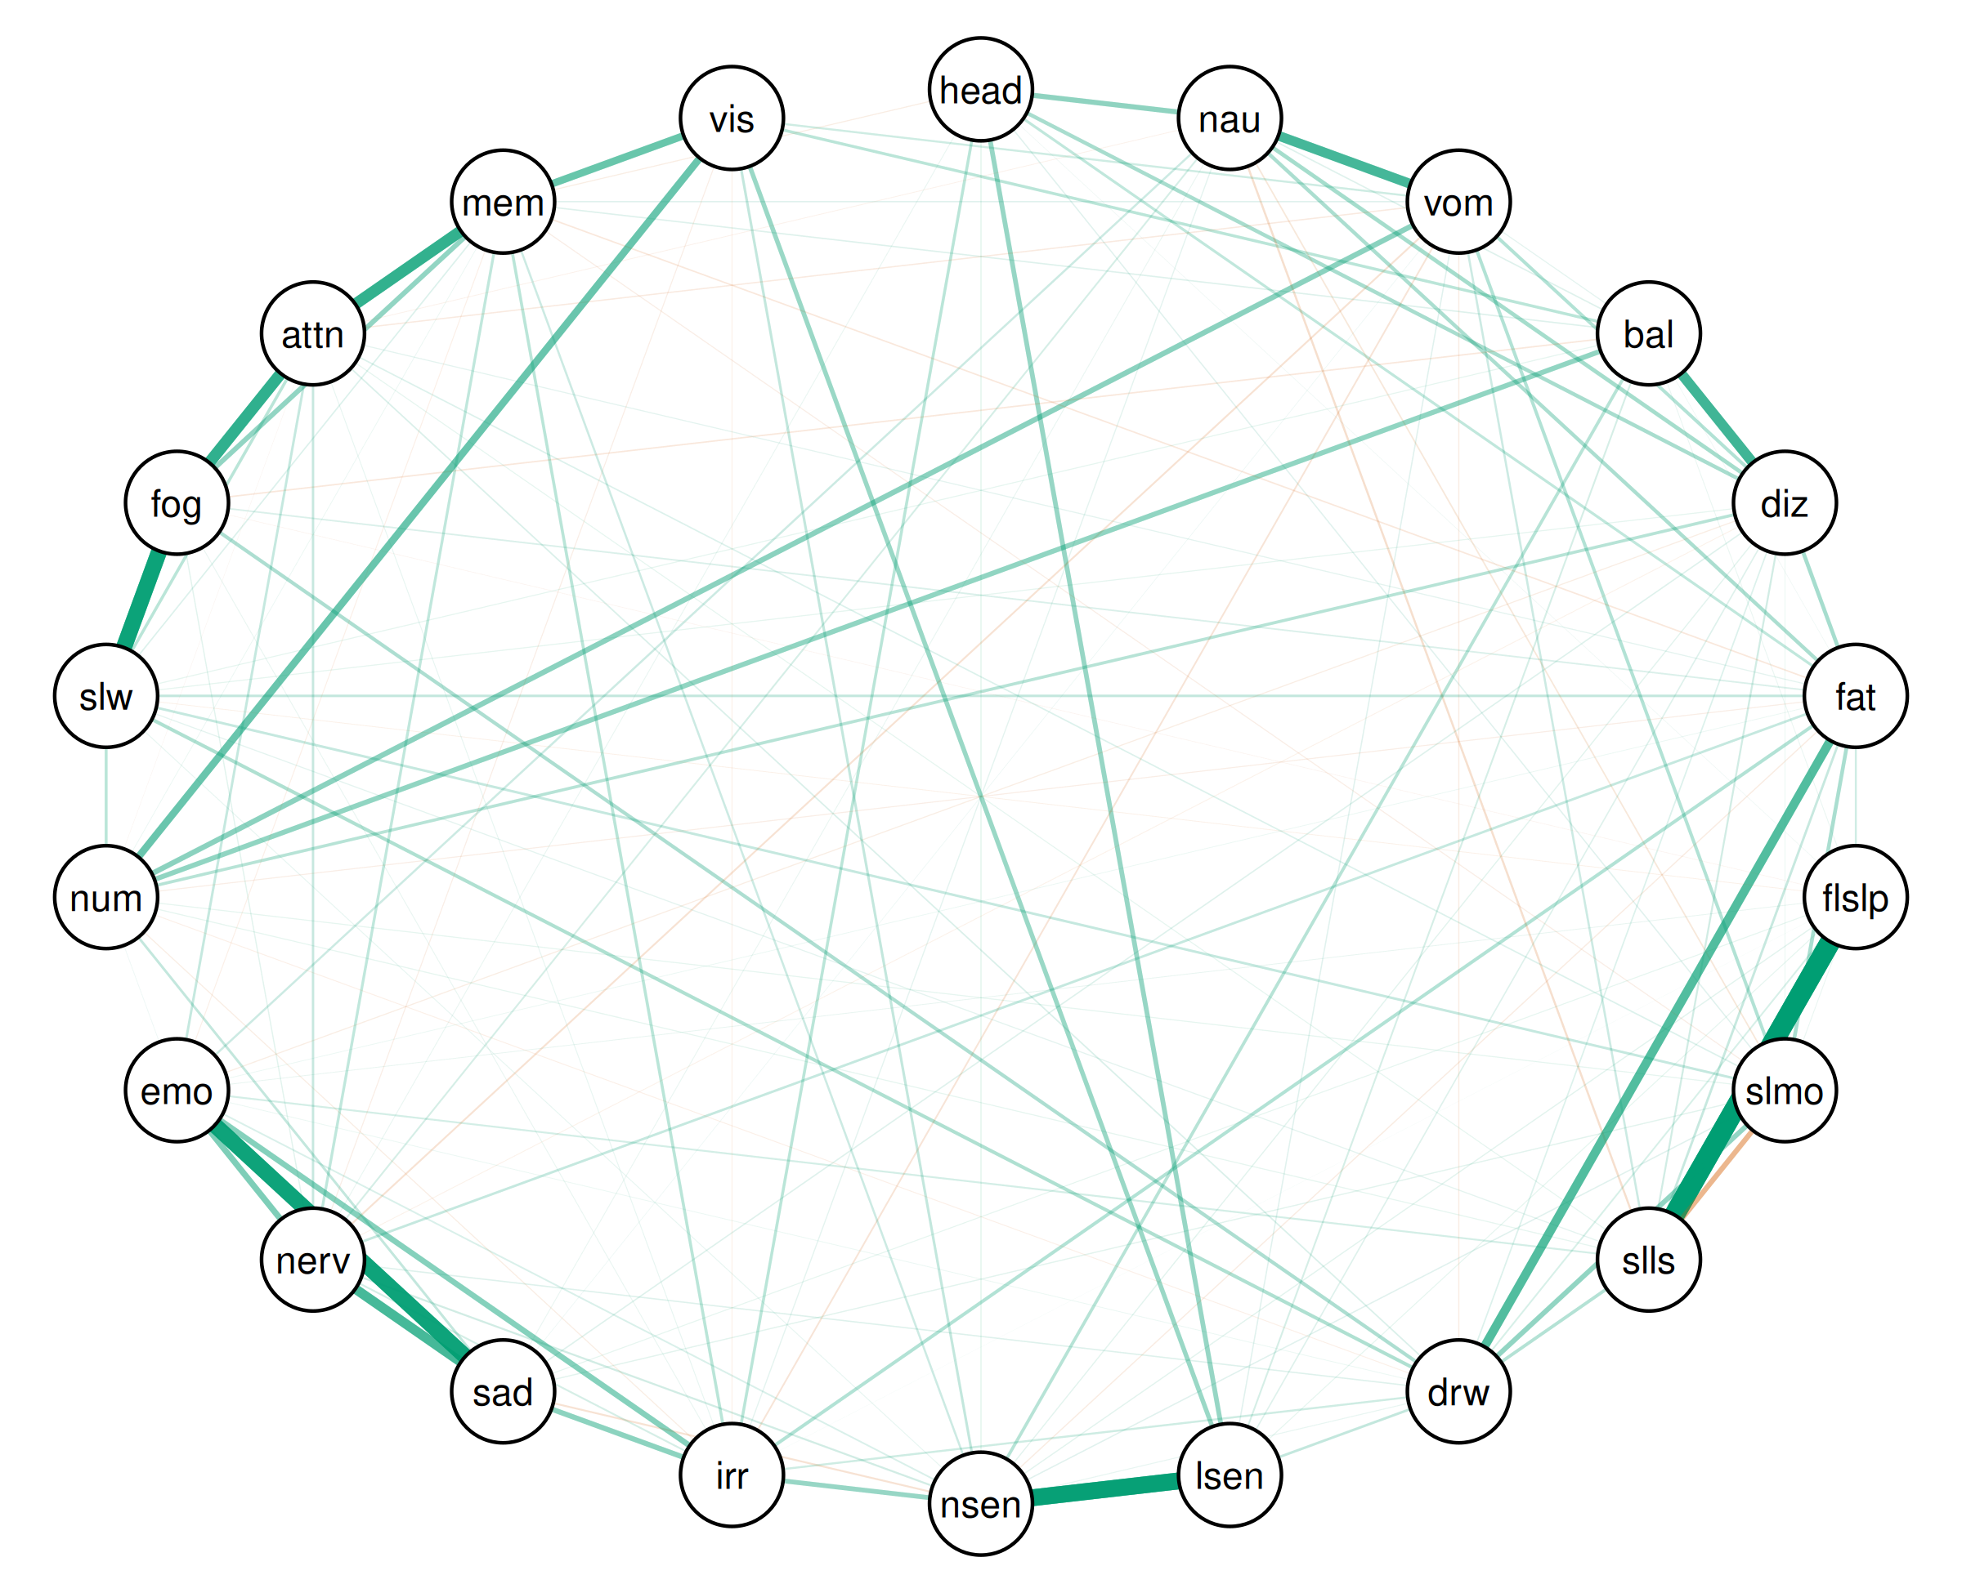

| Relation | Post.mean | Post.sd | Cred.lb | Cred.ub |
| --- | --- | --- | --- | --- |
| Trouble Falling Asleep--Sleeping Less Than Usual | 0.56 | 0.01 | 0.54 | 0.58 |
| Sensitivity to Light--Sensitivity to Noise | 0.46 | 0.01 | 0.43 | 0.47 |
| Feeling Slowed Down--Feeling Mentally “Foggy” | 0.44 | 0.01 | 0.42 | 0.46 |
| Sadness--Feeling More Emotional | 0.43 | 0.01 | 0.41 | 0.45 |
| Feeling Mentally “Foggy”--Difficulty Concentrating | 0.32 | 0.01 | 0.29 | 0.33 |
| Difficulty Concentrating--Difficulty Remembering | 0.31 | 0.01 | 0.31 | 0.35 |
| Balance Problems--Dizziness | 0.28 | 0.01 | 0.24 | 0.30 |
| Nausea--Vomiting | 0.27 | 0.01 | 0.25 | 0.31 |
| Sadness--Nervousness | 0.26 | 0.01 | 0.25 | 0.29 |
| Fatigue--Drowsiness | 0.24 | 0.01 | 0.23 | 0.27 |
| Difficulty Remembering--Visual Problems | 0.20 | 0.02 | 0.14 | 0.20 |
| Numbness or Tingling--Visual Problems | 0.20 | 0.02 | 0.15 | 0.24 |
| Nervousness--Feeling More Emotional | 0.17 | 0.01 | 0.15 | 0.19 |
| Irritability--Feeling More Emotional | 0.15 | 0.01 | 0.13 | 0.17 |
| Vomiting--Numbness or Tingling | 0.15 | 0.02 | 0.12 | 0.18 |
| Irritability--Sadness | 0.14 | 0.01 | 0.13 | 0.16 |
| Sleeping More Than Usual--Sleeping Less Than Usual | -0.14 | 0.01 | -0.15 | -0.12 |
| Headache--Nausea | 0.14 | 0.01 | 0.11 | 0.16 |
| Balance Problems--Numbness or Tingling | 0.14 | 0.01 | 0.12 | 0.16 |
| Sleeping More Than Usual--Drowsiness | 0.14 | 0.01 | 0.13 | 0.17 |
| Feeling Mentally “Foggy”--Difficulty Remembering | 0.14 | 0.01 | 0.12 | 0.16 |
| Sensitivity to Noise--Irritability | 0.13 | 0.01 | 0.12 | 0.16 |
| Headache--Sensitivity to Light | 0.13 | 0.01 | 0.11 | 0.15 |
| Sensitivity to Light--Visual Problems | 0.12 | 0.01 | 0.09 | 0.15 |
| Nausea--Dizziness | 0.11 | 0.01 | 0.09 | 0.13 |
| Dizziness--Fatigue | 0.11 | 0.01 | 0.08 | 0.12 |
| Headache--Dizziness | 0.10 | 0.01 | 0.07 | 0.11 |
| Fatigue--Sleeping More Than Usual | 0.10 | 0.01 | 0.08 | 0.12 |
| Nausea--Fatigue | 0.10 | 0.01 | 0.07 | 0.11 |
| Drowsiness--Feeling Mentally “Foggy” | 0.10 | 0.01 | 0.07 | 0.11 |
| Drowsiness--Feeling Slowed Down | 0.10 | 0.01 | 0.07 | 0.12 |
| Fatigue--Irritability | 0.09 | 0.01 | 0.07 | 0.11 |
| Vomiting--Dizziness | 0.09 | 0.01 | 0.06 | 0.11 |
| Vomiting--Sleeping More Than Usual | 0.09 | 0.01 | 0.06 | 0.11 |
| Sleeping Less Than Usual--Drowsiness | 0.09 | 0.01 | 0.06 | 0.10 |
| Balance Problems--Sensitivity to Noise | 0.09 | 0.01 | 0.05 | 0.10 |
| Dizziness--Numbness or Tingling | 0.08 | 0.01 | 0.07 | 0.11 |
| Feeling Slowed Down--Difficulty Concentrating | 0.08 | 0.01 | 0.07 | 0.10 |
| Irritability--Difficulty Remembering | 0.08 | 0.01 | 0.07 | 0.11 |
| Headache--Irritability | 0.08 | 0.01 | 0.06 | 0.10 |
| Numbness or Tingling--Feeling Slowed Down | 0.08 | 0.01 | 0.07 | 0.11 |
| Balance Problems--Visual Problems | 0.08 | 0.01 | 0.07 | 0.13 |
| Nervousness--Difficulty Remembering | 0.07 | 0.01 | 0.04 | 0.08 |
| Headache--Fatigue | 0.07 | 0.01 | 0.07 | 0.11 |
| Sensitivity to Noise--Visual Problems | 0.07 | 0.01 | 0.06 | 0.12 |
| Drowsiness--Sensitivity to Light | 0.07 | 0.01 | 0.05 | 0.08 |
| Sadness--Numbness or Tingling | 0.07 | 0.01 | 0.04 | 0.08 |
| Fatigue--Feeling Slowed Down | 0.07 | 0.01 | 0.05 | 0.09 |
| Sleeping More Than Usual--Feeling Slowed Down | 0.07 | 0.01 | 0.05 | 0.09 |
| Feeling More Emotional--Difficulty Concentrating | 0.07 | 0.01 | 0.04 | 0.08 |
| Fatigue--Nervousness | 0.07 | 0.01 | 0.04 | 0.09 |
| Fatigue--Sleeping Less Than Usual | 0.07 | 0.01 | 0.06 | 0.10 |
| Nervousness--Difficulty Concentrating | 0.07 | 0.01 | 0.05 | 0.09 |
| Vomiting--Sleeping Less Than Usual | 0.06 | 0.01 | 0.03 | 0.07 |
| Nausea--Feeling More Emotional | 0.06 | 0.01 | 0.03 | 0.07 |
| Nausea--Sleeping Less Than Usual | -0.06 | 0.01 | -0.07 | -0.03 |
| Sensitivity to Noise--Difficulty Remembering | 0.06 | 0.01 | 0.04 | 0.09 |
| Drowsiness--Irritability | 0.06 | 0.01 | 0.02 | 0.07 |
| Vomiting--Visual Problems | 0.06 | 0.02 | 0.01 | 0.07 |
| Fatigue--Trouble Falling Asleep | 0.06 | 0.01 | 0.03 | 0.06 |
| Dizziness--Sleeping Less Than Usual | 0.05 | 0.01 | 0.03 | 0.07 |
| Sensitivity to Noise--Nervousness | 0.05 | 0.01 | 0.04 | 0.07 |
| Sensitivity to Noise--Sadness | -0.05 | 0.01 | -0.06 | -0.02 |
| Vomiting--Nervousness | -0.05 | 0.01 | -0.06 | -0.03 |
| Irritability--Nervousness | 0.05 | 0.01 | 0.03 | 0.07 |
| Sleeping Less Than Usual--Feeling More Emotional | 0.05 | 0.01 | 0.03 | 0.06 |
| Nausea--Nervousness | 0.05 | 0.01 | 0.03 | 0.07 |
| Balance Problems--Sensitivity to Light | 0.05 | 0.01 | 0.02 | 0.05 |
| Trouble Falling Asleep--Drowsiness | 0.05 | 0.01 | 0.03 | 0.06 |
| Vomiting--Irritability | -0.05 | 0.01 | -0.06 | -0.02 |
| Sensitivity to Noise--Feeling More Emotional | 0.04 | 0.01 | 0.02 | 0.06 |
| Fatigue--Feeling Mentally “Foggy” | 0.04 | 0.01 | 0.03 | 0.07 |
| Nausea--Sleeping More Than Usual | -0.04 | 0.01 | -0.06 | -0.02 |
| Drowsiness--Difficulty Concentrating | 0.04 | 0.01 | 0.02 | 0.06 |
| Balance Problems--Feeling Mentally “Foggy” | -0.04 | 0.01 | -0.04 | -0.01 |
| Fatigue--Difficulty Remembering | -0.04 | 0.01 | -0.07 | -0.03 |
| Dizziness--Drowsiness | 0.04 | 0.01 | 0.01 | 0.05 |
| Sleeping More Than Usual--Difficulty Concentrating | 0.04 | 0.01 | 0.03 | 0.06 |
| Feeling Slowed Down--Difficulty Remembering | 0.04 | 0.01 | 0.01 | 0.05 |
| Nausea--Balance Problems | 0.04 | 0.01 | 0.02 | 0.06 |
| Dizziness--Sensitivity to Light | 0.04 | 0.01 | 0.02 | 0.06 |
| Balance Problems--Difficulty Remembering | 0.04 | 0.01 | 0.01 | 0.06 |
| Dizziness--Sadness | 0.04 | 0.01 | 0.02 | 0.06 |
| Drowsiness--Nervousness | 0.04 | 0.01 | 0.02 | 0.05 |
| Sleeping More Than Usual--Sensitivity to Noise | 0.04 | 0.01 | 0.01 | 0.05 |
| Vomiting--Difficulty Concentrating | -0.04 | 0.01 | -0.05 | -0.01 |
| Headache--Sleeping More Than Usual | 0.04 | 0.01 | 0.01 | 0.05 |
| Vomiting--Sensitivity to Light | 0.04 | 0.01 | 0.02 | 0.06 |
| Vomiting--Difficulty Remembering | 0.04 | 0.01 | 0.02 | 0.06 |
| Feeling Mentally “Foggy”--Visual Problems | -0.04 | 0.01 | -0.04 | 0.01 |
| Headache--Sensitivity to Noise | 0.03 | 0.01 | 0.00 | 0.04 |
| Fatigue--Sensitivity to Noise | -0.03 | 0.01 | -0.05 | -0.01 |
| Sensitivity to Light--Sadness | 0.03 | 0.01 | -0.00 | 0.04 |
| Nervousness--Feeling Mentally “Foggy” | 0.03 | 0.01 | 0.02 | 0.05 |
| Vomiting--Drowsiness | -0.03 | 0.01 | -0.04 | -0.00 |
| Dizziness--Sensitivity to Noise | 0.03 | 0.01 | 0.03 | 0.07 |
| Trouble Falling Asleep--Sensitivity to Noise | 0.03 | 0.01 | 0.03 | 0.06 |
| Nausea--Irritability | 0.03 | 0.01 | 0.02 | 0.06 |
| Sleeping More Than Usual--Sadness | 0.03 | 0.01 | 0.01 | 0.05 |
| Trouble Falling Asleep--Difficulty Remembering | 0.03 | 0.01 | -0.00 | 0.04 |
| Dizziness--Feeling More Emotional | -0.03 | 0.01 | -0.05 | -0.01 |
| Vomiting--Balance Problems | 0.03 | 0.01 | 0.00 | 0.06 |
| Irritability--Numbness or Tingling | -0.03 | 0.01 | -0.06 | -0.02 |
| Sleeping Less Than Usual--Feeling Slowed Down | 0.03 | 0.01 | 0.01 | 0.04 |
| Fatigue--Difficulty Concentrating | 0.03 | 0.01 | 0.01 | 0.05 |
| Headache--Difficulty Remembering | -0.03 | 0.01 | -0.06 | -0.02 |
| Sleeping More Than Usual--Difficulty Remembering | -0.03 | 0.01 | -0.05 | -0.02 |
| Sleeping More Than Usual--Numbness or Tingling | 0.03 | 0.01 | 0.01 | 0.04 |
| Sleeping Less Than Usual--Numbness or Tingling | 0.03 | 0.01 | 0.01 | 0.05 |
| Balance Problems--Feeling Slowed Down | 0.03 | 0.01 | 0.01 | 0.05 |
| Dizziness--Feeling Slowed Down | 0.03 | 0.01 | 0.01 | 0.05 |
| Trouble Falling Asleep--Sensitivity to Light | 0.03 | 0.01 | 0.01 | 0.05 |
| Trouble Falling Asleep--Sadness | 0.03 | 0.01 | 0.01 | 0.04 |
| Fatigue--Numbness or Tingling | -0.03 | 0.01 | -0.05 | -0.01 |
| Sleeping Less Than Usual--Difficulty Concentrating | 0.03 | 0.01 | 0.00 | 0.05 |
| Nervousness--Visual Problems | -0.03 | 0.01 | -0.05 | -0.01 |
| Headache--Vomiting | -0.03 | 0.01 | -0.03 | 0.00 |
| Drowsiness--Sensitivity to Noise | 0.03 | 0.01 | 0.01 | 0.05 |
| Feeling More Emotional--Difficulty Remembering | -0.03 | 0.01 | -0.04 | -0.00 |
| Trouble Falling Asleep--Nervousness | 0.03 | 0.01 | -0.00 | 0.04 |
| Drowsiness--Numbness or Tingling | -0.03 | 0.01 | -0.04 | -0.00 |
| Sensitivity to Noise--Feeling Slowed Down | 0.03 | 0.01 | 0.01 | 0.05 |
| Irritability--Difficulty Concentrating | 0.03 | 0.01 | 0.01 | 0.05 |
| Nausea--Difficulty Remembering | -0.03 | 0.01 | -0.03 | 0.00 |
| Irritability--Visual Problems | -0.03 | 0.01 | -0.06 | -0.01 |
| Headache--Nervousness | 0.03 | 0.01 | 0.01 | 0.04 |
| Irritability--Feeling Mentally “Foggy” | 0.03 | 0.01 | 0.02 | 0.05 |
| Trouble Falling Asleep--Sleeping More Than Usual | 0.02 | 0.01 | 0.00 | 0.04 |
| Nausea--Sadness | 0.02 | 0.01 | 0.00 | 0.04 |
| Dizziness--Nervousness | -0.02 | 0.01 | -0.04 | -0.00 |
| Balance Problems--Trouble Falling Asleep | 0.02 | 0.01 | 0.01 | 0.05 |
| Drowsiness--Sadness | -0.02 | 0.01 | -0.03 | 0.01 |
| Trouble Falling Asleep--Feeling More Emotional | 0.02 | 0.01 | 0.00 | 0.04 |
| Sensitivity to Noise--Numbness or Tingling | 0.02 | 0.01 | -0.00 | 0.04 |
| Trouble Falling Asleep--Feeling Slowed Down | -0.02 | 0.01 | -0.04 | -0.01 |
| Nausea--Difficulty Concentrating | -0.02 | 0.01 | -0.05 | -0.01 |
| Difficulty Concentrating--Visual Problems | 0.02 | 0.01 | -0.01 | 0.04 |
| Dizziness--Sleeping More Than Usual | 0.02 | 0.01 | 0.01 | 0.04 |
| Drowsiness--Feeling More Emotional | 0.02 | 0.01 | 0.01 | 0.05 |
| Sensitivity to Light--Feeling Slowed Down | -0.02 | 0.01 | -0.03 | 0.01 |
| Fatigue--Feeling More Emotional | 0.02 | 0.01 | 0.00 | 0.04 |
| Sadness--Difficulty Remembering | 0.02 | 0.01 | -0.01 | 0.03 |
| Numbness or Tingling--Difficulty Remembering | 0.02 | 0.01 | 0.02 | 0.06 |
| Sensitivity to Light--Irritability | 0.02 | 0.01 | -0.00 | 0.03 |
| Balance Problems--Nervousness | -0.02 | 0.01 | -0.03 | 0.00 |
| Nervousness--Numbness or Tingling | 0.02 | 0.01 | -0.01 | 0.03 |
| Feeling More Emotional--Numbness or Tingling | 0.02 | 0.01 | 0.01 | 0.04 |
| Vomiting--Sadness | 0.02 | 0.01 | 0.00 | 0.04 |
| Fatigue--Sadness | -0.02 | 0.01 | -0.04 | 0.00 |
| Balance Problems--Fatigue | 0.02 | 0.01 | 0.00 | 0.04 |
| Headache--Trouble Falling Asleep | 0.02 | 0.01 | 0.01 | 0.05 |
| Trouble Falling Asleep--Feeling Mentally “Foggy” | -0.02 | 0.01 | -0.04 | -0.01 |
| Fatigue--Visual Problems | 0.02 | 0.01 | -0.01 | 0.03 |
| Sensitivity to Light--Feeling More Emotional | -0.02 | 0.01 | -0.02 | 0.01 |
| Drowsiness--Difficulty Remembering | -0.02 | 0.01 | -0.03 | 0.01 |
| Sadness--Visual Problems | -0.02 | 0.01 | -0.03 | 0.01 |
| Nausea--Trouble Falling Asleep | 0.02 | 0.01 | -0.01 | 0.03 |
| Vomiting--Trouble Falling Asleep | 0.02 | 0.01 | -0.00 | 0.04 |
| Nausea--Numbness or Tingling | 0.02 | 0.01 | -0.01 | 0.03 |
| Numbness or Tingling--Difficulty Concentrating | -0.01 | 0.01 | -0.05 | -0.01 |
| Headache--Sadness | -0.01 | 0.01 | -0.03 | 0.01 |
| Sleeping Less Than Usual--Nervousness | -0.01 | 0.01 | -0.02 | 0.01 |
| Sensitivity to Light--Numbness or Tingling | 0.01 | 0.01 | -0.01 | 0.03 |
| Headache--Feeling Slowed Down | 0.01 | 0.01 | -0.01 | 0.03 |
| Sleeping More Than Usual--Feeling Mentally “Foggy” | 0.01 | 0.01 | -0.00 | 0.03 |
| Sleeping Less Than Usual--Irritability | 0.01 | 0.01 | -0.02 | 0.02 |
| Balance Problems--Sadness | -0.01 | 0.01 | -0.03 | 0.01 |
| Nausea--Feeling Slowed Down | 0.01 | 0.01 | -0.00 | 0.03 |
| Nervousness--Feeling Slowed Down | -0.01 | 0.01 | -0.03 | 0.00 |
| Dizziness--Feeling Mentally “Foggy” | -0.01 | 0.01 | -0.02 | 0.01 |
| Sleeping Less Than Usual--Feeling Mentally “Foggy” | 0.01 | 0.01 | -0.01 | 0.04 |
| Sadness--Feeling Mentally “Foggy” | 0.01 | 0.01 | -0.01 | 0.03 |
| Feeling More Emotional--Feeling Mentally “Foggy” | 0.01 | 0.01 | -0.00 | 0.04 |
| Vomiting--Sensitivity to Noise | 0.01 | 0.01 | -0.03 | 0.02 |
| Sensitivity to Light--Nervousness | -0.01 | 0.01 | -0.02 | 0.02 |
| Sensitivity to Noise--Difficulty Concentrating | -0.01 | 0.01 | -0.02 | 0.02 |
| Dizziness--Difficulty Remembering | 0.01 | 0.01 | -0.01 | 0.03 |
| Trouble Falling Asleep--Irritability | 0.01 | 0.01 | 0.00 | 0.04 |
| Sleeping More Than Usual--Nervousness | 0.01 | 0.01 | -0.01 | 0.02 |
| Sensitivity to Light--Feeling Mentally “Foggy” | 0.01 | 0.01 | -0.00 | 0.03 |
| Sleeping Less Than Usual--Sadness | 0.01 | 0.01 | -0.00 | 0.04 |
| Headache--Feeling More Emotional | 0.01 | 0.01 | -0.01 | 0.03 |
| Vomiting--Feeling Slowed Down | -0.01 | 0.01 | -0.03 | 0.01 |
| Headache--Feeling Mentally “Foggy” | 0.01 | 0.01 | -0.01 | 0.03 |
| Sensitivity to Noise--Feeling Mentally “Foggy” | 0.01 | 0.01 | -0.03 | 0.01 |
| Sensitivity to Light--Difficulty Concentrating | 0.01 | 0.01 | -0.01 | 0.03 |
| Nausea--Drowsiness | -0.01 | 0.01 | -0.03 | 0.01 |
| Sensitivity to Light--Difficulty Remembering | 0.01 | 0.01 | -0.00 | 0.04 |
| Trouble Falling Asleep--Visual Problems | 0.01 | 0.01 | -0.01 | 0.03 |
| Dizziness--Trouble Falling Asleep | 0.01 | 0.01 | -0.01 | 0.03 |
| Balance Problems--Sleeping Less Than Usual | -0.01 | 0.01 | -0.03 | 0.01 |
| Balance Problems--Drowsiness | 0.01 | 0.01 | -0.00 | 0.03 |
| Sleeping Less Than Usual--Sensitivity to Light | -0.01 | 0.01 | -0.03 | 0.01 |
| Dizziness--Visual Problems | 0.01 | 0.01 | -0.00 | 0.05 |
| Trouble Falling Asleep--Numbness or Tingling | -0.01 | 0.01 | -0.01 | 0.03 |
| Nausea--Feeling Mentally “Foggy” | 0.01 | 0.01 | -0.01 | 0.02 |
| Nausea--Sensitivity to Noise | 0.01 | 0.01 | -0.00 | 0.04 |
| Dizziness--Irritability | -0.01 | 0.01 | -0.03 | 0.00 |
| Balance Problems--Feeling More Emotional | -0.01 | 0.01 | -0.03 | 0.01 |
| Sadness--Difficulty Concentrating | -0.01 | 0.01 | -0.03 | 0.01 |
| Headache--Drowsiness | -0.01 | 0.01 | -0.01 | 0.02 |
| Nausea--Sensitivity to Light | 0.01 | 0.01 | -0.01 | 0.03 |
| Balance Problems--Irritability | -0.01 | 0.01 | -0.02 | 0.01 |
| Nausea--Visual Problems | 0.01 | 0.01 | -0.03 | 0.02 |
| Sleeping Less Than Usual--Sensitivity to Noise | 0.00 | 0.01 | -0.02 | 0.02 |
| Vomiting--Feeling More Emotional | -0.00 | 0.01 | -0.03 | 0.01 |
| Irritability--Feeling Slowed Down | 0.00 | 0.01 | -0.02 | 0.02 |
| Feeling More Emotional--Feeling Slowed Down | -0.00 | 0.01 | -0.01 | 0.02 |
| Dizziness--Difficulty Concentrating | 0.00 | 0.01 | -0.02 | 0.02 |
| Headache--Balance Problems | -0.00 | 0.01 | -0.01 | 0.04 |
| Vomiting--Fatigue | -0.00 | 0.01 | -0.03 | 0.01 |
| Balance Problems--Sleeping More Than Usual | -0.00 | 0.01 | -0.01 | 0.02 |
| Numbness or Tingling--Feeling Mentally “Foggy” | 0.00 | 0.01 | -0.01 | 0.03 |
| Headache--Difficulty Concentrating | 0.00 | 0.01 | -0.02 | 0.02 |
| Sleeping Less Than Usual--Difficulty Remembering | 0.00 | 0.01 | -0.02 | 0.02 |
| Headache--Visual Problems | 0.00 | 0.01 | -0.02 | 0.01 |
| Drowsiness--Visual Problems | 0.00 | 0.01 | -0.02 | 0.02 |
| Headache--Sleeping Less Than Usual | -0.00 | 0.01 | -0.02 | 0.01 |
| Fatigue--Sensitivity to Light | -0.00 | 0.01 | -0.02 | 0.01 |
| Sleeping More Than Usual--Feeling More Emotional | 0.00 | 0.01 | -0.01 | 0.03 |
| Headache--Numbness or Tingling | 0.00 | 0.01 | -0.01 | 0.03 |
| Sadness--Feeling Slowed Down | -0.00 | 0.01 | -0.01 | 0.02 |
| Vomiting--Feeling Mentally “Foggy” | -0.00 | 0.01 | -0.03 | 0.01 |
| Trouble Falling Asleep--Difficulty Concentrating | 0.00 | 0.01 | -0.00 | 0.03 |
| Sleeping Less Than Usual--Visual Problems | 0.00 | 0.01 | 0.00 | 0.05 |
| Feeling More Emotional--Visual Problems | 0.00 | 0.01 | -0.02 | 0.02 |
| Sleeping More Than Usual--Irritability | -0.00 | 0.01 | -0.02 | 0.02 |
| Balance Problems--Difficulty Concentrating | 0.00 | 0.01 | -0.01 | 0.02 |
| Feeling Slowed Down--Visual Problems | -0.00 | 0.01 | -0.04 | 0.01 |
| Sleeping More Than Usual--Sensitivity to Light | -0.00 | 0.01 | -0.01 | 0.03 |
| Sleeping More Than Usual--Visual Problems | 0.00 | 0.01 | -0.01 | 0.03 |

### Bridge strength

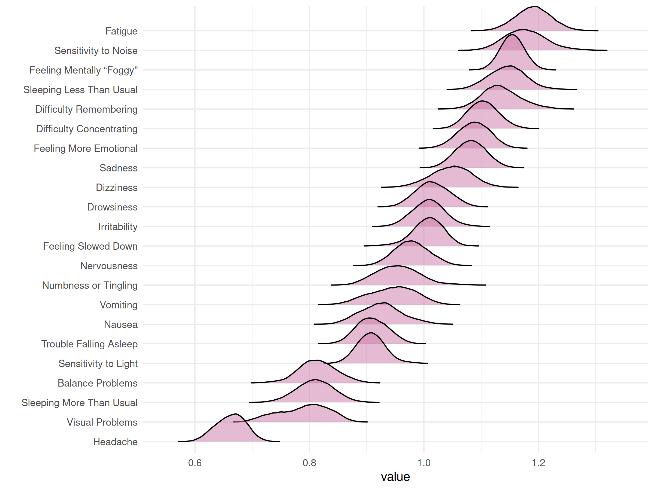

| Node | Post.mean | Post.sd | Cred.lb | Cred.ub |
| --- | --- | --- | --- | --- |
| Headache | 0.66 | 0.03 | 0.61 | 0.71 |
| Nausea | 0.93 | 0.04 | 0.86 | 1.00 |
| Vomiting | 0.94 | 0.04 | 0.87 | 1.02 |
| Balance Problems | 0.81 | 0.03 | 0.75 | 0.88 |
| Dizziness | 1.05 | 0.04 | 0.98 | 1.11 |
| Fatigue | 1.19 | 0.03 | 1.13 | 1.25 |
| Trouble Falling Asleep | 0.91 | 0.03 | 0.86 | 0.96 |
| Sleeping More Than Usual | 0.81 | 0.03 | 0.74 | 0.87 |
| Sleeping Less Than Usual | 1.15 | 0.03 | 1.08 | 1.21 |
| Drowsiness | 1.01 | 0.03 | 0.96 | 1.07 |
| Sensitivity to Light | 0.91 | 0.03 | 0.86 | 0.96 |
| Sensitivity to Noise | 1.18 | 0.04 | 1.11 | 1.25 |
| Irritability | 1.01 | 0.03 | 0.95 | 1.06 |
| Sadness | 1.08 | 0.03 | 1.03 | 1.13 |
| Nervousness | 0.98 | 0.03 | 0.92 | 1.04 |
| Feeling More Emotional | 1.09 | 0.03 | 1.03 | 1.14 |
| Numbness or Tingling | 0.95 | 0.04 | 0.89 | 1.04 |
| Feeling Slowed Down | 1.01 | 0.03 | 0.95 | 1.06 |
| Feeling Mentally “Foggy” | 1.16 | 0.02 | 1.11 | 1.20 |
| Difficulty Concentrating | 1.10 | 0.03 | 1.05 | 1.16 |
| Difficulty Remembering | 1.14 | 0.03 | 1.07 | 1.21 |
| Visual Problems | 0.79 | 0.04 | 0.70 | 0.86 |

## Grahical VAR (vector autoregression)

A variety of methods for time series data. These particular models are VAR(1) models which are also known as time series chain graphical models.

### Average contemporaneous network - Total sample

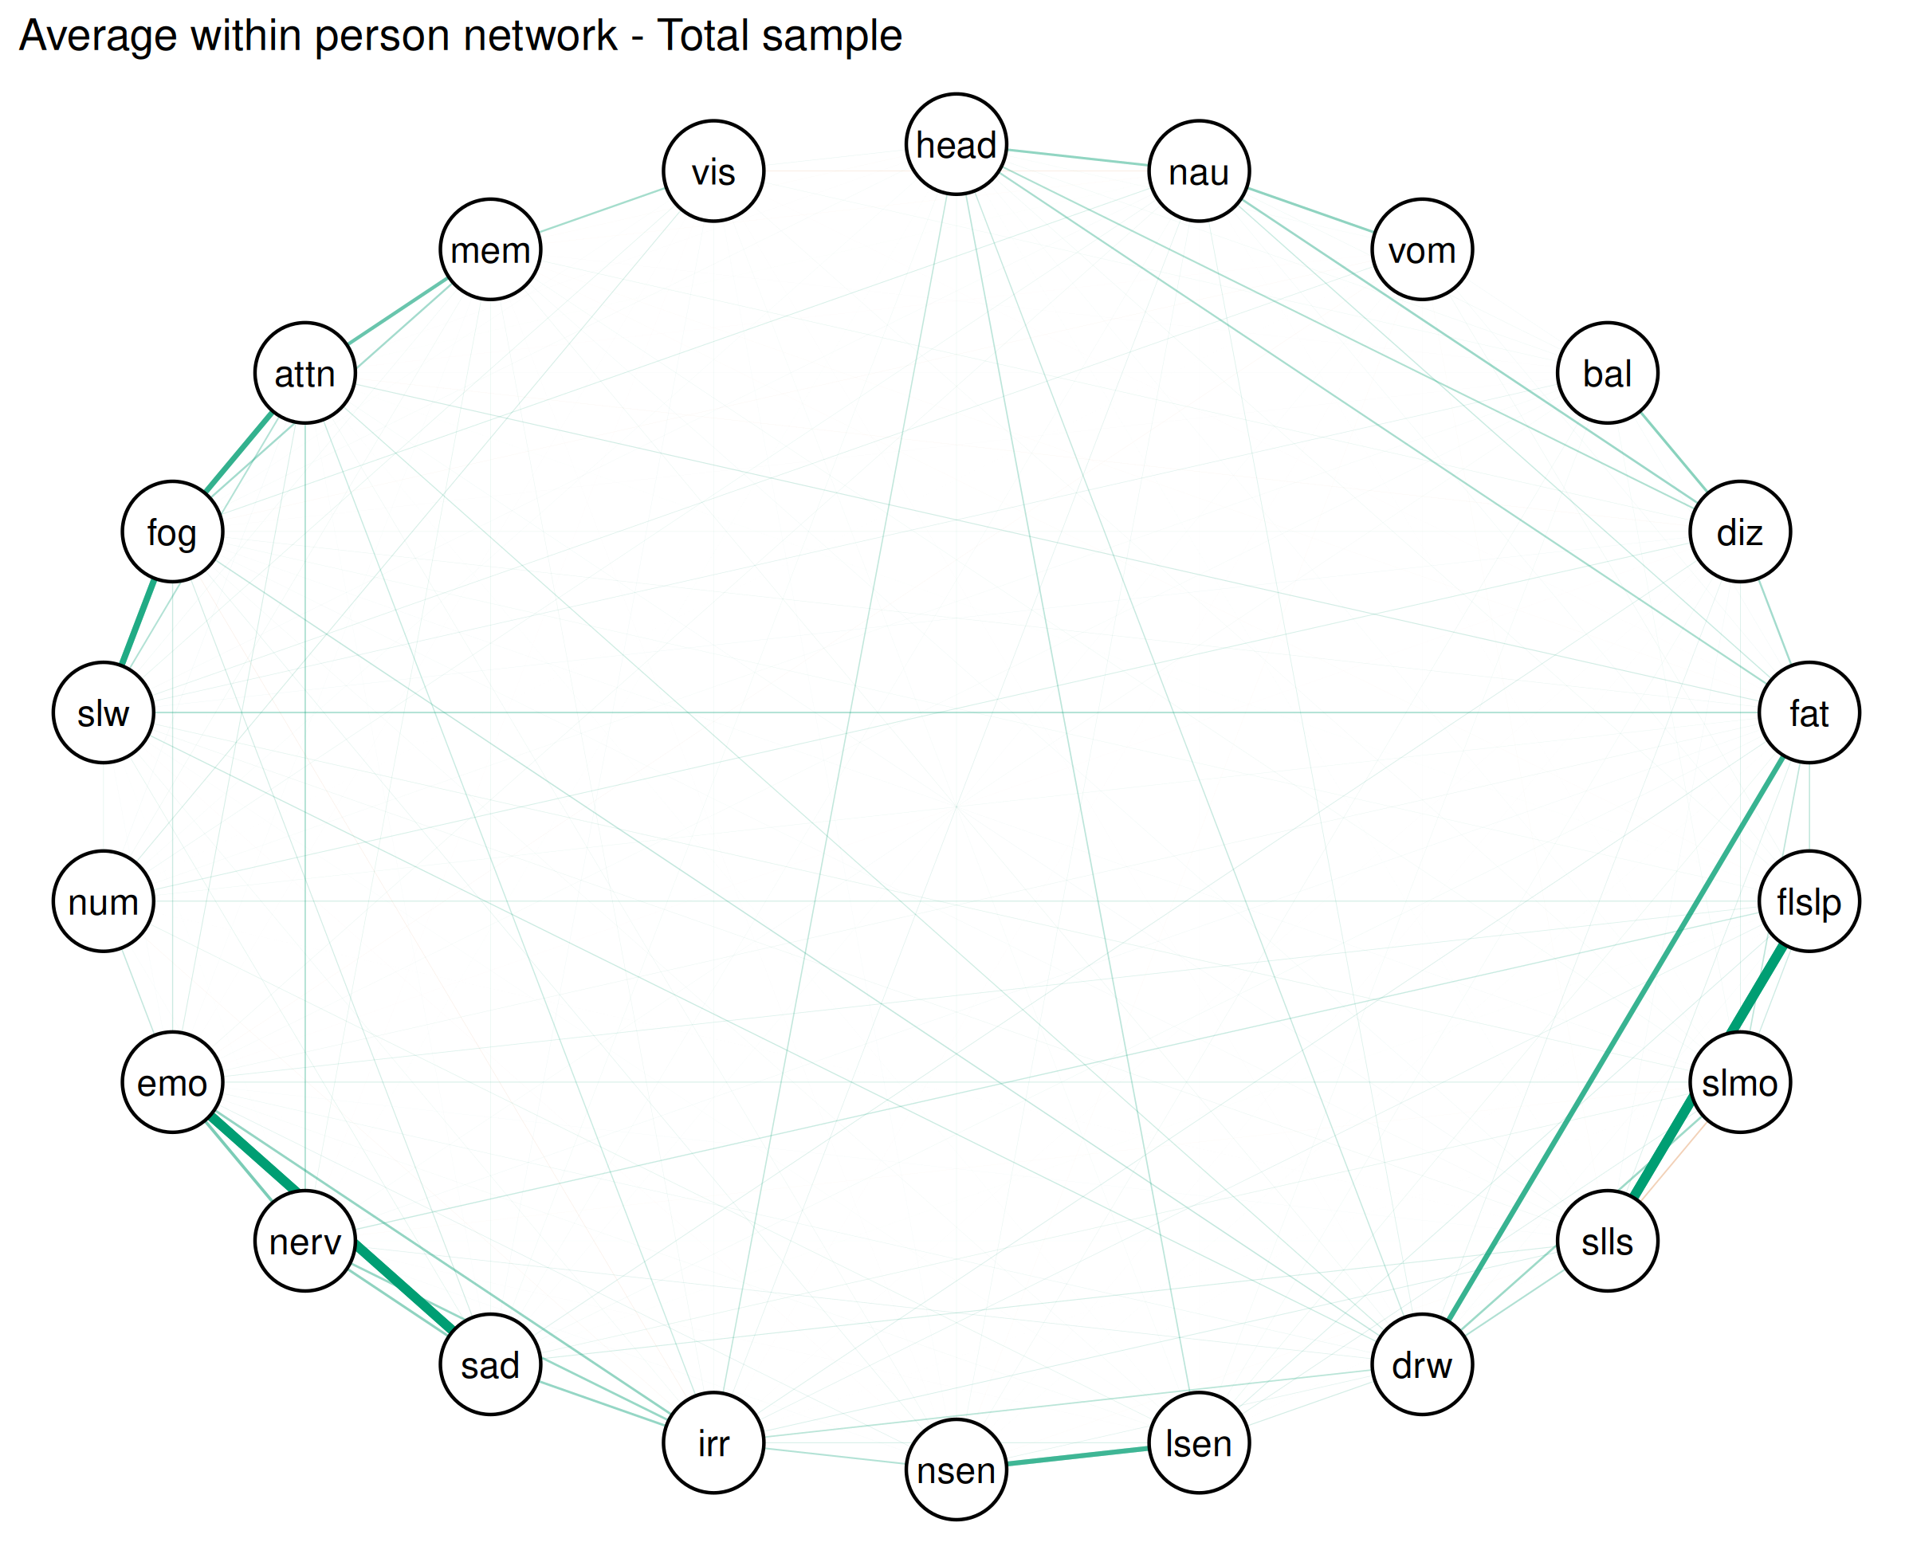

### Average contemporaneous network - Concussion

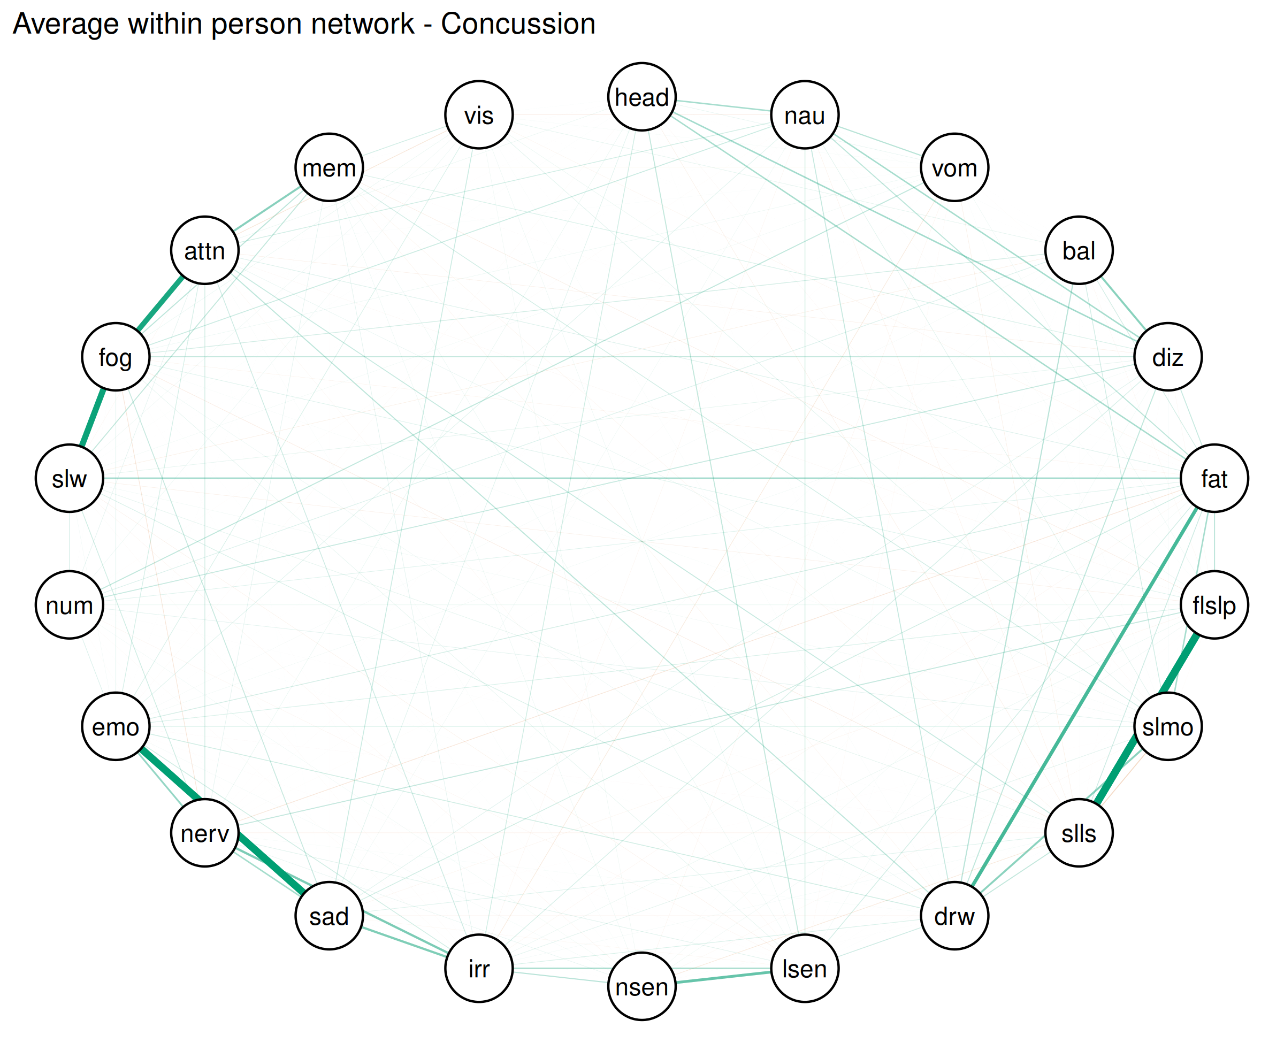

### Average contemporaneous network - Control

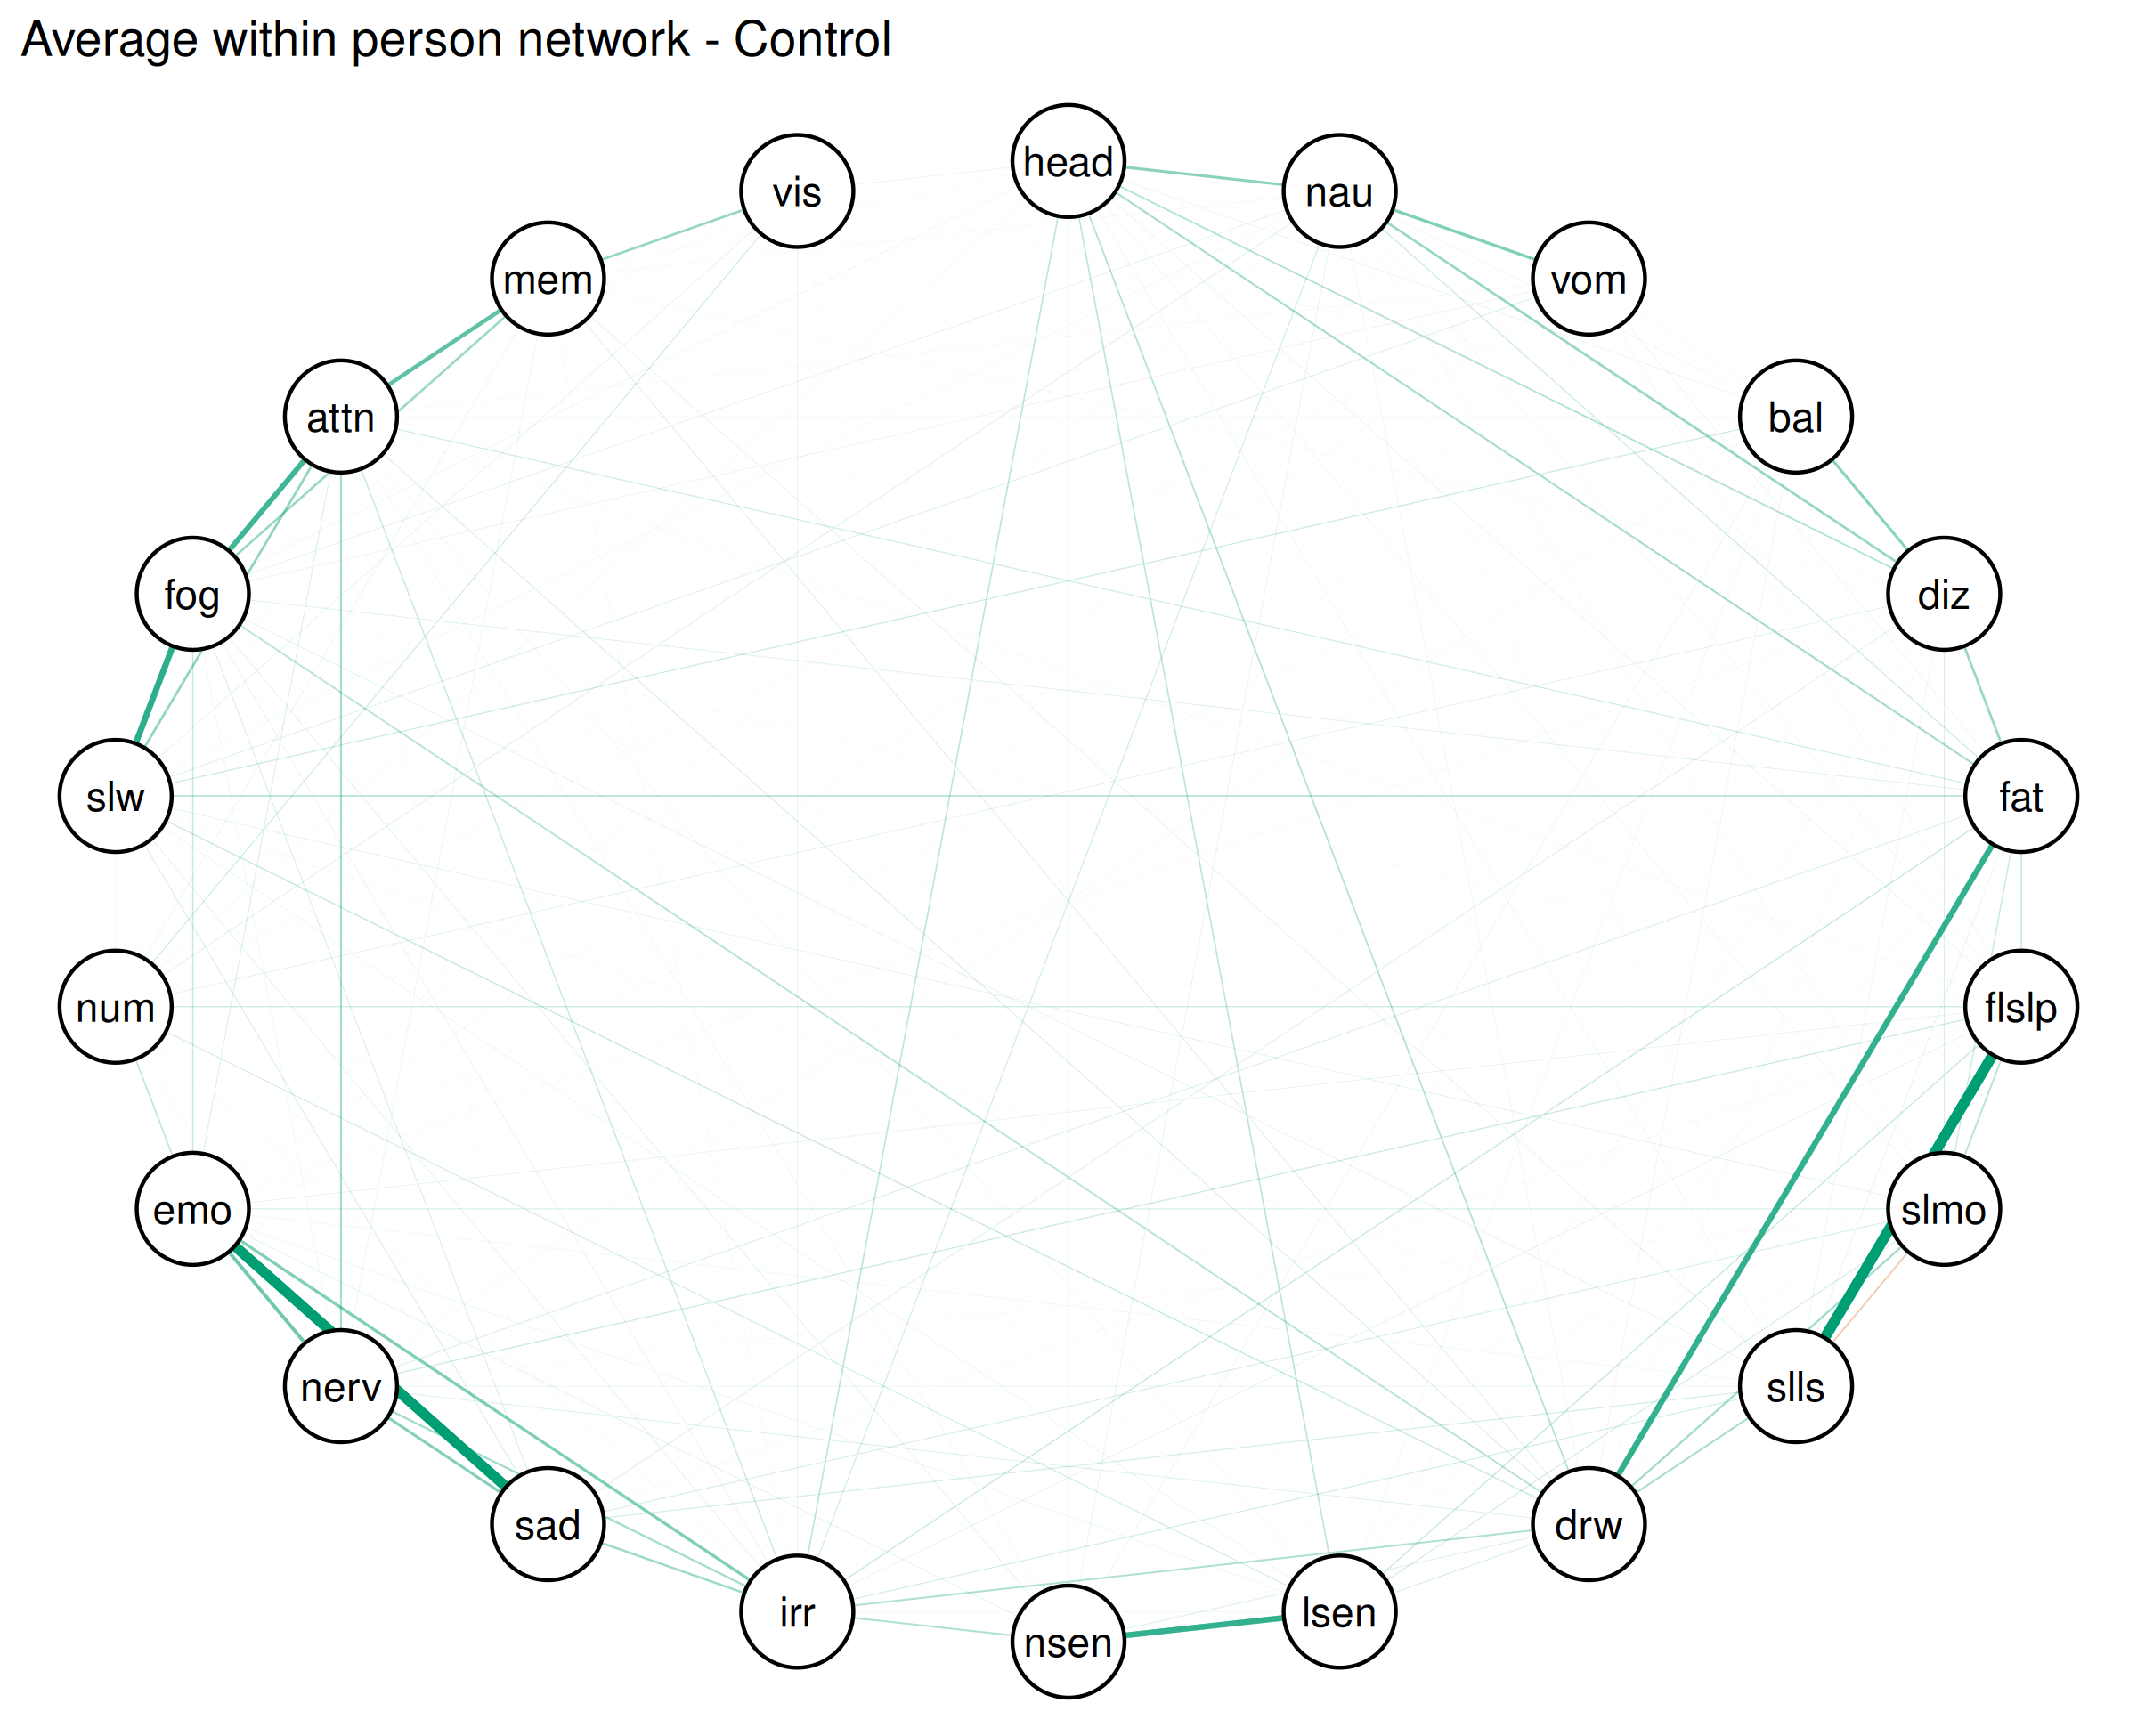

| Symptom | Total sample | Concussion | Control |
| --- | --- | --- | --- |
| Headache | 6 (2.5) | 1 (1.72) | 5 (2.75) |
| Nausea | 10 (4.17) | 3 (5.17) | 7 (3.85) |
| Vomiting | 4 (1.67) | NA (NA) | 4 (2.2) |
| Balance Problems | 9 (3.75) | 3 (5.17) | 6 (3.3) |
| Dizziness | 10 (4.17) | 2 (3.45) | 8 (4.4) |
| Fatigue | 16 (6.67) | 1 (1.72) | 15 (8.24) |
| Trouble Falling Asleep | 14 (5.83) | 6 (10.34) | 8 (4.4) |
| Sleeping More Than Usual | 8 (3.33) | 3 (5.17) | 5 (2.75) |
| Sleeping Less Than Usual | 12 (5) | 4 (6.9) | 8 (4.4) |
| Drowsiness | 14 (5.83) | 6 (10.34) | 8 (4.4) |
| Sensitivity to Light | 5 (2.08) | 1 (1.72) | 4 (2.2) |
| Sensitivity to Noise | 9 (3.75) | 1 (1.72) | 8 (4.4) |
| Irritability | 23 (9.58) | 6 (10.34) | 17 (9.34) |
| Sadness | 13 (5.42) | 1 (1.72) | 12 (6.59) |
| Nervousness | 14 (5.83) | 4 (6.9) | 10 (5.49) |
| Feeling More Emotional | 12 (5) | 4 (6.9) | 8 (4.4) |
| Numbness or Tingling | 6 (2.5) | 1 (1.72) | 5 (2.75) |
| Feeling Slowed Down | 16 (6.67) | 3 (5.17) | 13 (7.14) |
| Feeling Mentally “Foggy” | 14 (5.83) | 5 (8.62) | 9 (4.95) |
| Difficulty Concentrating | 9 (3.75) | NA (NA) | 9 (4.95) |
| Difficulty Remembering | 9 (3.75) | 2 (3.45) | 7 (3.85) |
| Visual Problems | 7 (2.92) | 1 (1.72) | 6 (3.3) |

# References

R Core Team. (2024). *R: A language and environment for statistical computing*. R Foundation for Statistical Computing. <https://www.R-project.org/>